**5. Docker CLI commands**

**Installing Docker and Setting up Nginx**

**Introduction**

**Docker** is a platform that allows us to run applications inside lightweight containers. Containers are isolated environments that include everything needed to run an application. This makes it easy to set up and deploy software without worrying about dependencies or configurations on the host system.

In this task, we used Docker to run an **Ubuntu container**, install **nginx** inside it, and serve a customized homepage

Step 1: Pulling the Ubuntu Image

First, we pulled the latest Ubuntu image from Docker Hub.

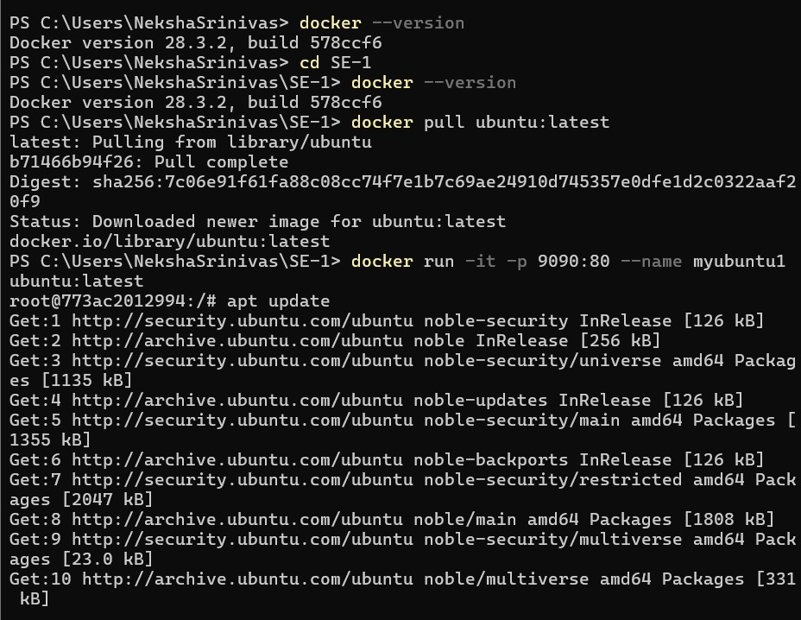

Step 2: Running the Container

We created and started a new container named **myubuntu**, mapping port **3000** on the host to port **80** inside the container.



Step 3: Installing Nginx and redirecting to index.html page to edit the content

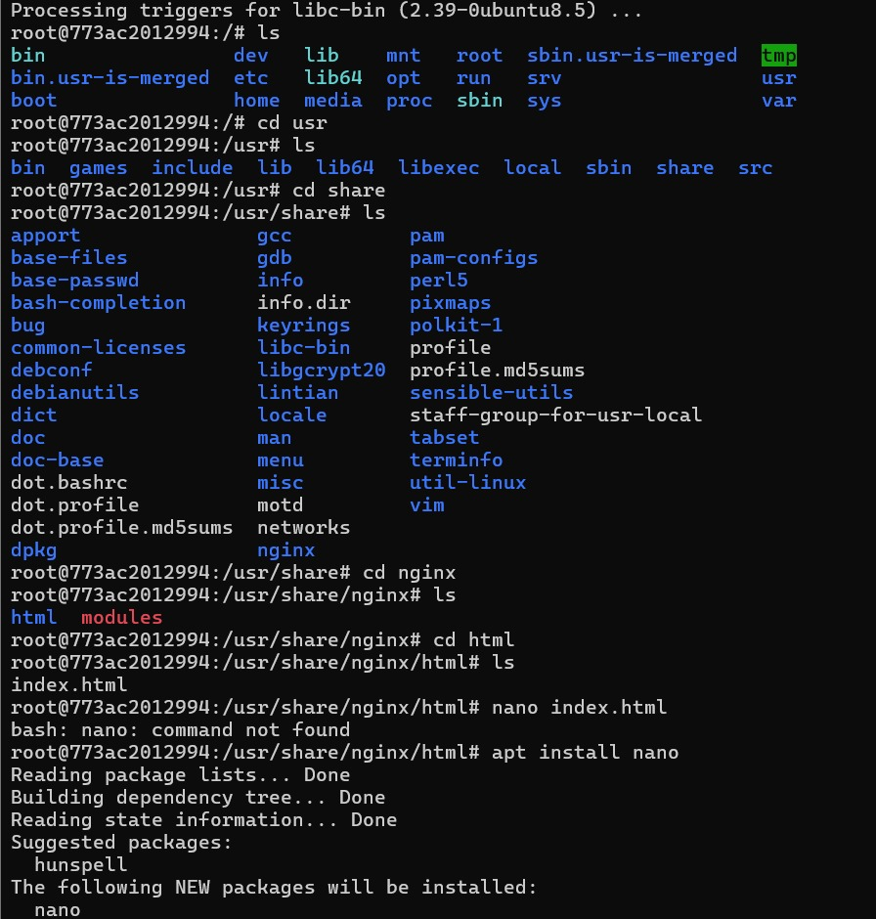

Step 4: navigate to index.html using command –“nano index.html” Changed the content of h1 tag

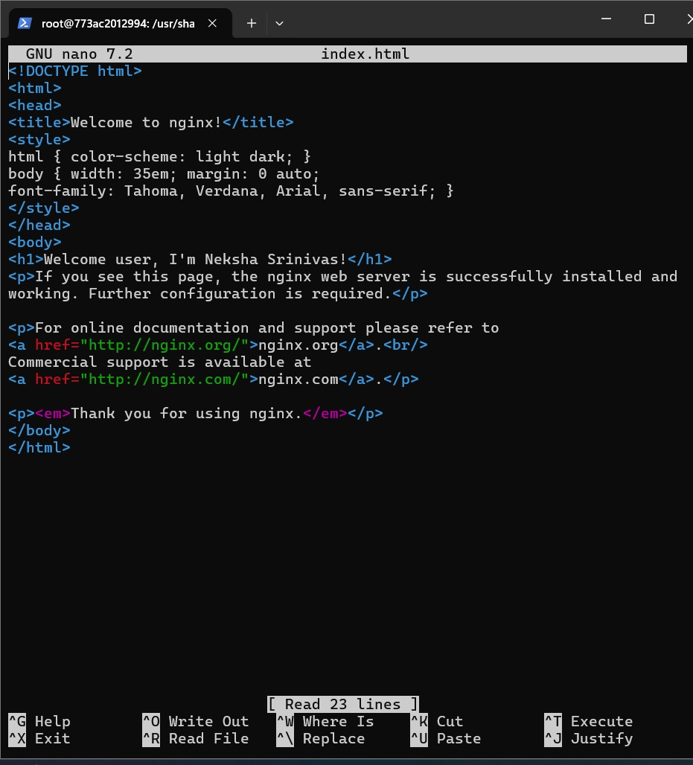

Step 5: Viewing the page from local host

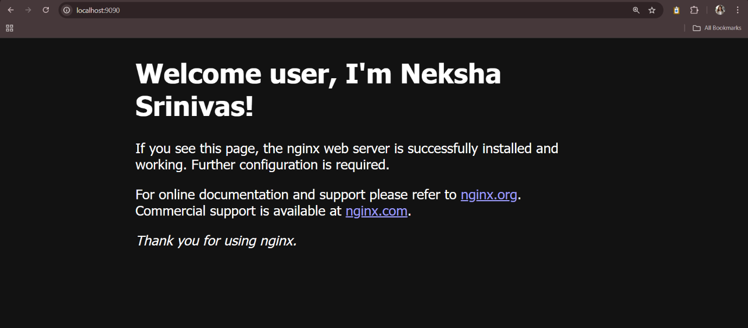

**6. Docker**

DOCKER IMAGE CREATION:

Image can be created in two ways:

1. Using Docker commit
2. Using docker file

Step 1: Created a new container of ubuntu so image can be created on that container

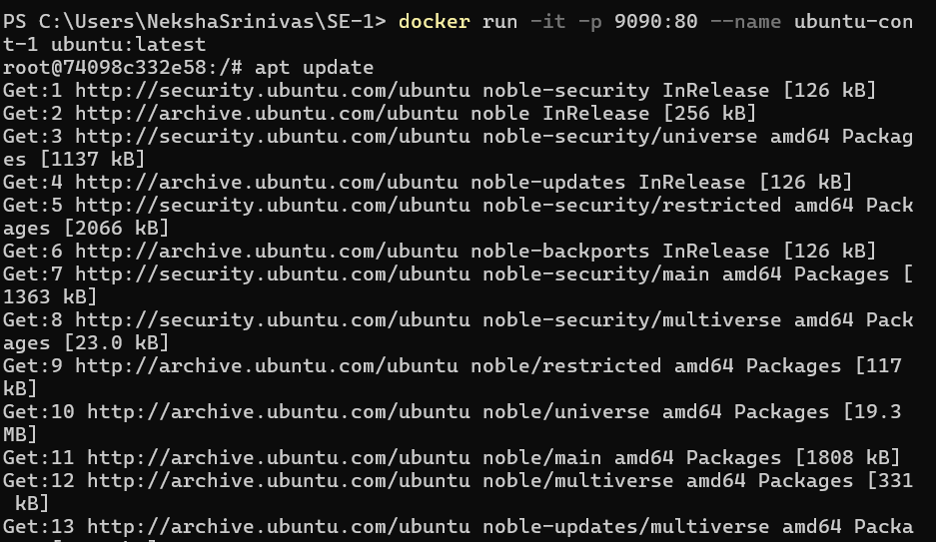

Step 2: Using commit the image is being created:

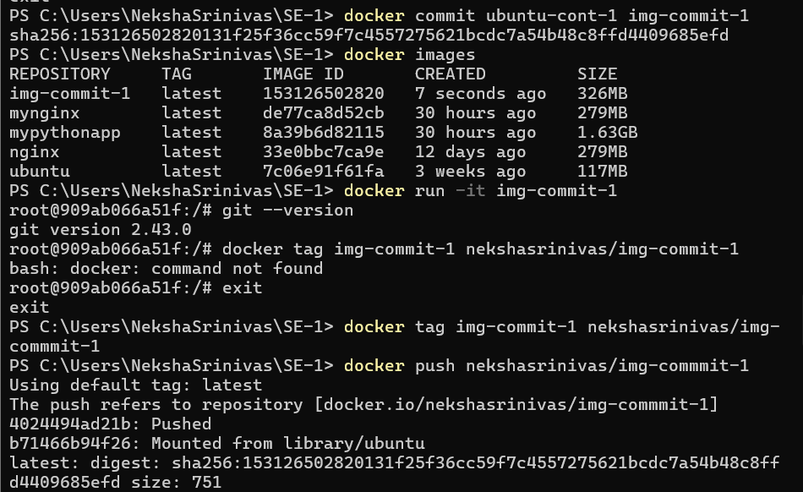

Step 3: Image creation using docker file 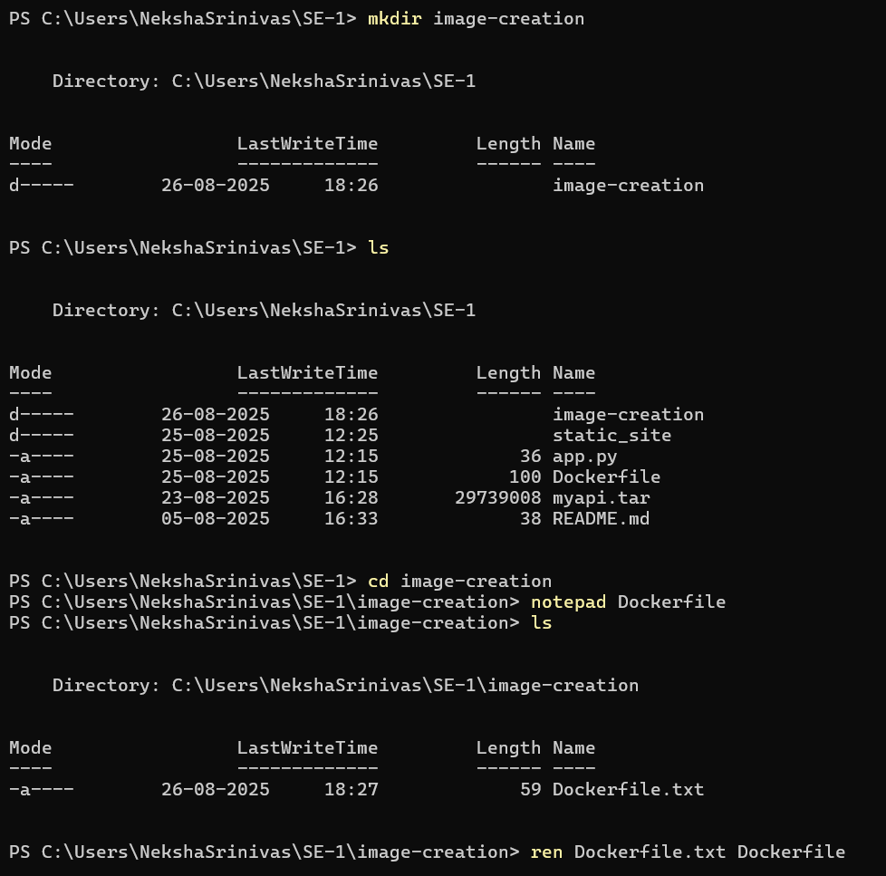

Step 4: after writing the content in docker file use the command docker build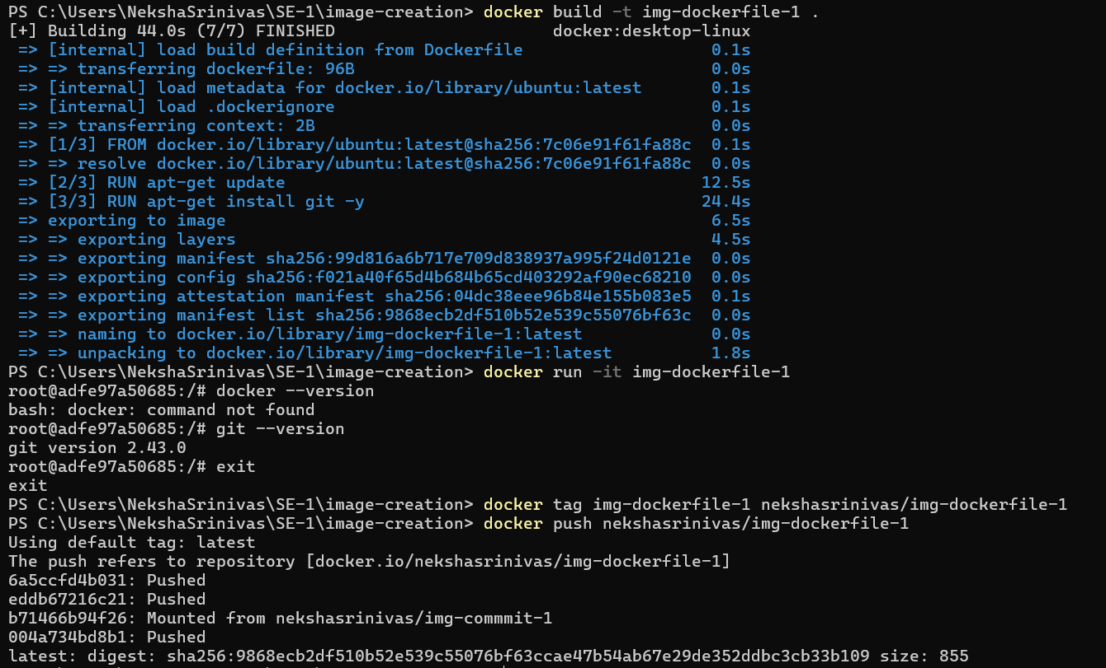

Step 5: checking the images

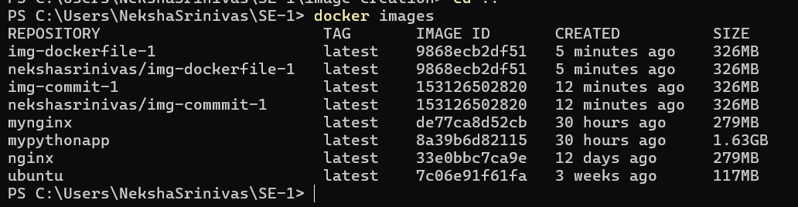

DOCKER COMPOSE FILE:

Docker Compose is a tool used to define and run multi-container Docker applications. It allows you to define services, networks, and volumes that your application needs, all in a single file. This makes it easier to manage complex applications that require multiple containers (e.g., a web server and a database).

Step 1: Running two servers at the same time on different ports

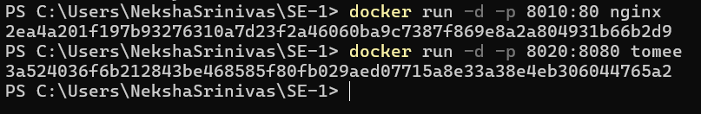

Step 2: Open the local host to view the pages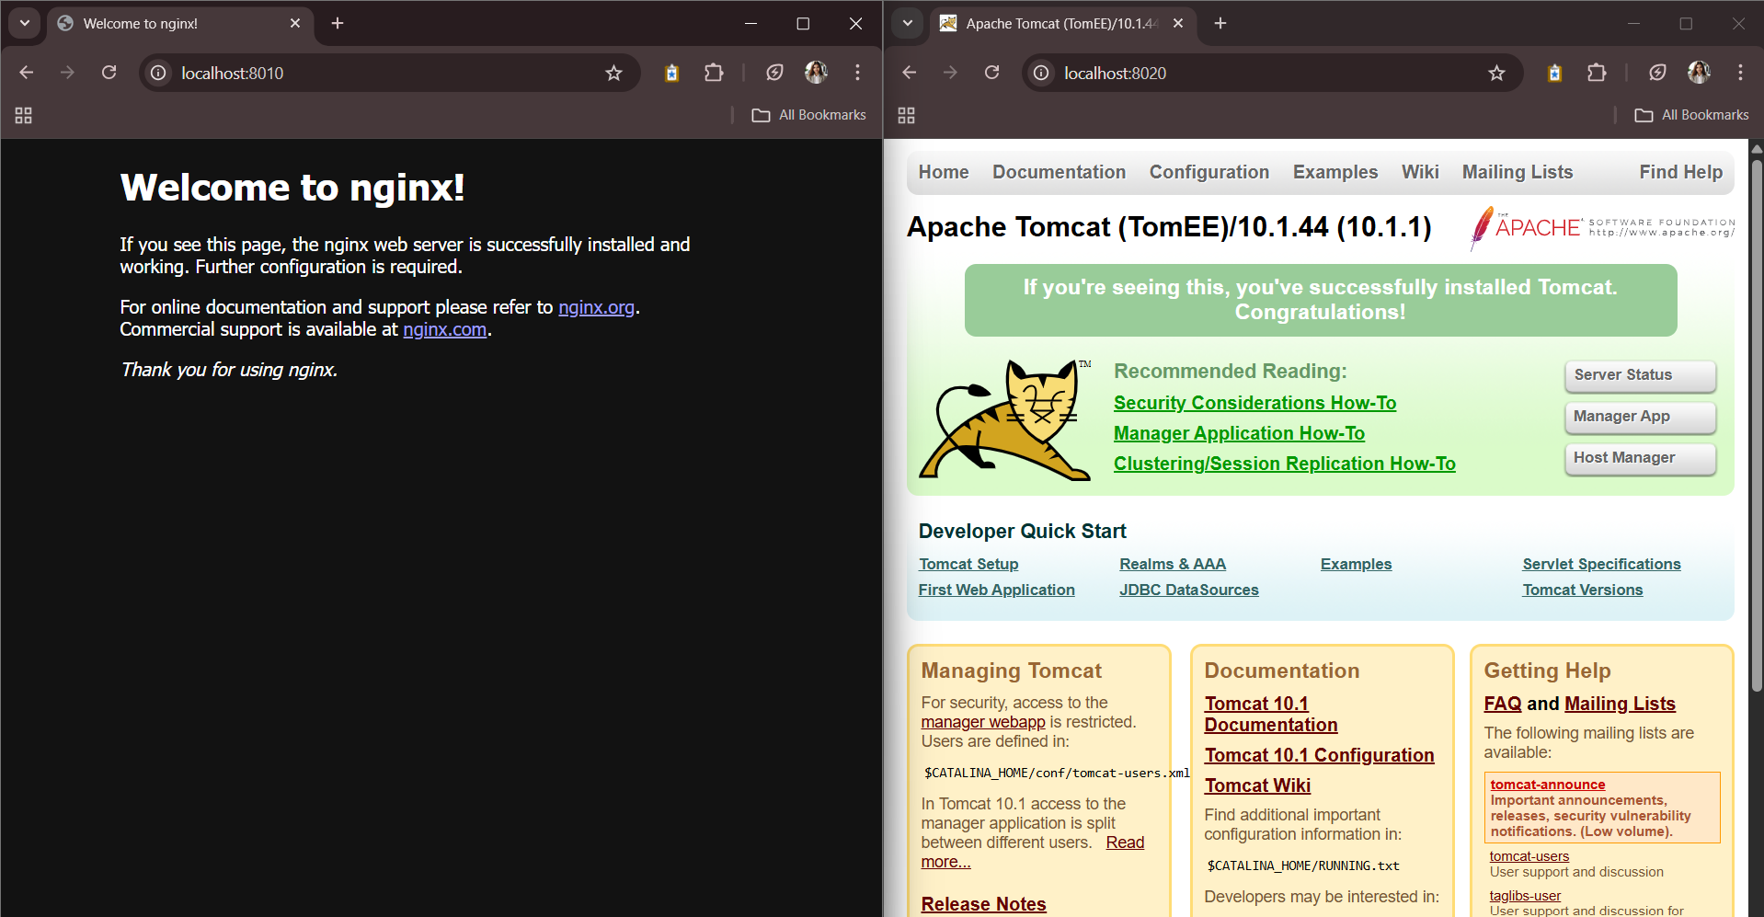

Step 3: Using docker file to run two servers parallelly

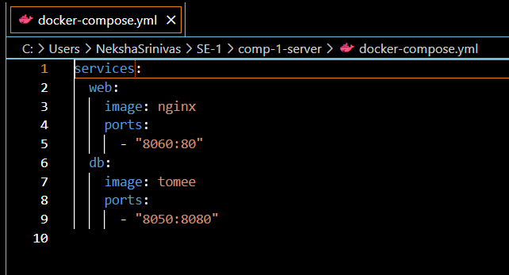

Step 4: Use the docker-compose up -d command to execute the docker file

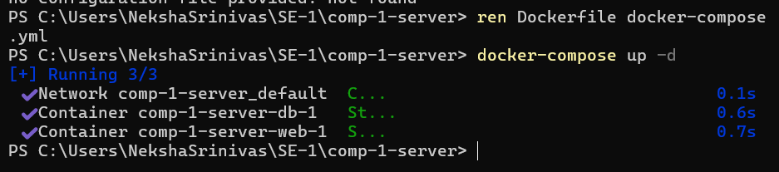

Step 5: Open the localhost to view the servers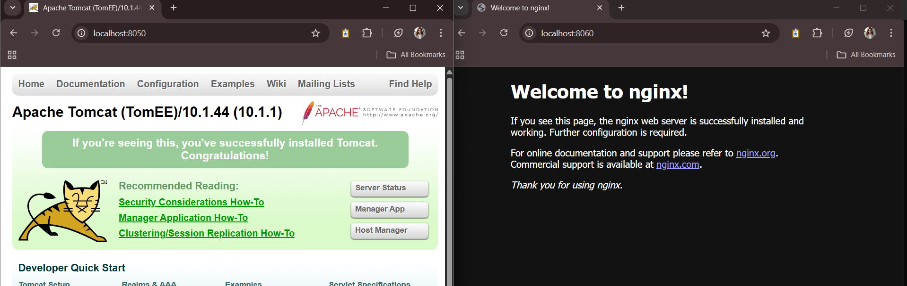

WORD-PRESS:

Step 1: Create a docker-compose file and write the content for wordpress and mysql

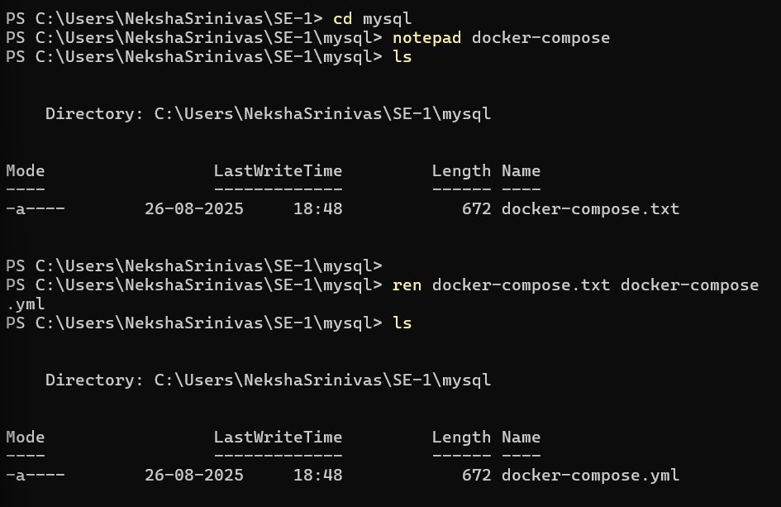

Step 2: docker-compose.yml file:

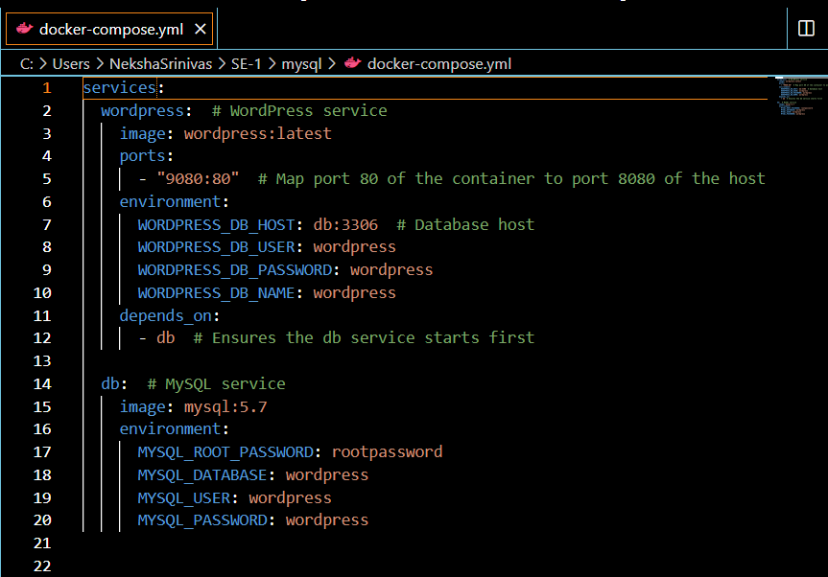

Step 3: Use the docker-compose up -d command to start the compose

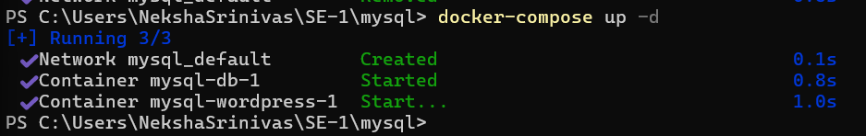

Step 4: Open in the local host and select the language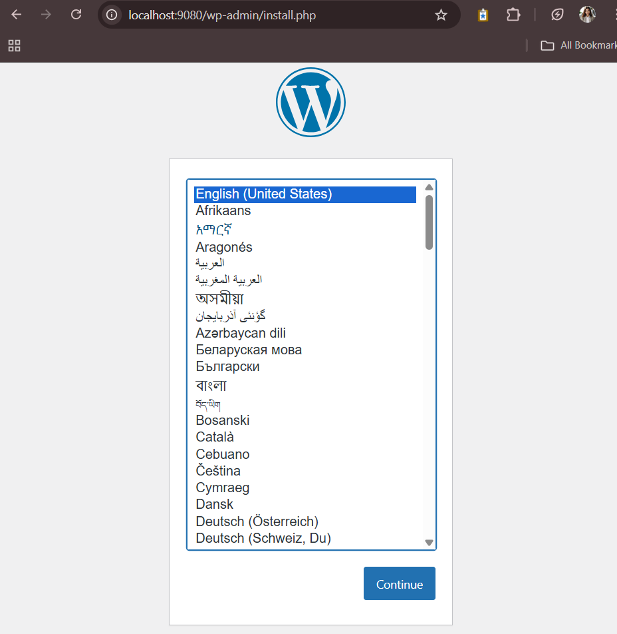

Step 5: Fill the details in the welcome page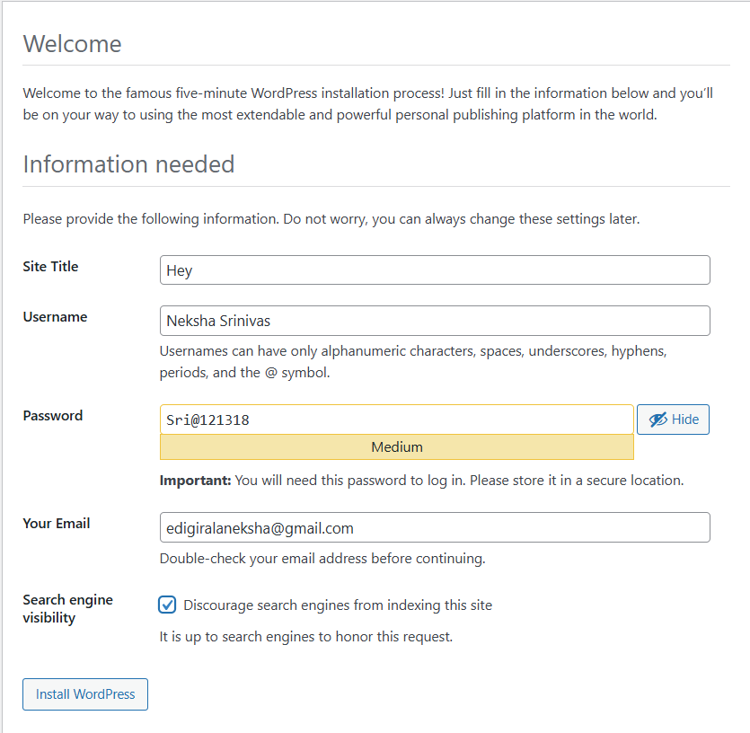

Step 6: Success message will be shown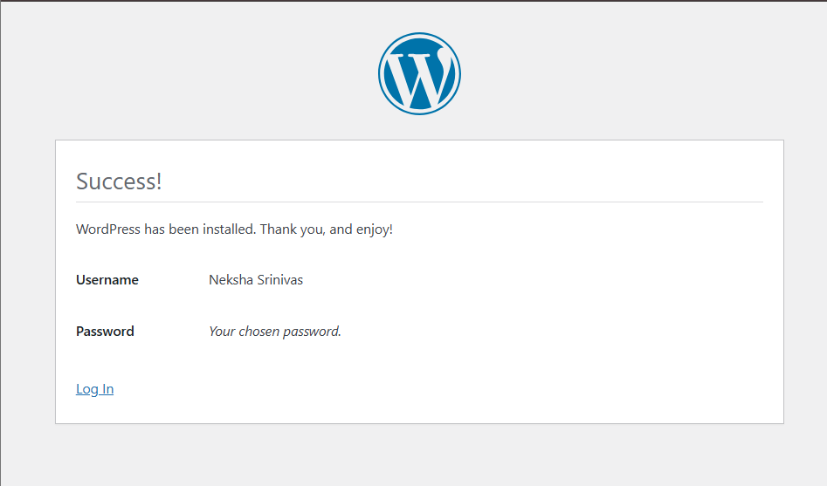

Step 7: Use your credentials to log in

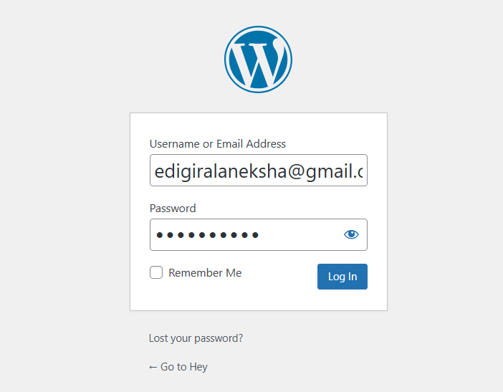

Step 7: The following page will be shown after login

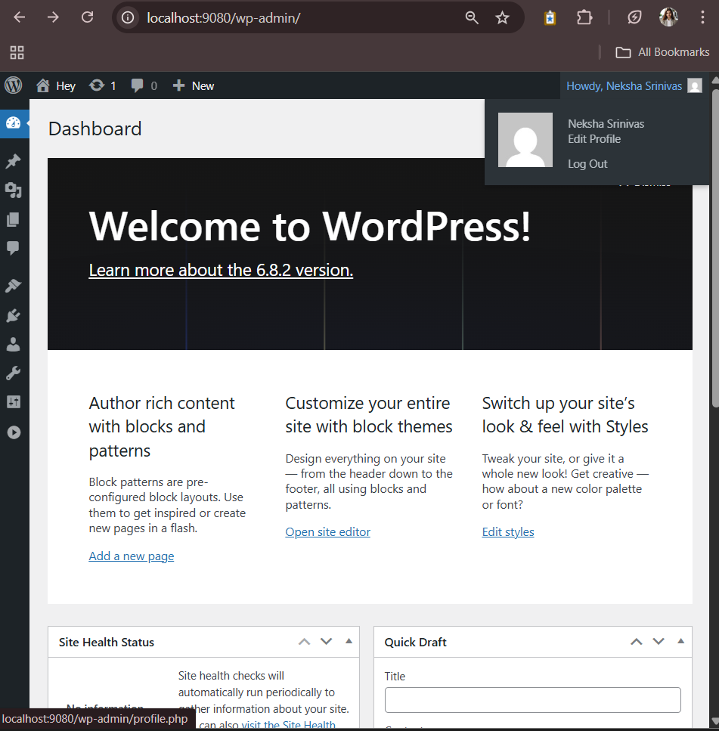

Task:

Create a simple Flask app in app.py:

Step 1: create a separate folder

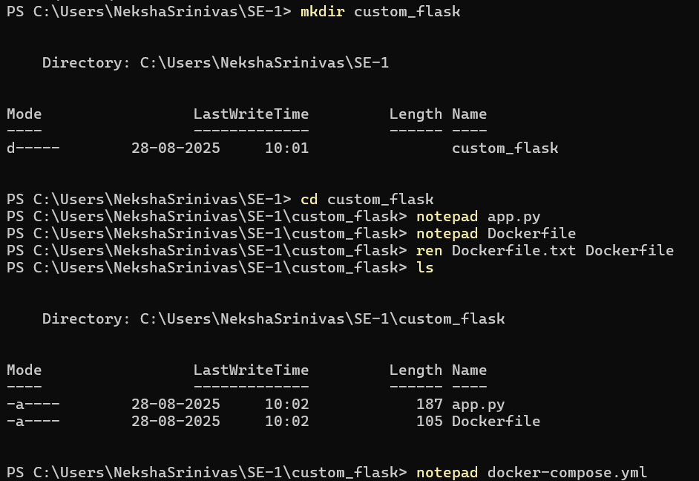

Step 2: write the content of app.py , docker-compose.yml & Dockerfile

app.py:

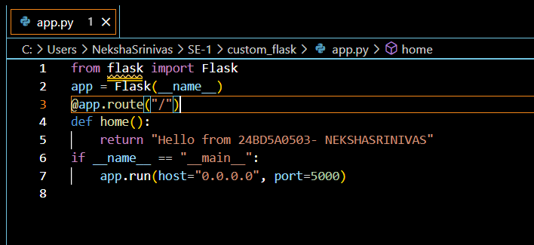

docker-compose.yml:

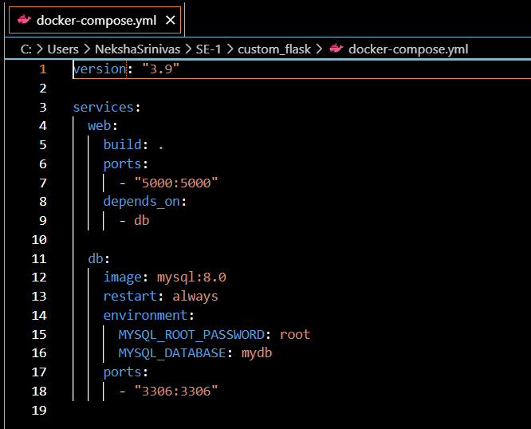

Dockerfile:

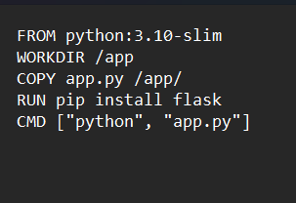

Step 3: run the compose using the command docker compose up –build: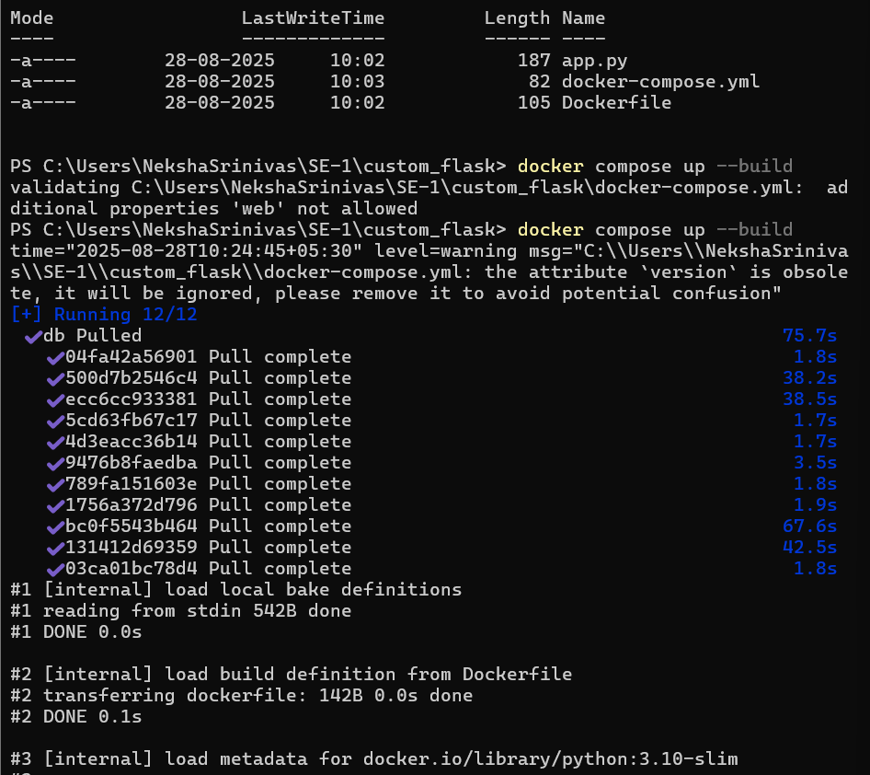

Step 4: Open the local host to view the custom page:

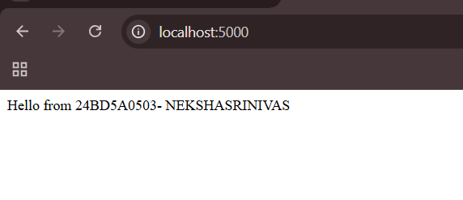

**7. Creating a Multi-Module Maven Project**

Step-1: Open the eclipse and click on file>new>Maven project 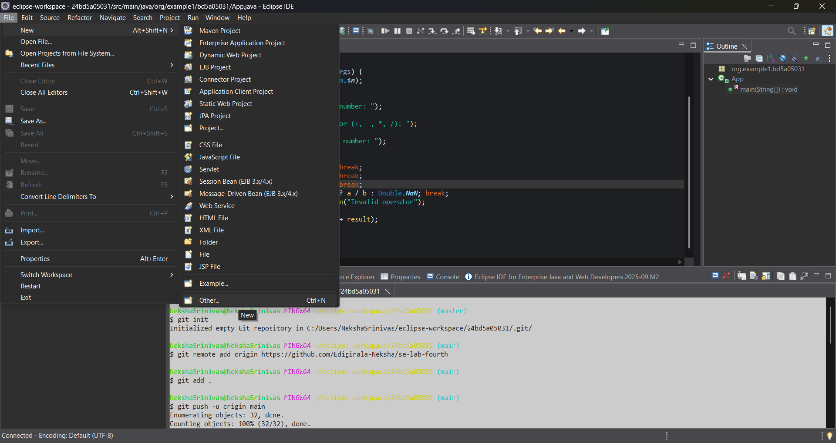

Step-2: select the default workspace and click on next

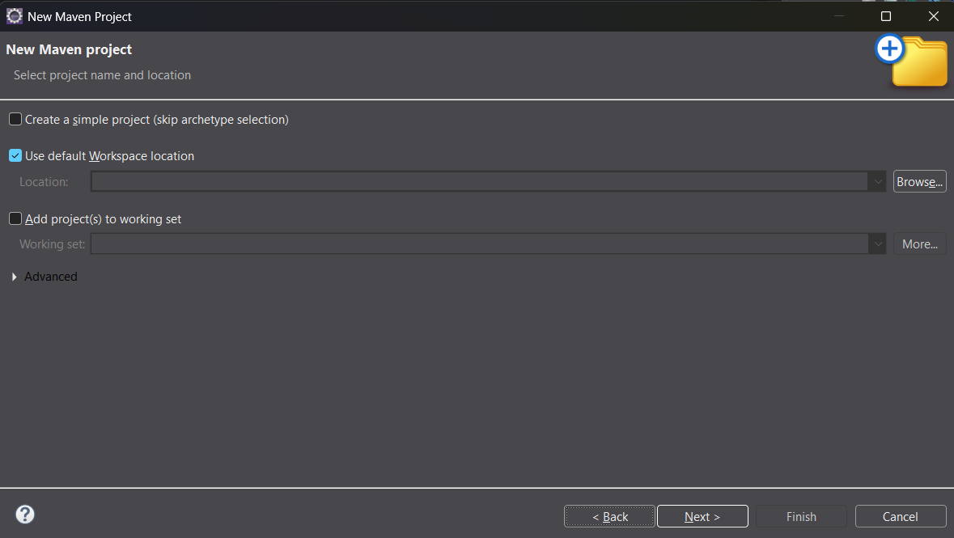

Step-3: in the filter option select the one maven-archetype-quickstart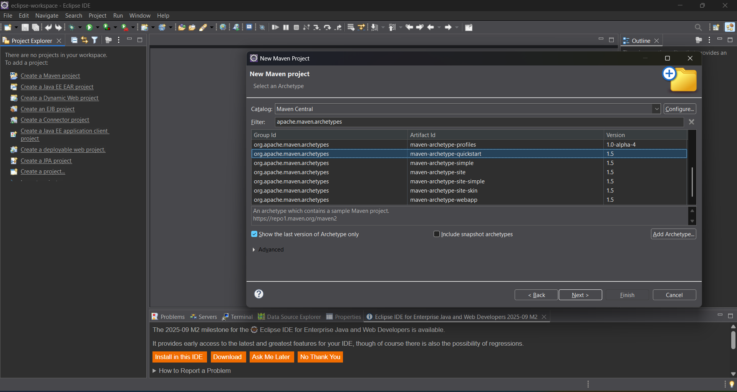

Step-4: give the Group Id and Artifact Id and click on next

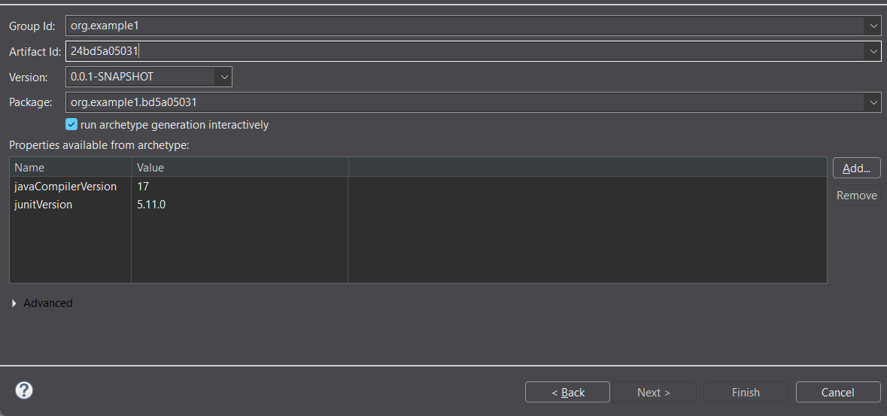

Step-5: In the console the progress will be showed type y (refers to yes) and press enter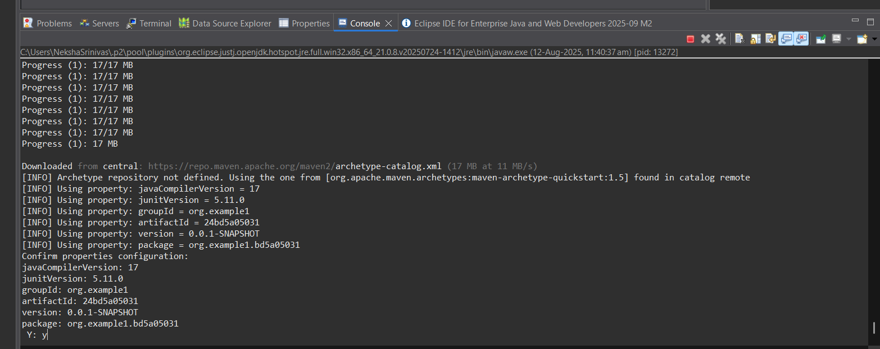

Step-6: BUILD SUCCESS will be shown

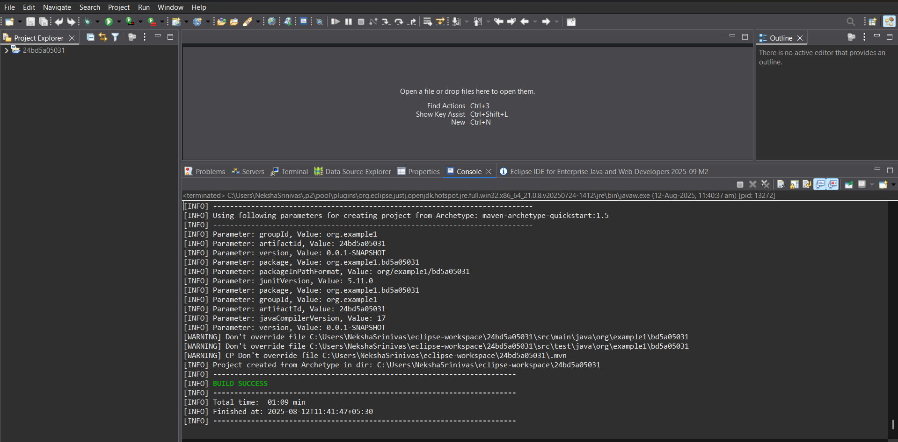

Step-6: write the code in the App.java file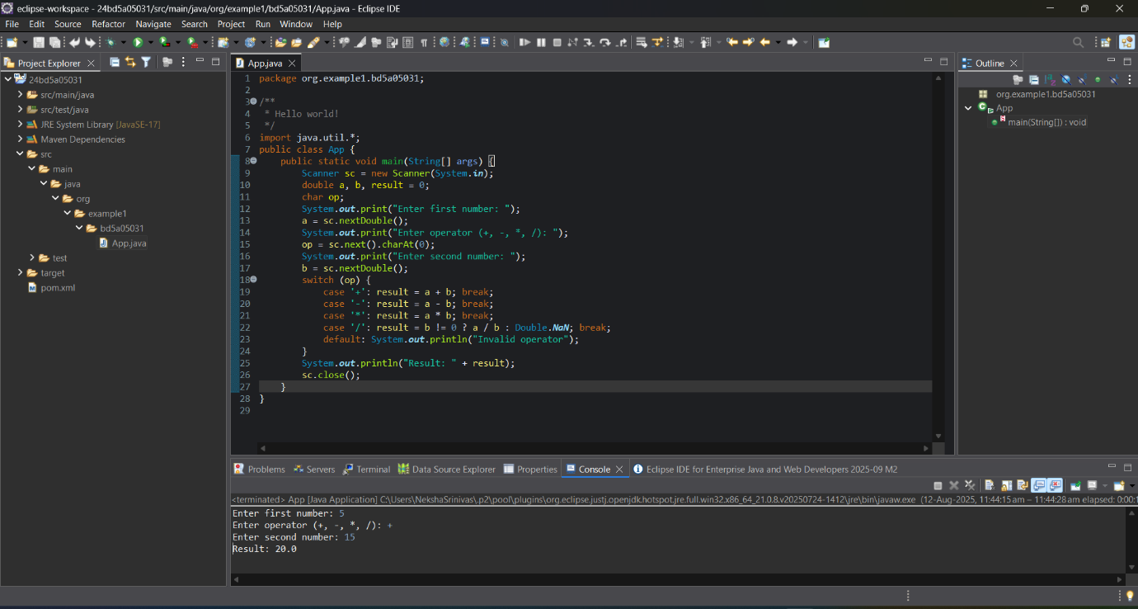

Step-7: right click on the root folder and select show in git bash

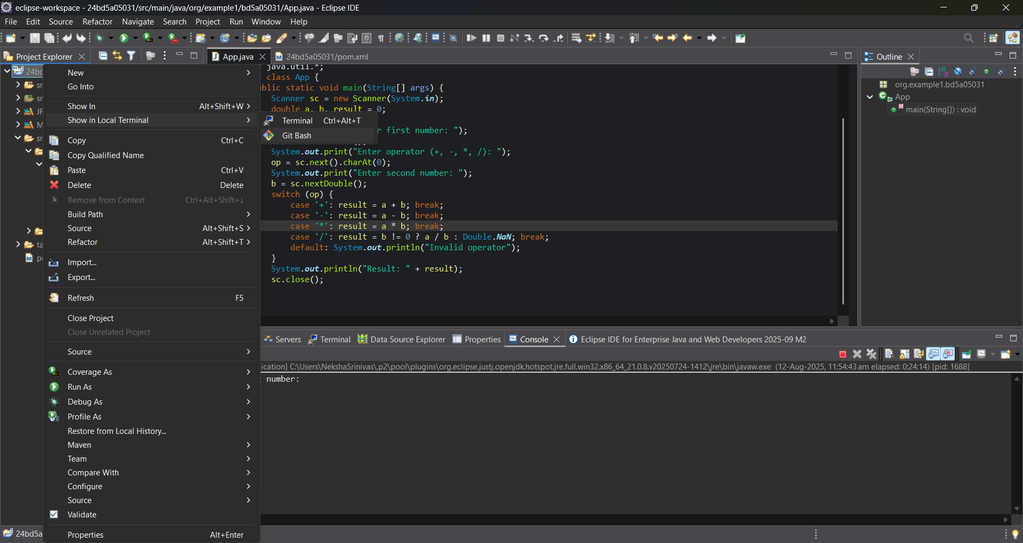

Step-8: push to the git repo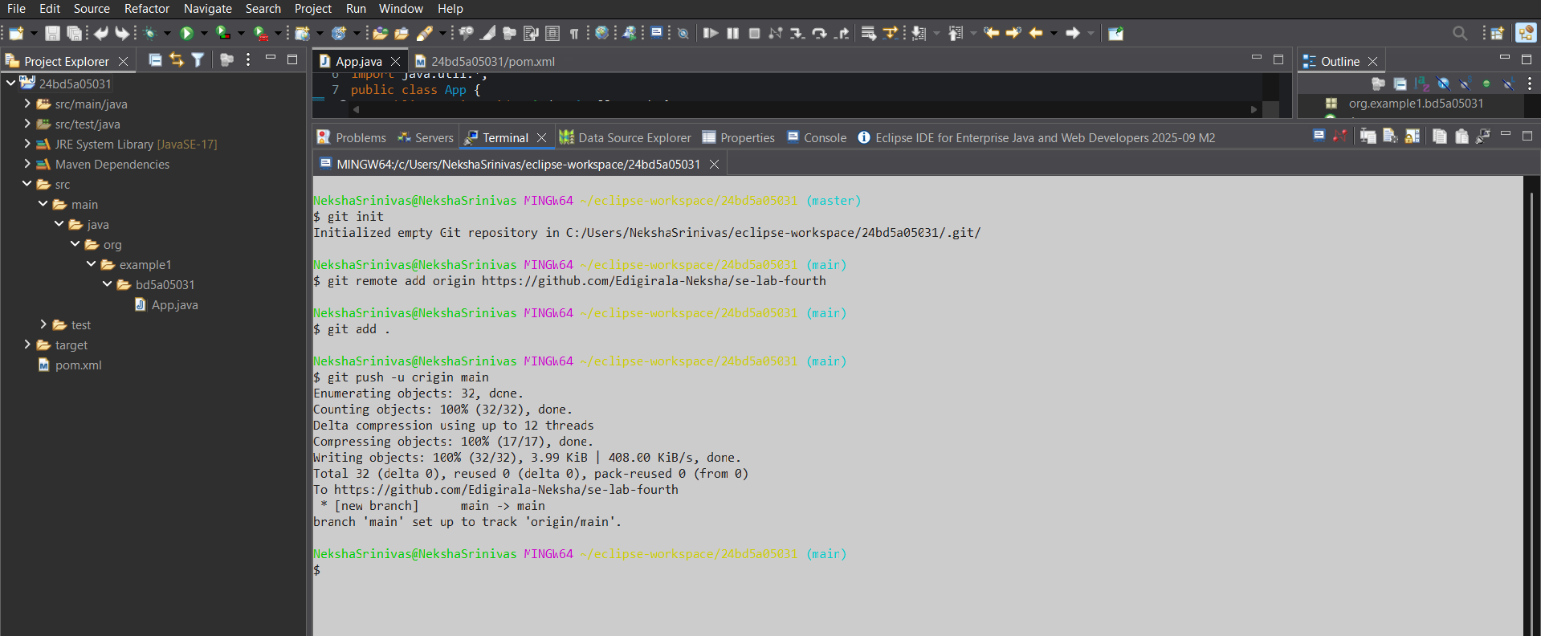

Git repo:

Git repo link: <https://github.com/Edigirala-Neksha/se-lab-fourth>

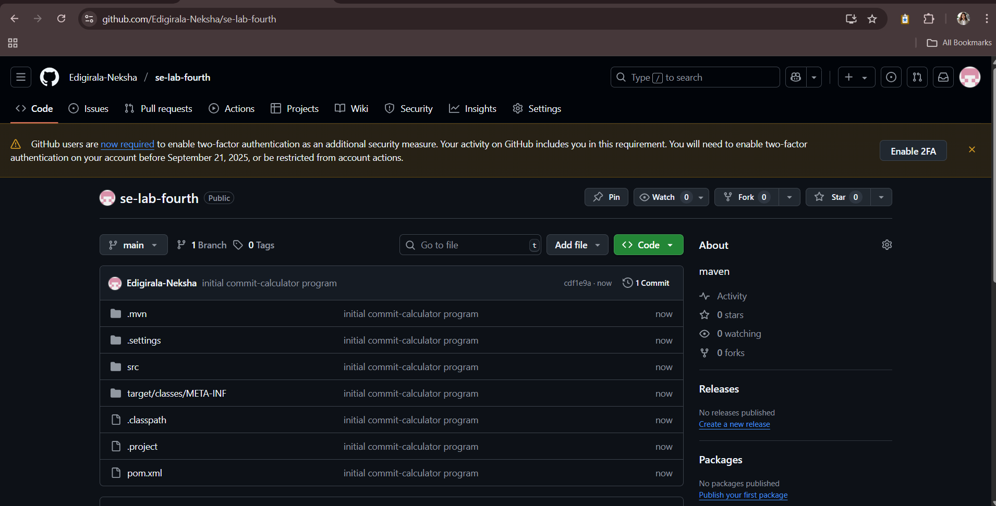

pom.xml file:

Shows the structure-

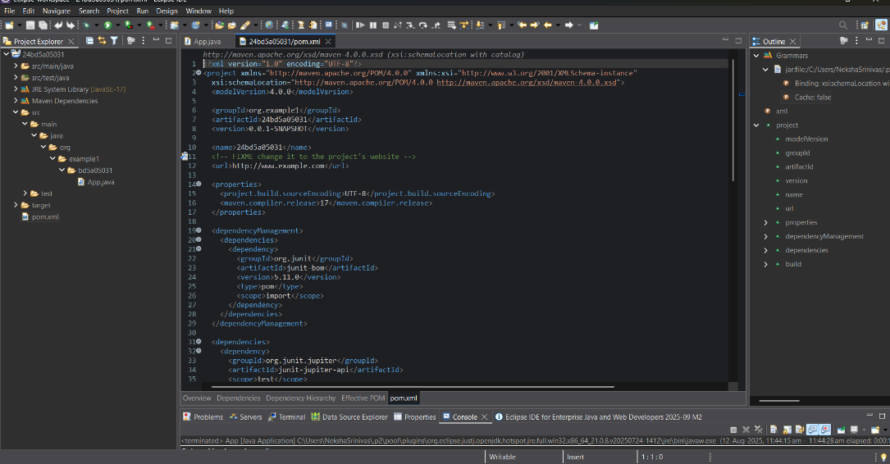

Creating maven-web project:

Step 1: Create a new maven project and give the details

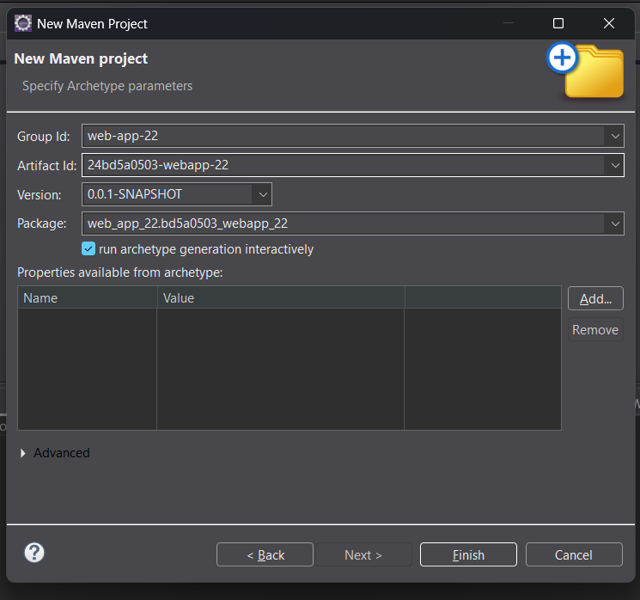

Step 2: Click y to continue the creation of project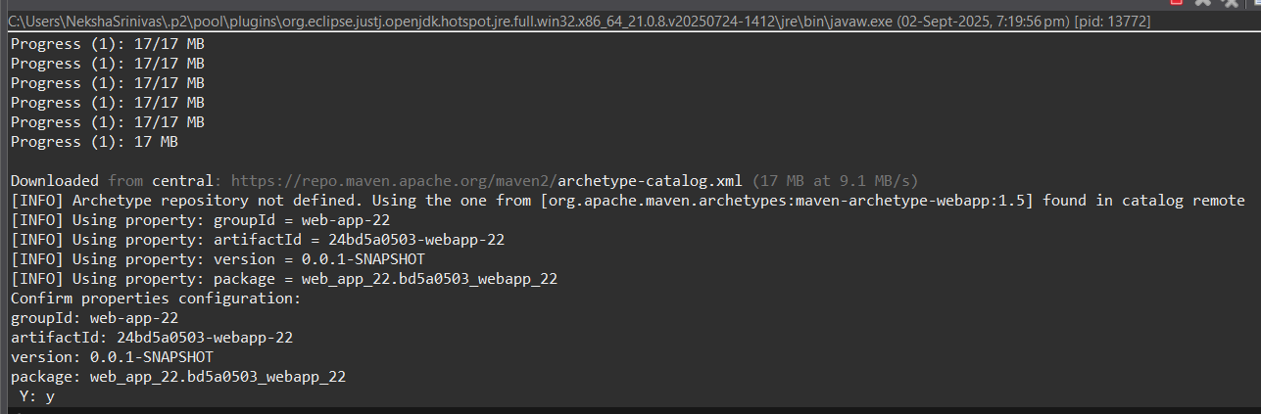

Step 3: If the build is success it will show the message

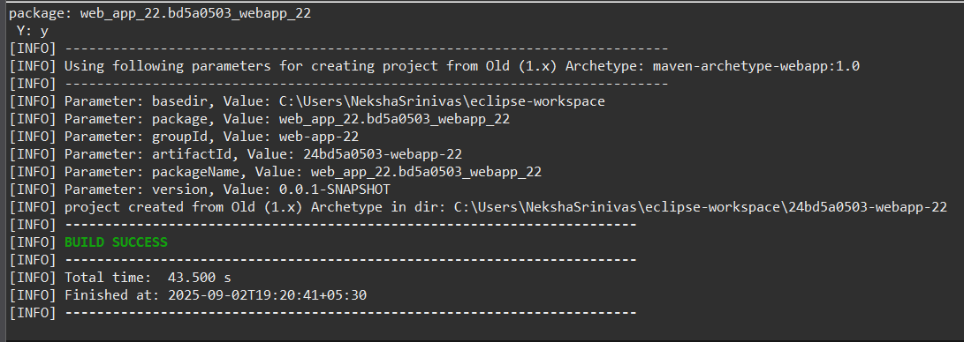

Step 4: write the html code for the web page:

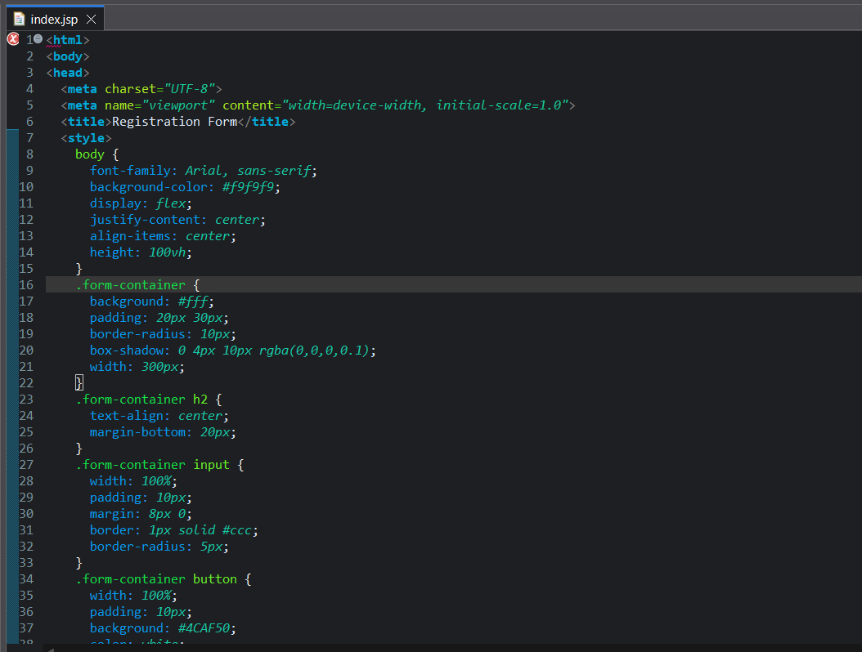

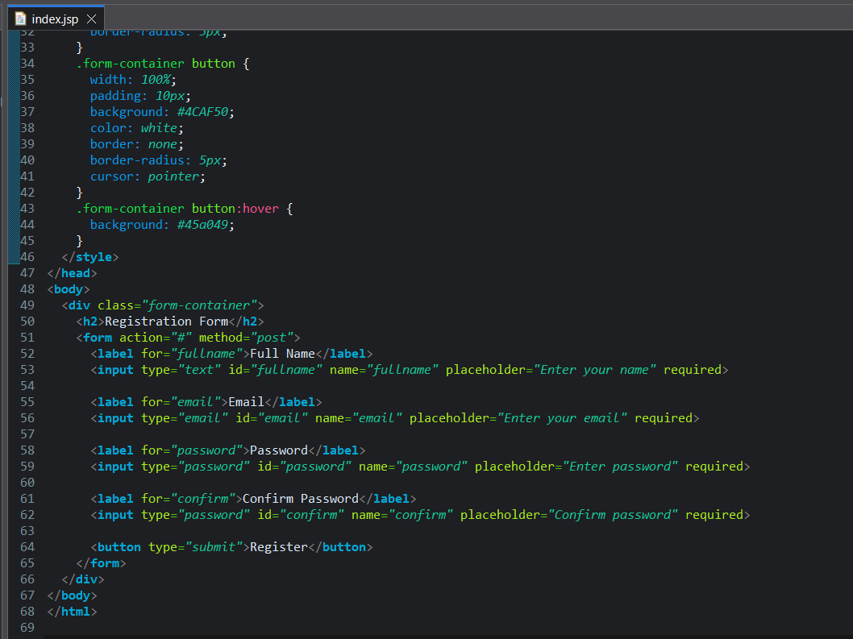

Step 5: Select run on server

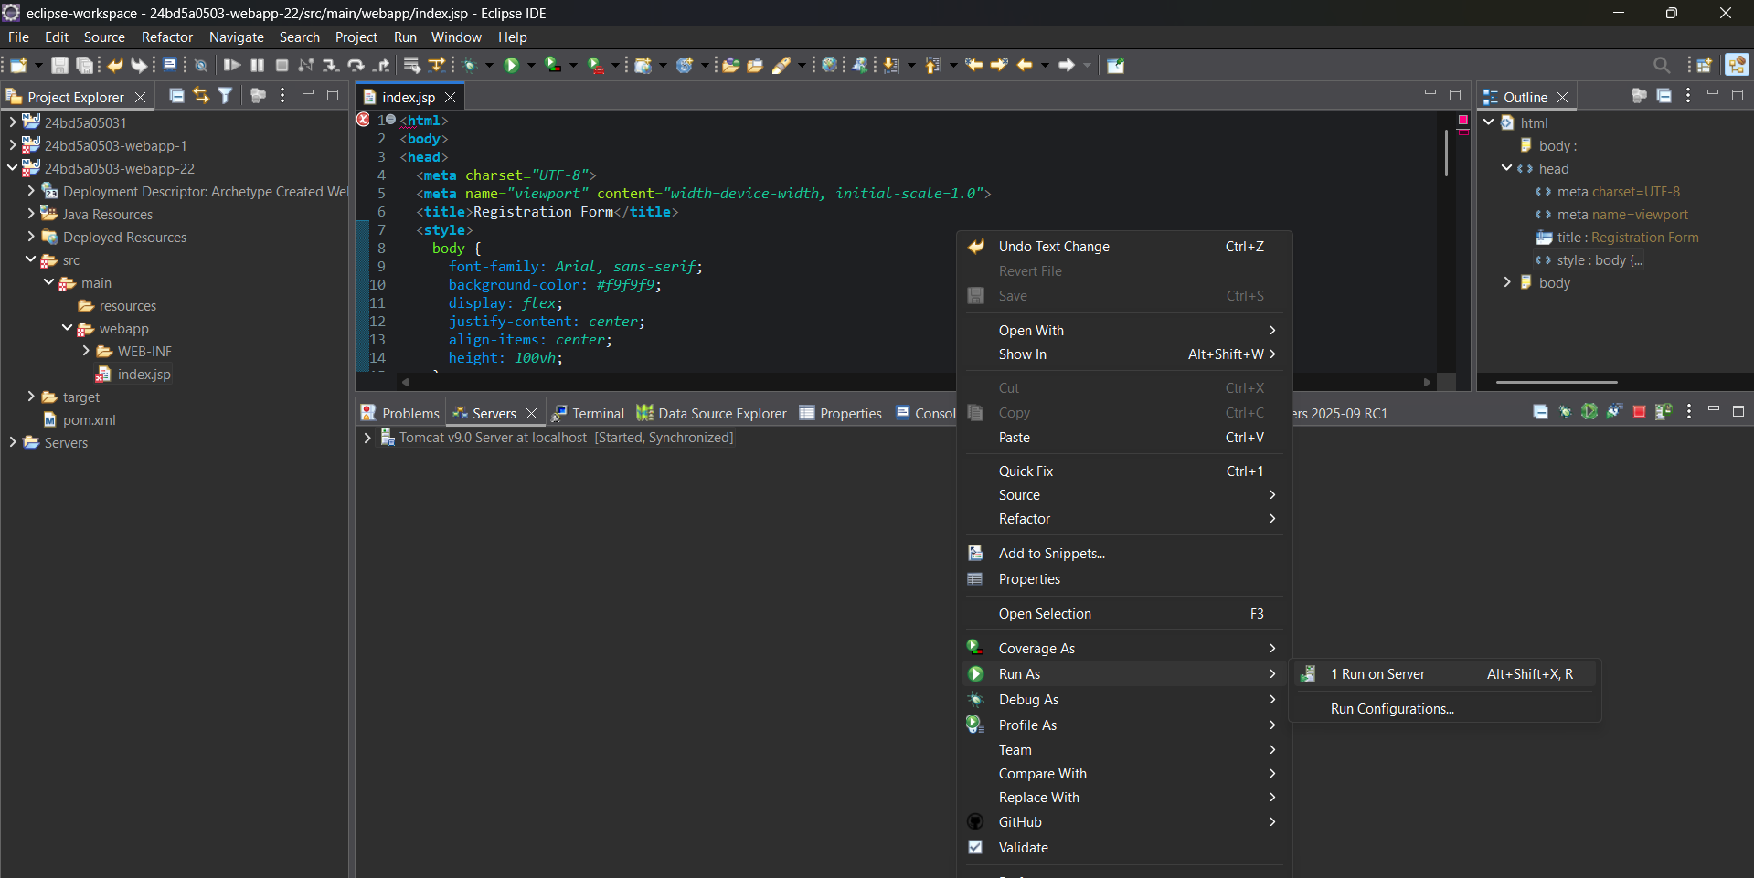

Step 6: It will show the following output: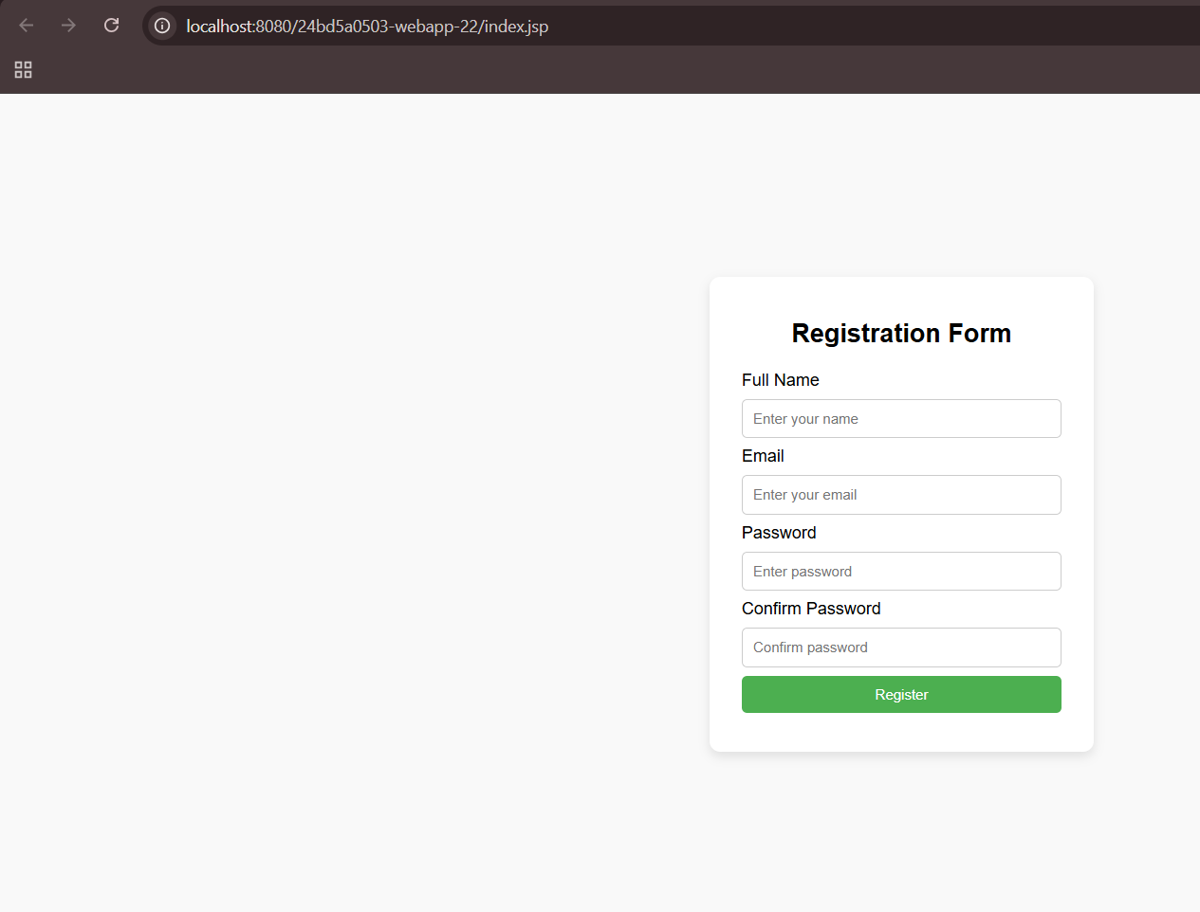

Step 7: To push it into git, select git bash from show in local terminal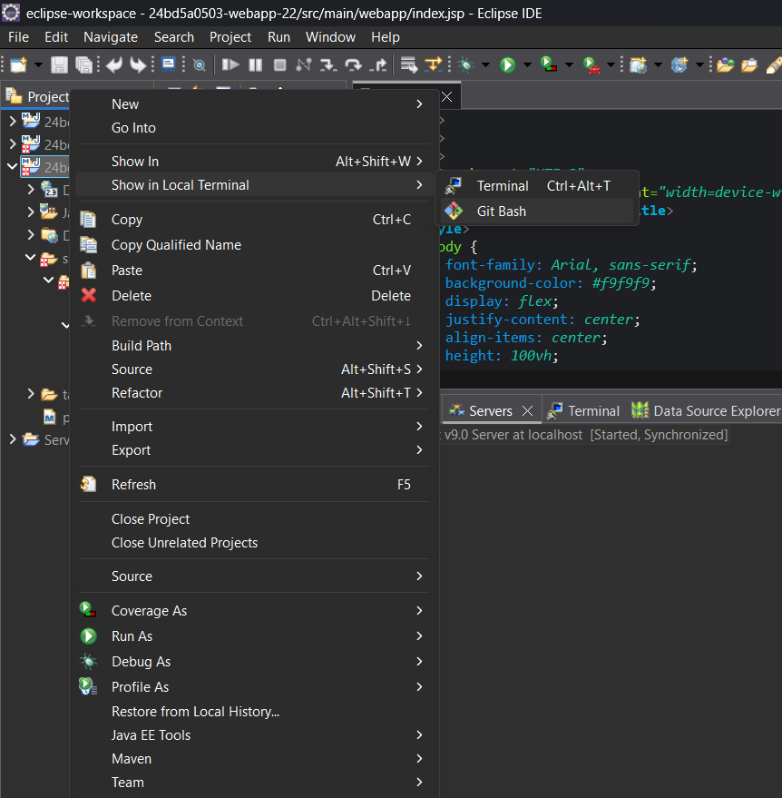

Step 8: use the command of git to push the maven web project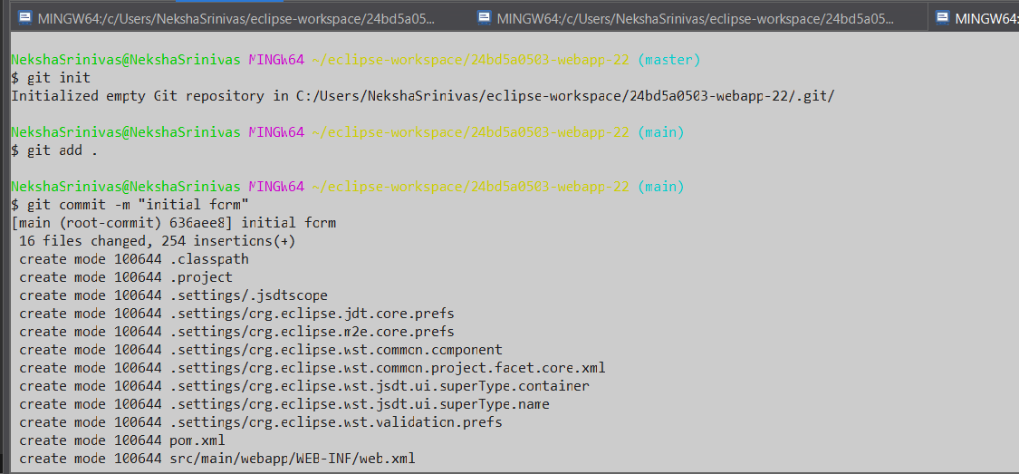

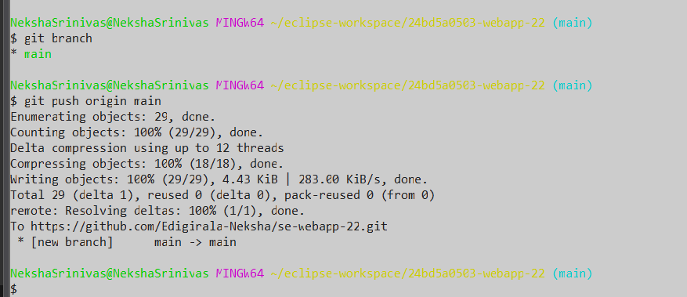

Step 9: verify the repo in git hub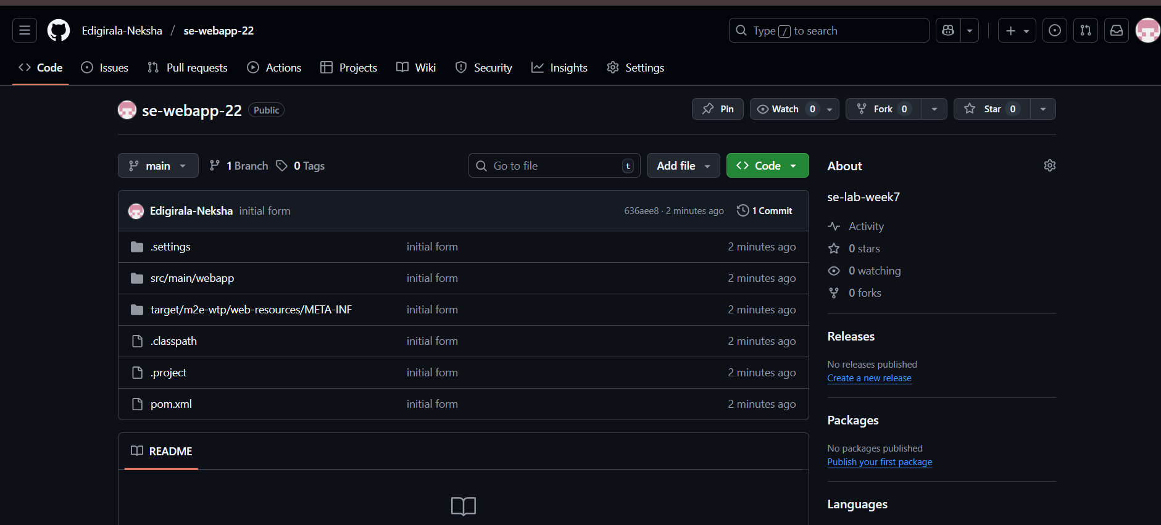

**8. Jenkins Automation**

**Steps for MavenJava Automation**

**Step 1: Open Jenkins (localhost:8888)**

Click on "New Item" (left side menu) and name it as maven_java > select freestyle project > click on “OK”

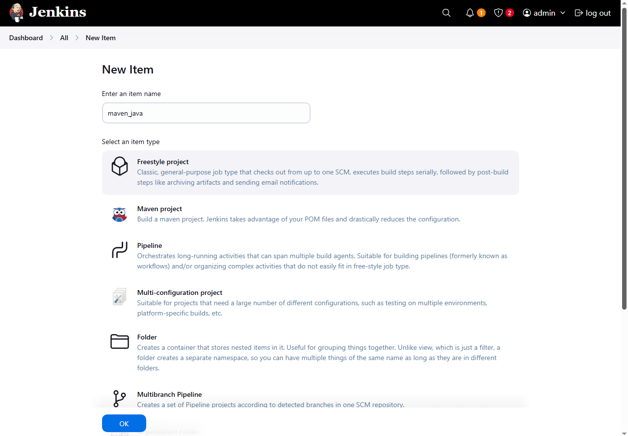

**Step 2: Configuration of maven_java project**

Give the description

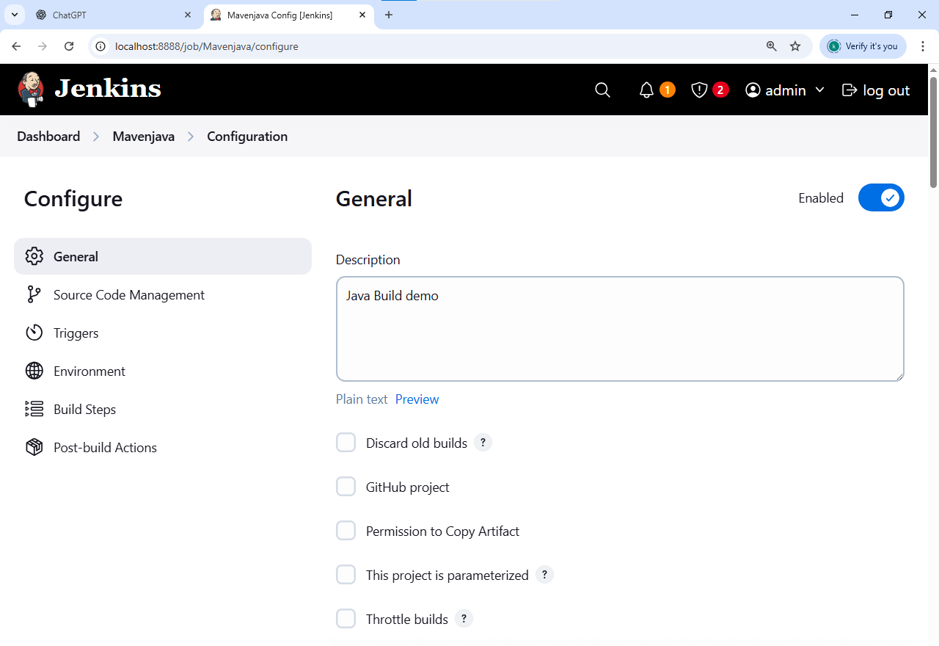

In the source code management select git and give the git repo link

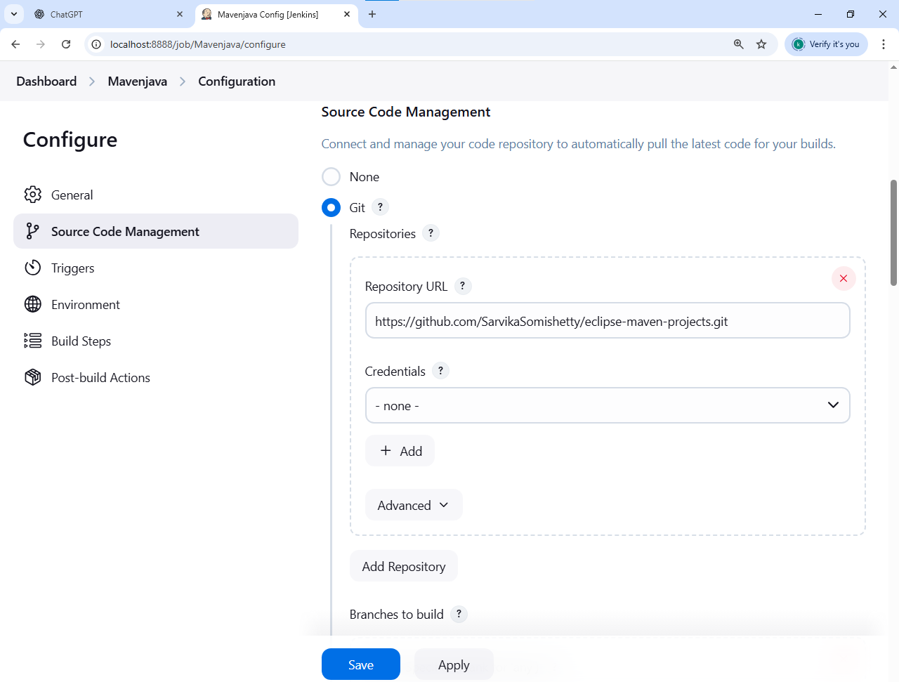

In the build steps click on add build step > give maven version as MAVEN_HOME > select invoke top-level maven targets > goals as clean

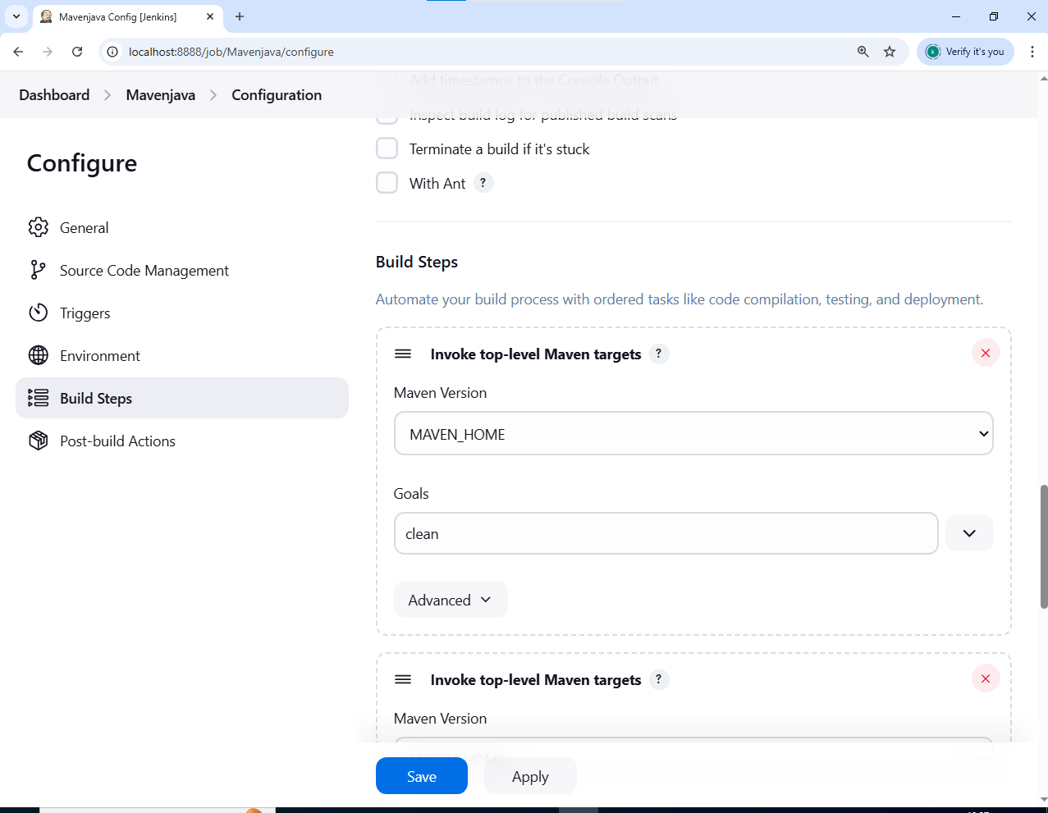

In the build steps click on add build step > give maven version as MAVEN_HOME > select invoke top-level maven targets > goals as install

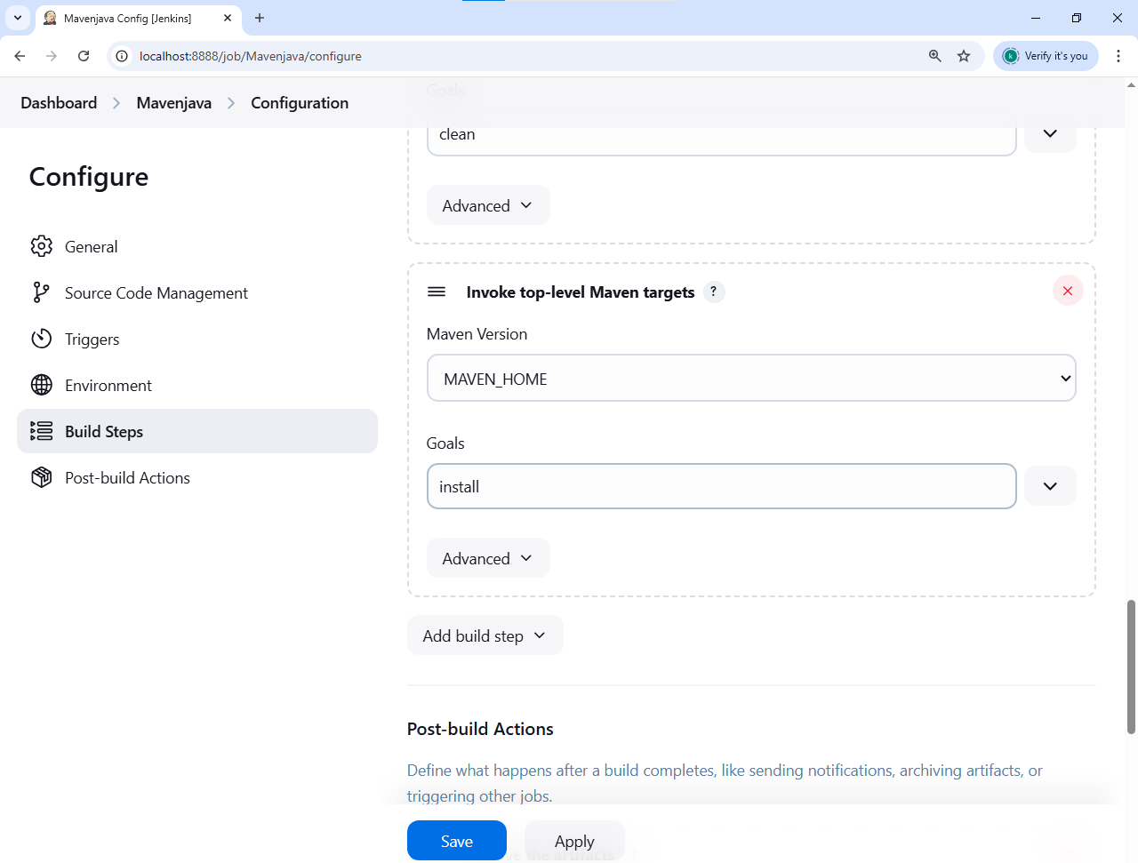

In the post build actions > click on add post build action > select the archive the artifacts > in the file to archive give “**/*”

For the second post build action,

In the post build actions > click on add post build action >select build other projects > give projects to build as MavenJava_Test

Click on apply and save

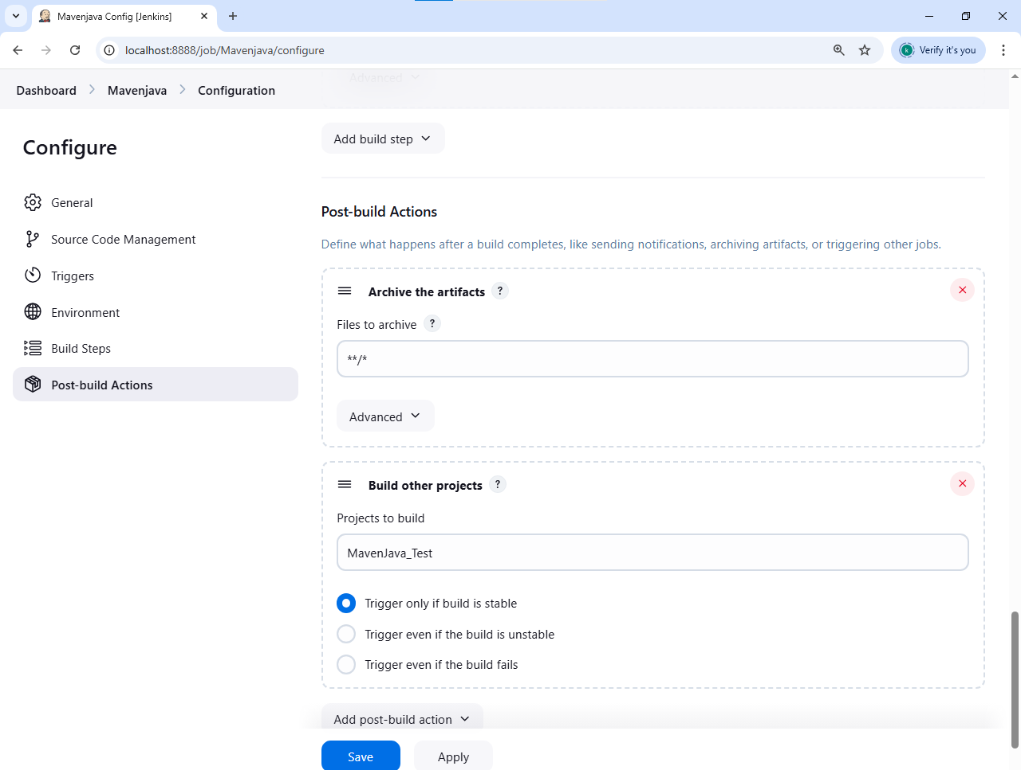

If the build is success:

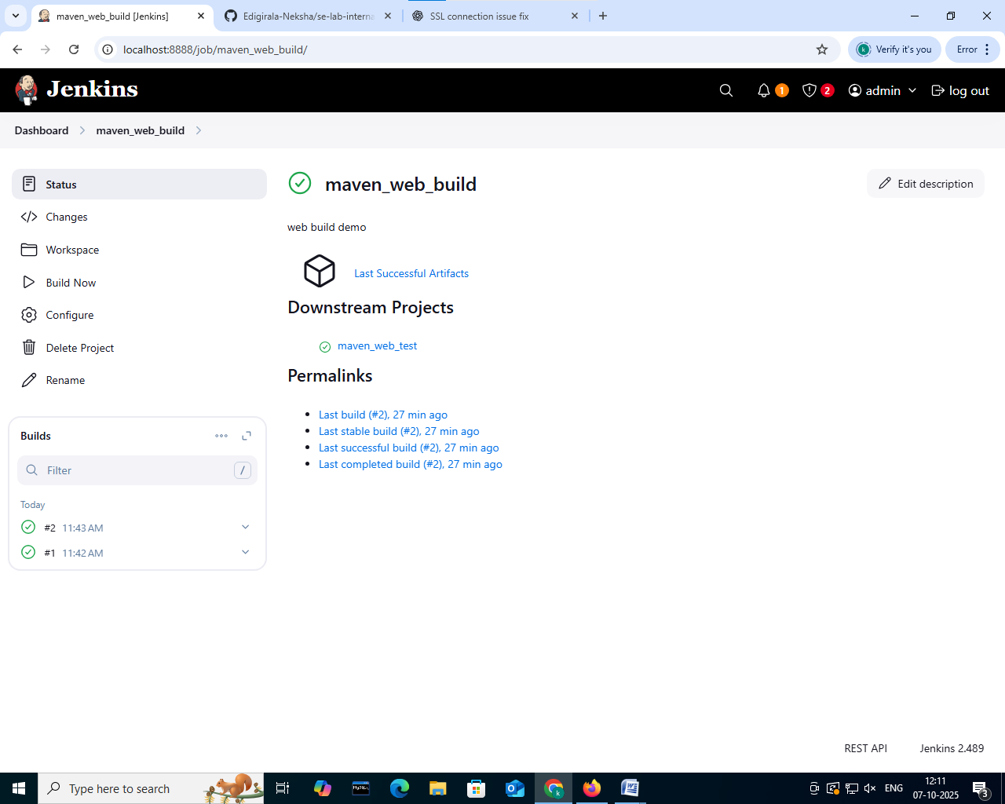

**Step 3: Create Freestyle Project (e.g., MavenJava_Test)**

Click on new item> give item name as mavaen_java_test or MavenJava_Test and select free style project and click ok

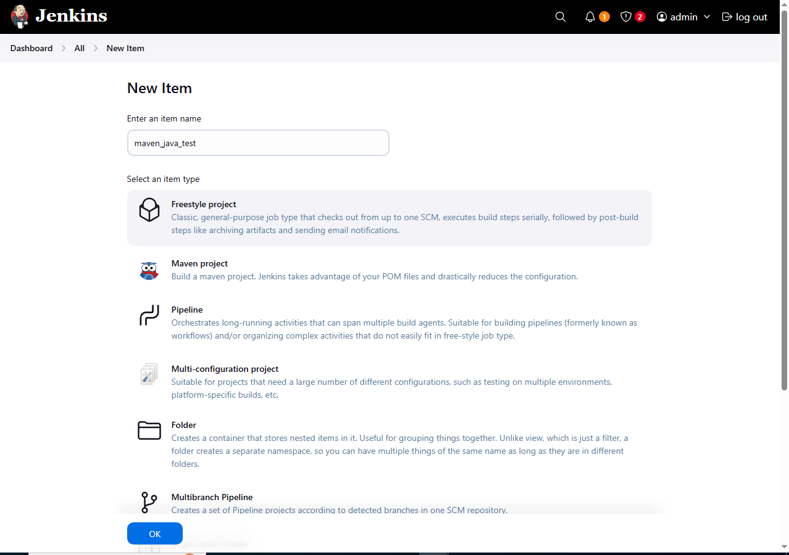

**Step 4: Configuration of maven_java project**

Give the description

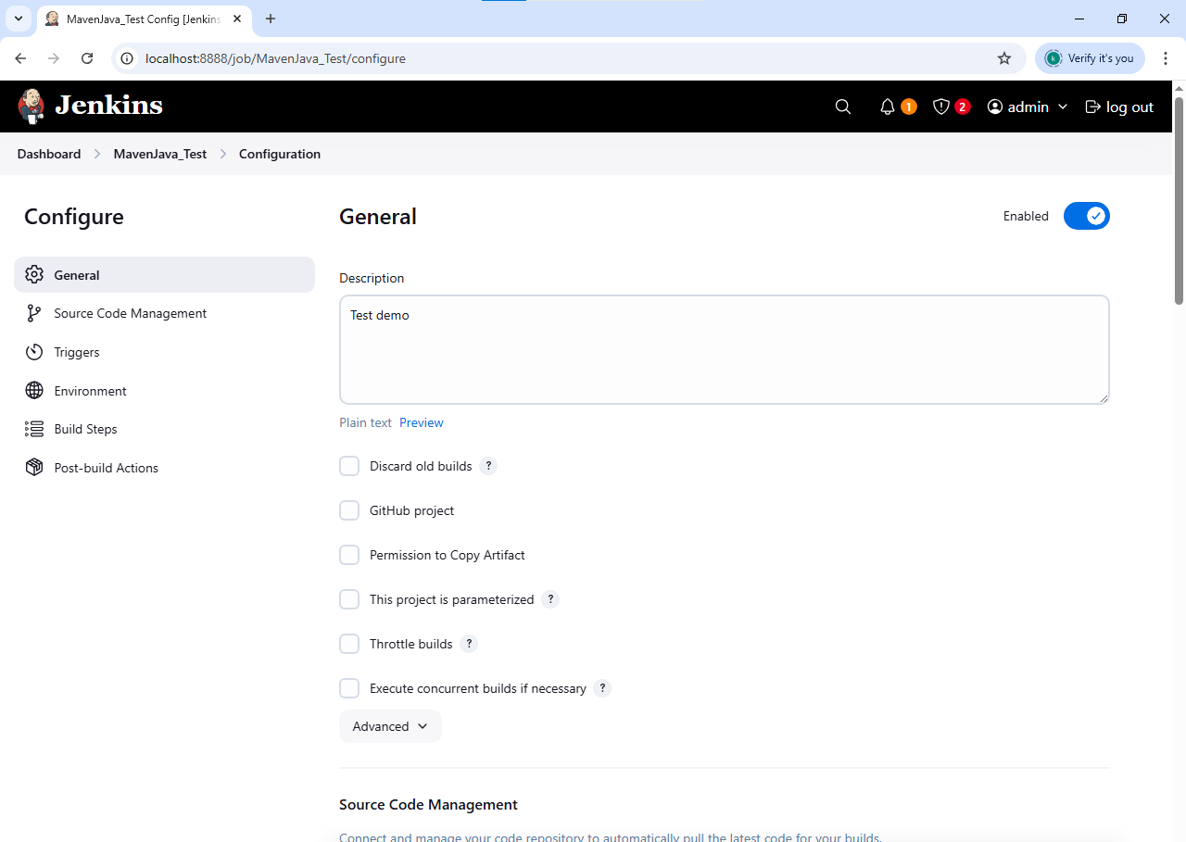

In the source code management select none and in environment select “delete workspace before build starts”

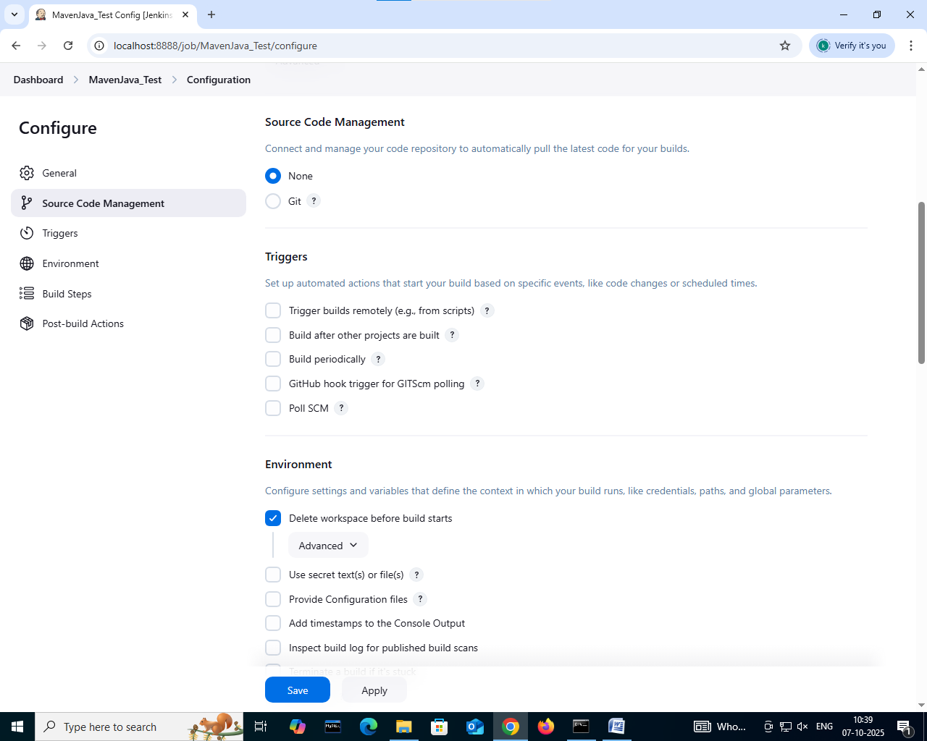

In the build steps> select add a build step> select “copy artifacts from another project” > give project name as Maven java and artifacts to copy as **/*

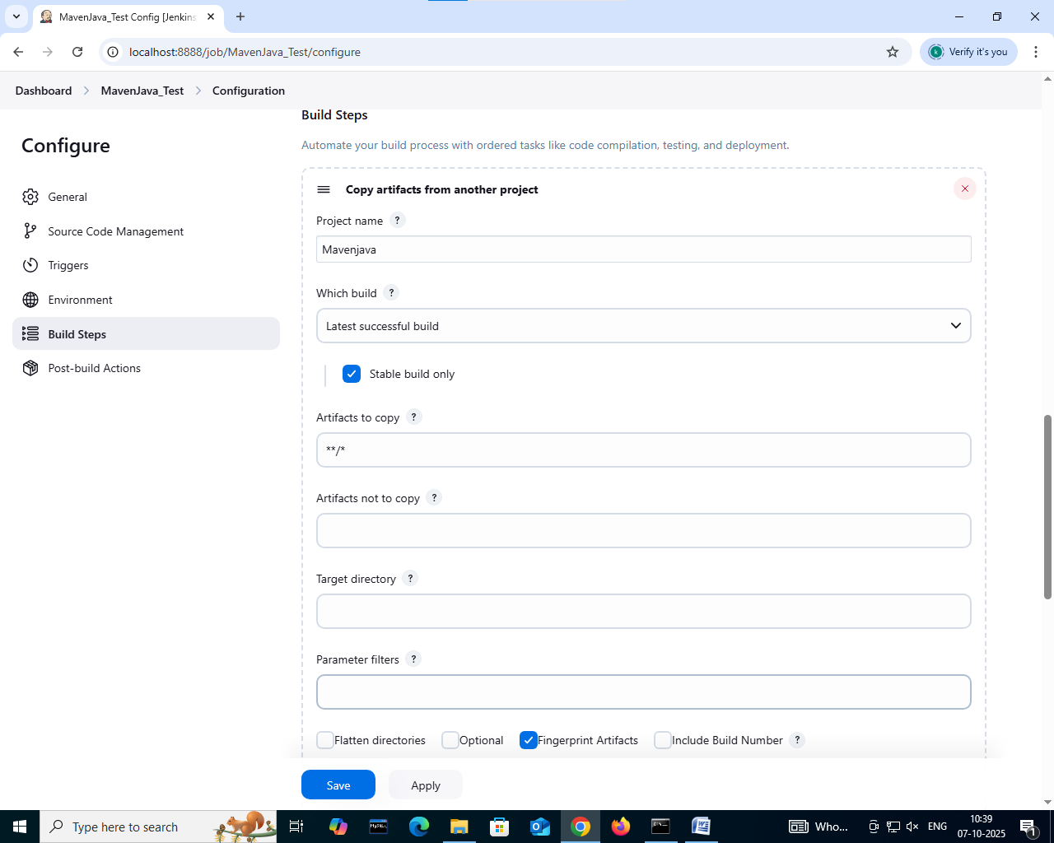

In the post build actions> select archive the artifacts and enter files as **/*

Click on apply and save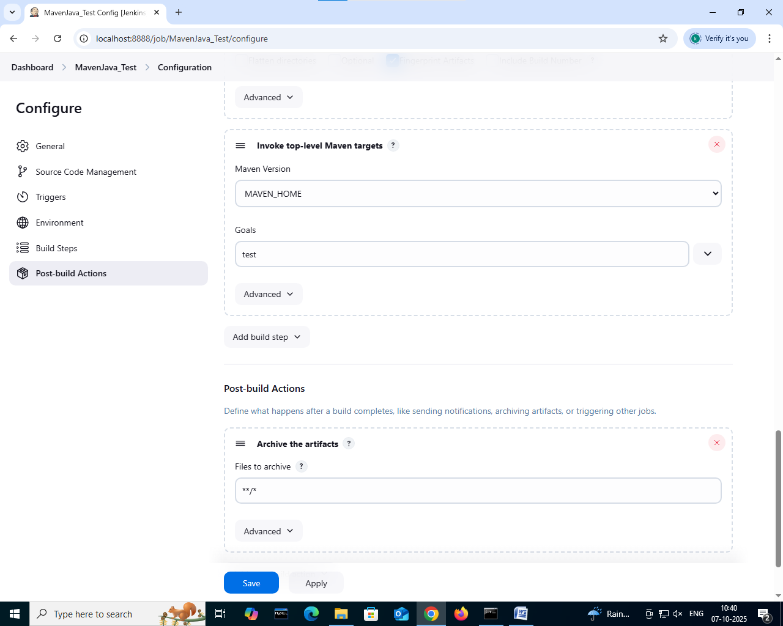

In the dashboard you will find MavenJava and MavenJava_Test

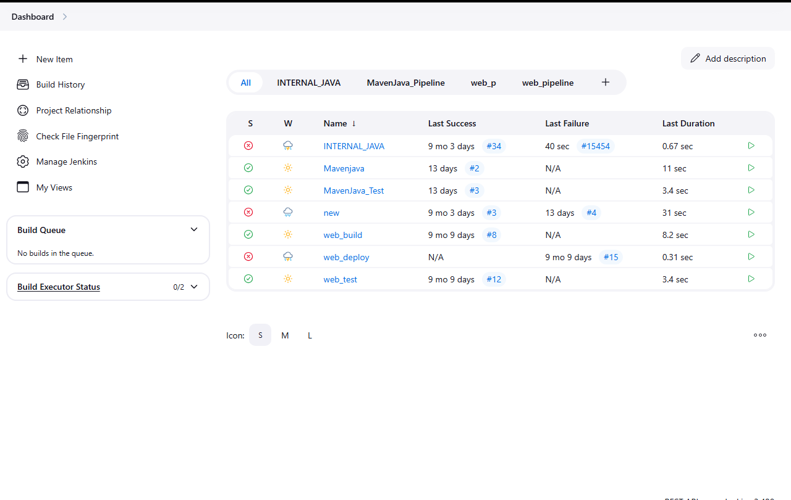

If you open the MavenJava file the following will be shown in case on no errors

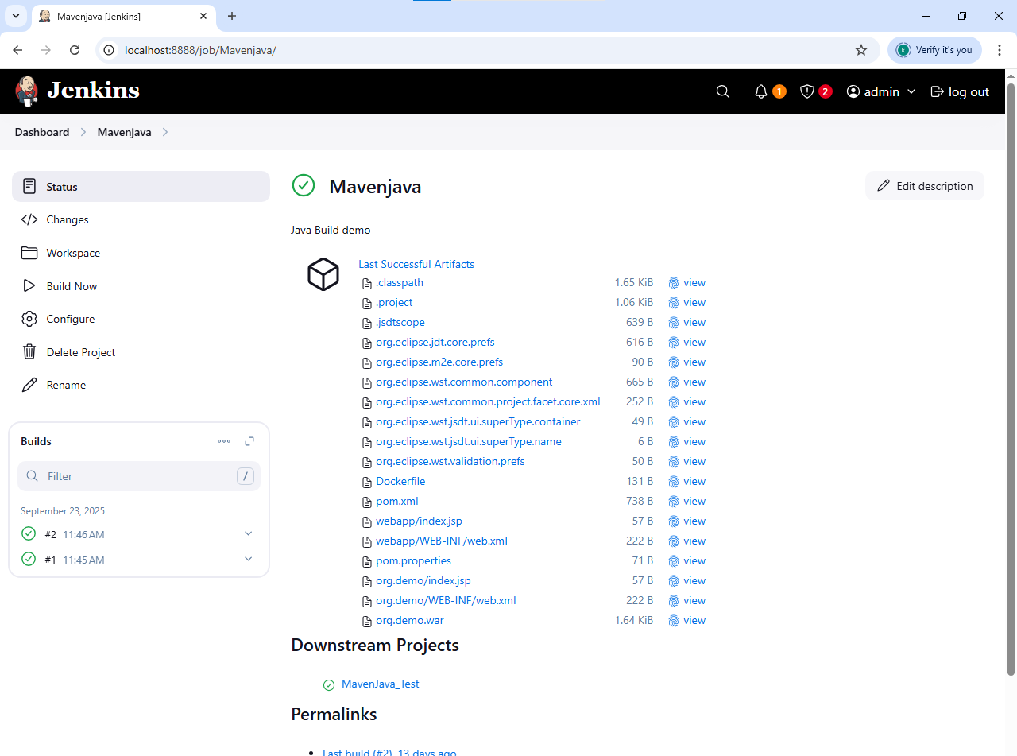

If you open the MavenJava_Test file the following will be shown in case on no errors

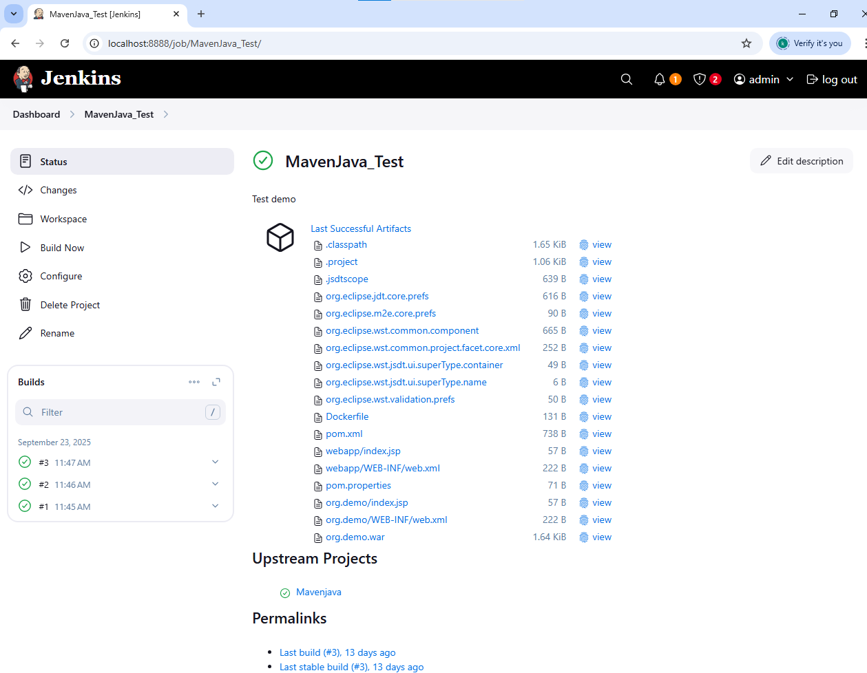

MavenJava_pipeline

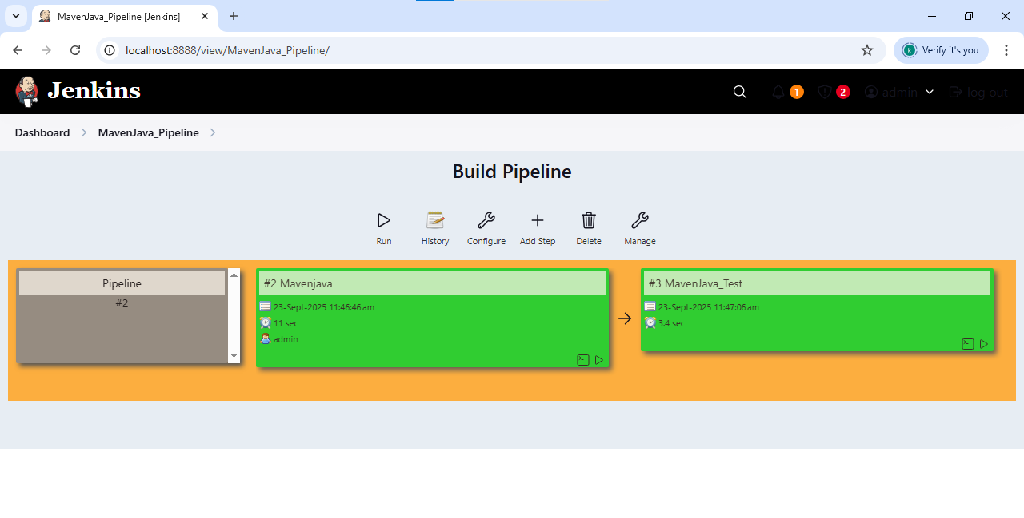

**II. Maven Web Automation Steps:**

Create Freestyle Project (e.g., MavenWeb_Build)

**Step 1: Open Jenkins (localhost:8888)**

Click on "New Item" (left side menu) and name it as maven_web_build> select freestyle project > click on “OK”

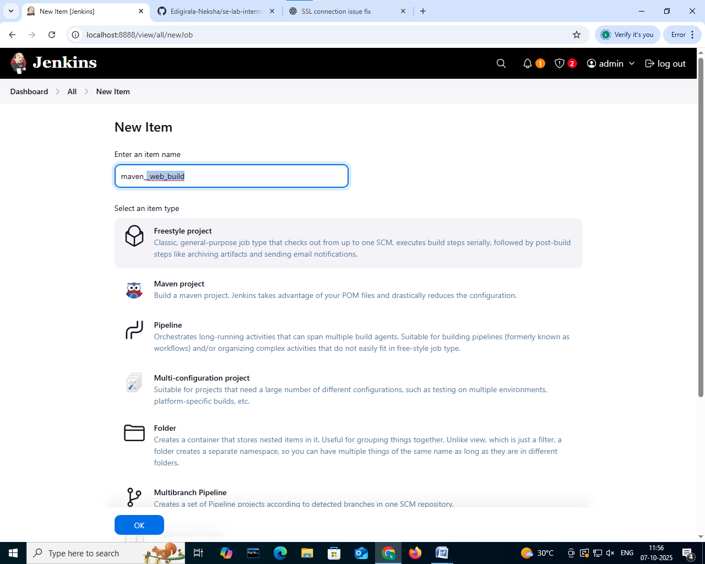

**Step 2: Configuration of maven_web_build project**

Give the description

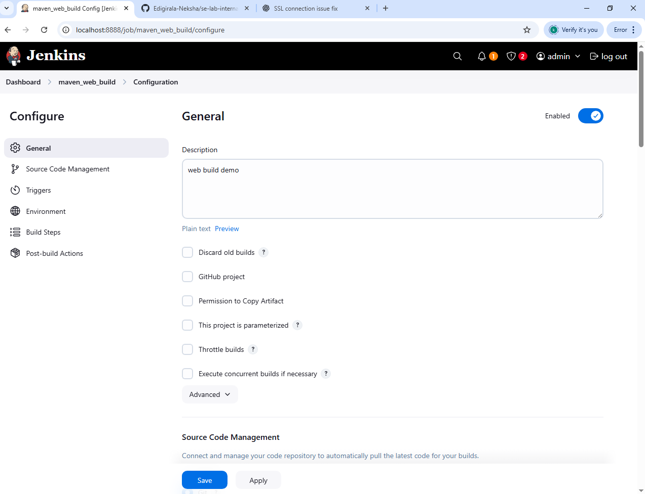

In the source code management select git and give the git repo link

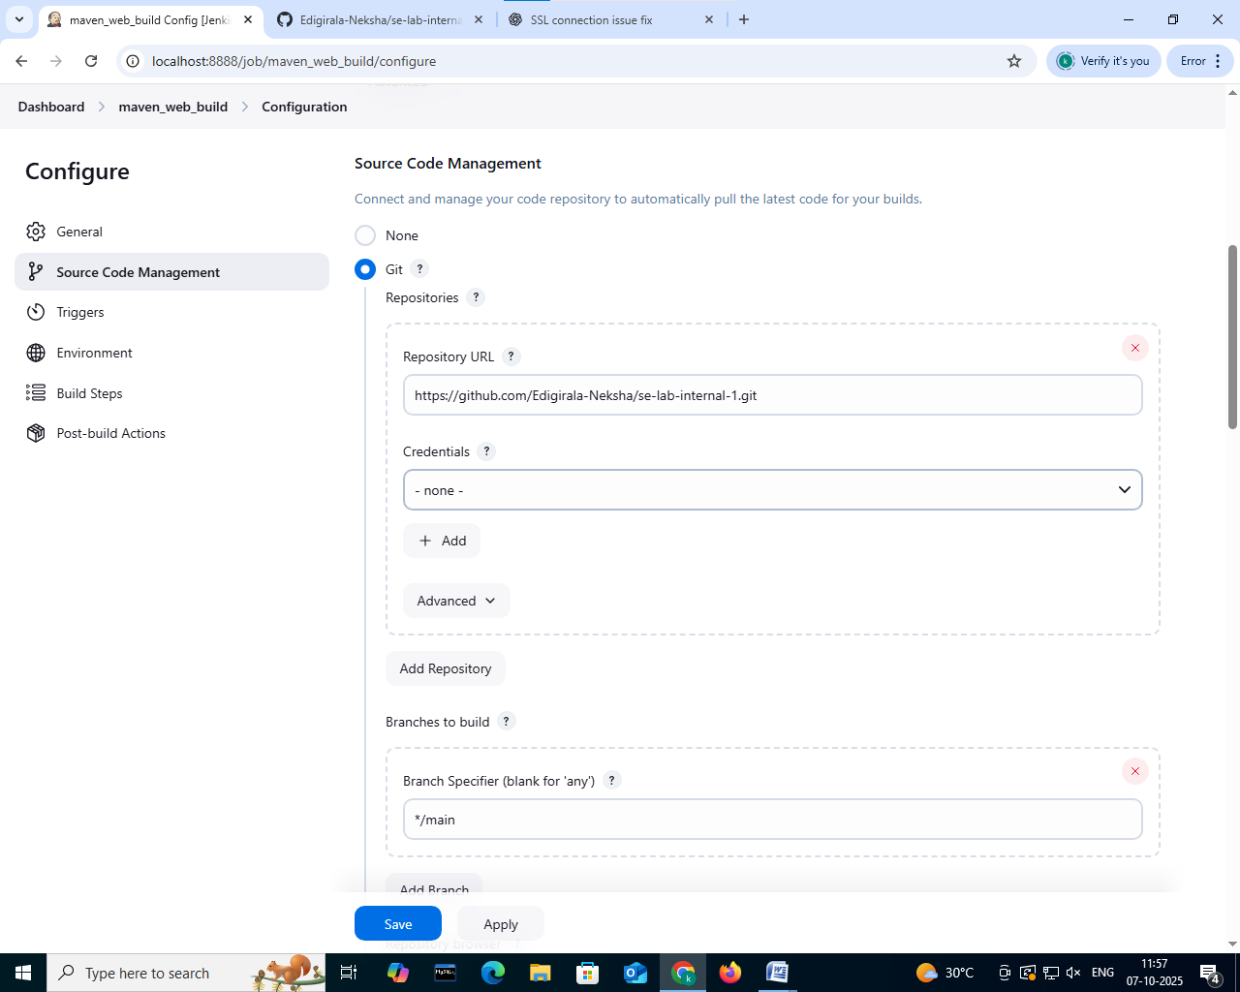

In the build steps click on add build step > give maven version as MAVEN_HOME > select invoke top-level maven targets > goals as clean

For the second build step,

In the build steps click on add build step > give maven version as MAVEN_HOME > select invoke top-level maven targets > goals as install

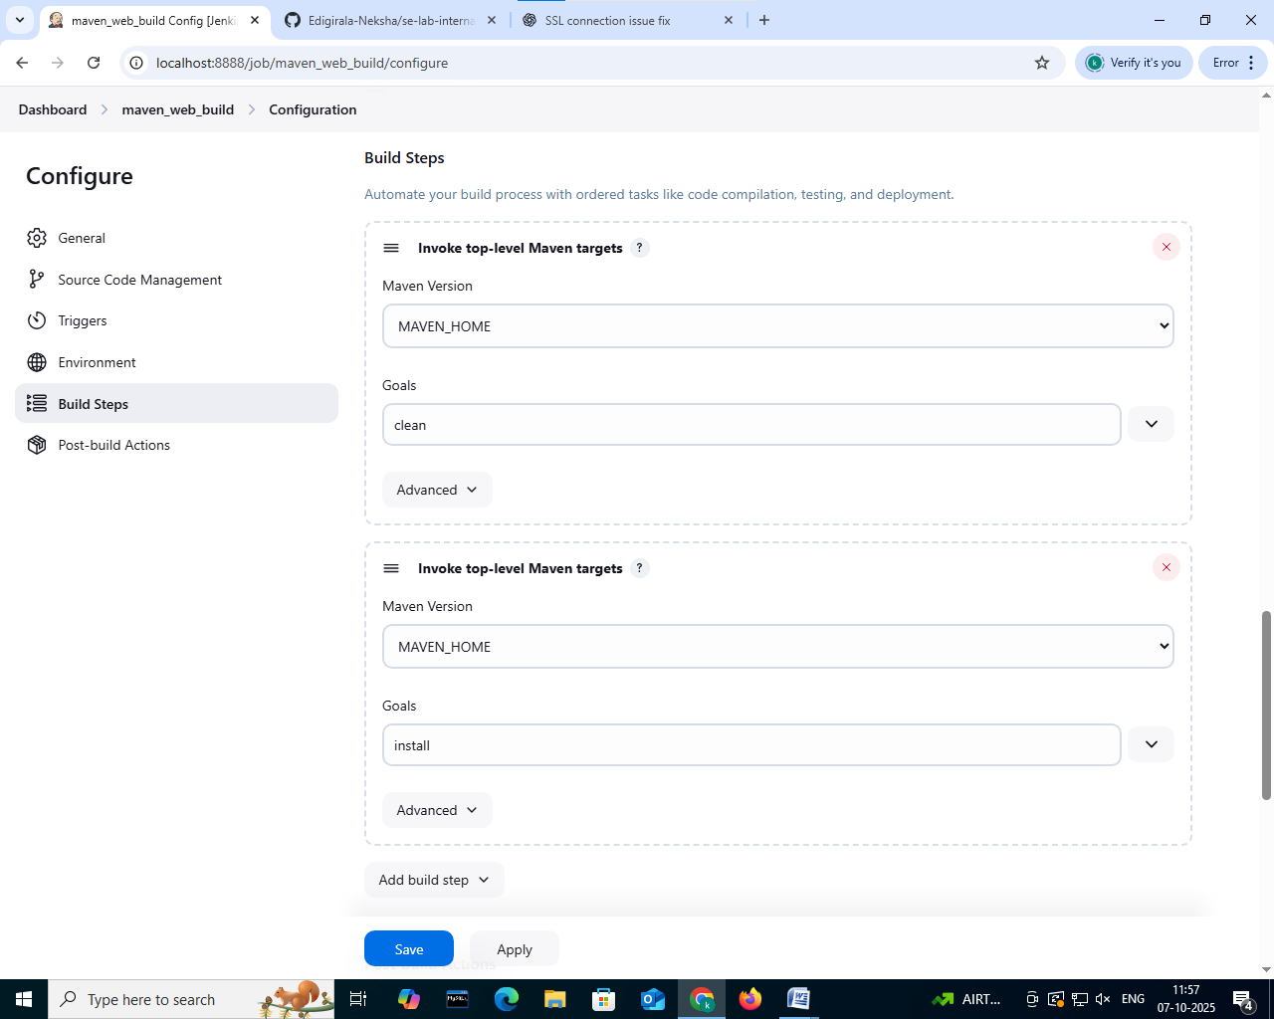

In the post build actions > click on add post build action > select the archive the artifacts > in the file to archive give “**/*”

For the second post build action,

In the post build actions > click on add post build action >select build other projects > give projects to build as maven_web_test

Click on apply and save

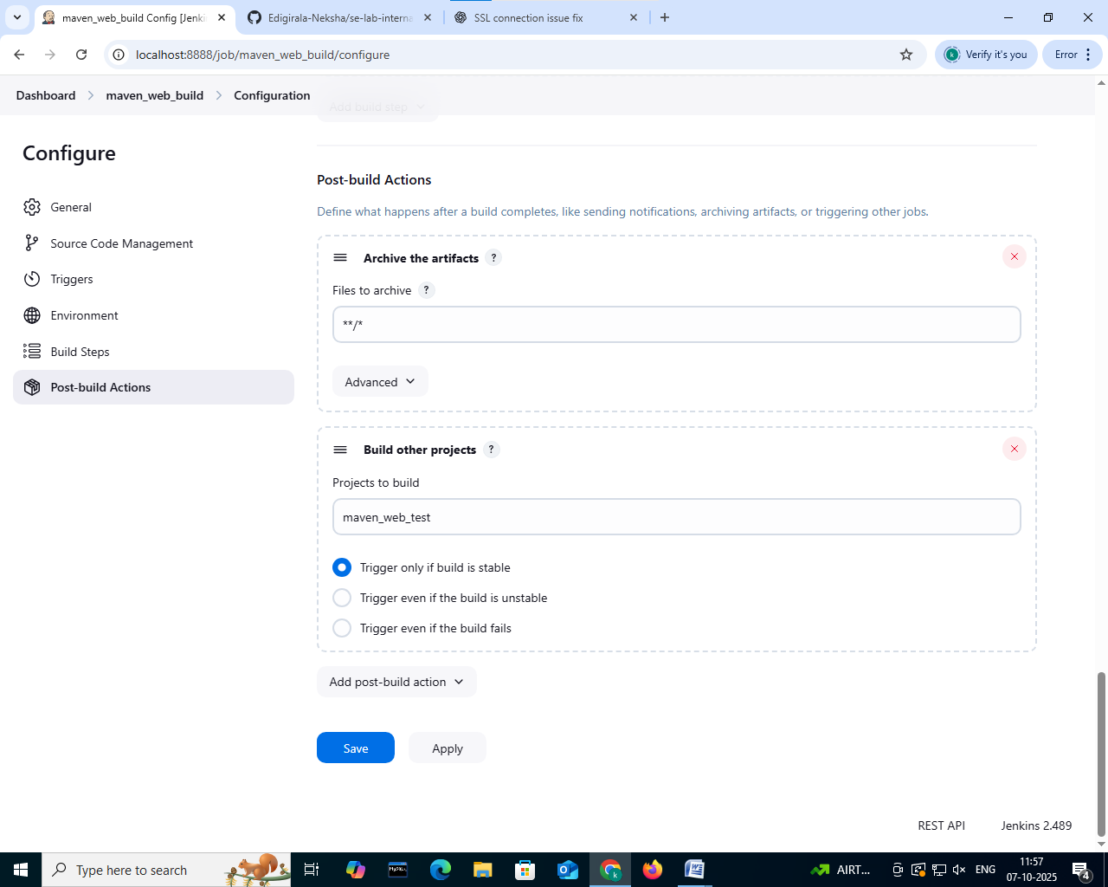

Create Freestyle Project (e.g., MavenWeb_Test):

**Step 1: Open Jenkins (localhost:8888)**

Click on "New Item" (left side menu) and name it as maven_web_test> select freestyle project > click on “OK”

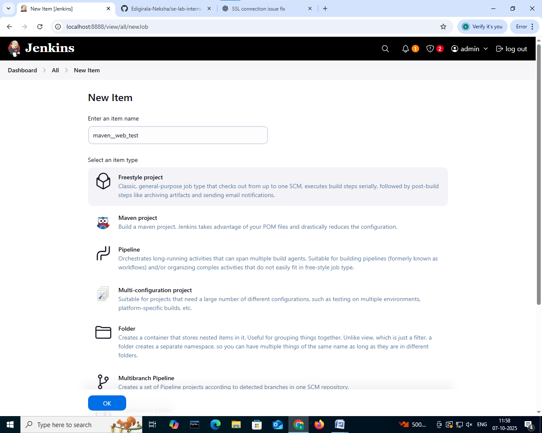

**Step 2: Configuration of maven_web_test project**

Give the description

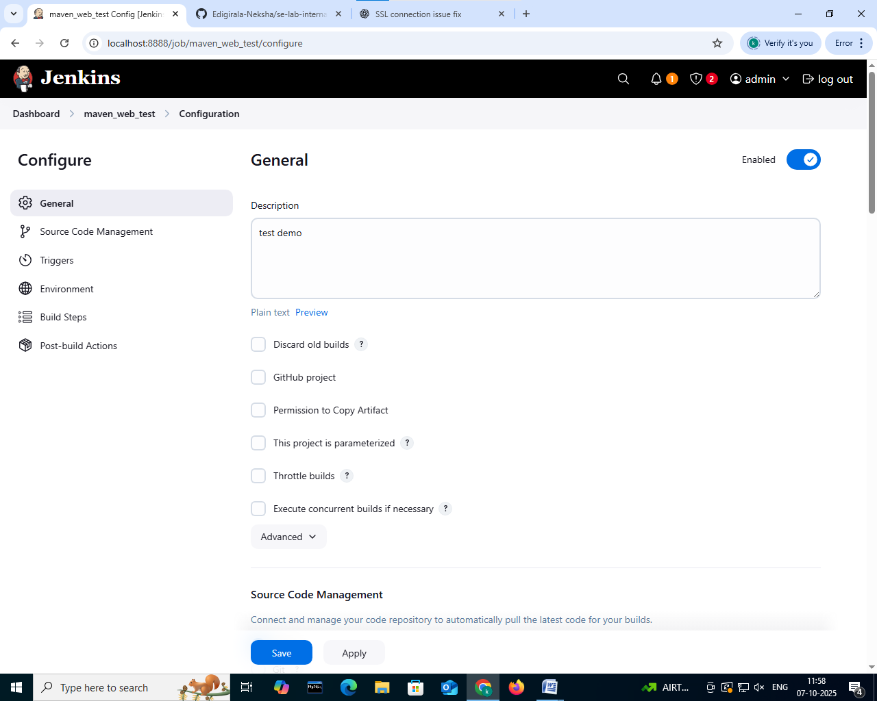

In the source code management select none and in environment select “delete workspace before build starts”

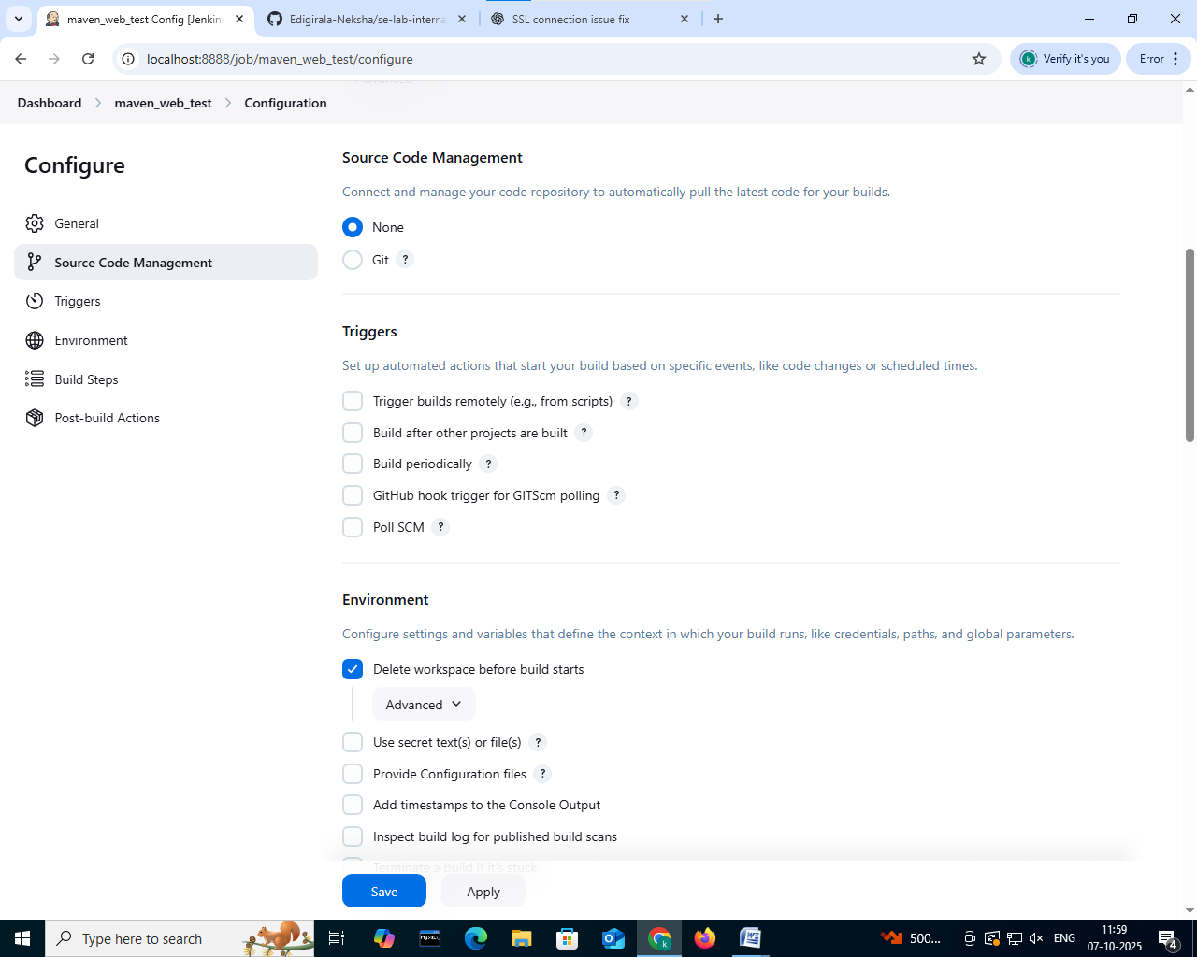

In the build steps click on add build step > select copy artifacts from another project > give project name as maven_web_build > give artifacts to copy as **/*

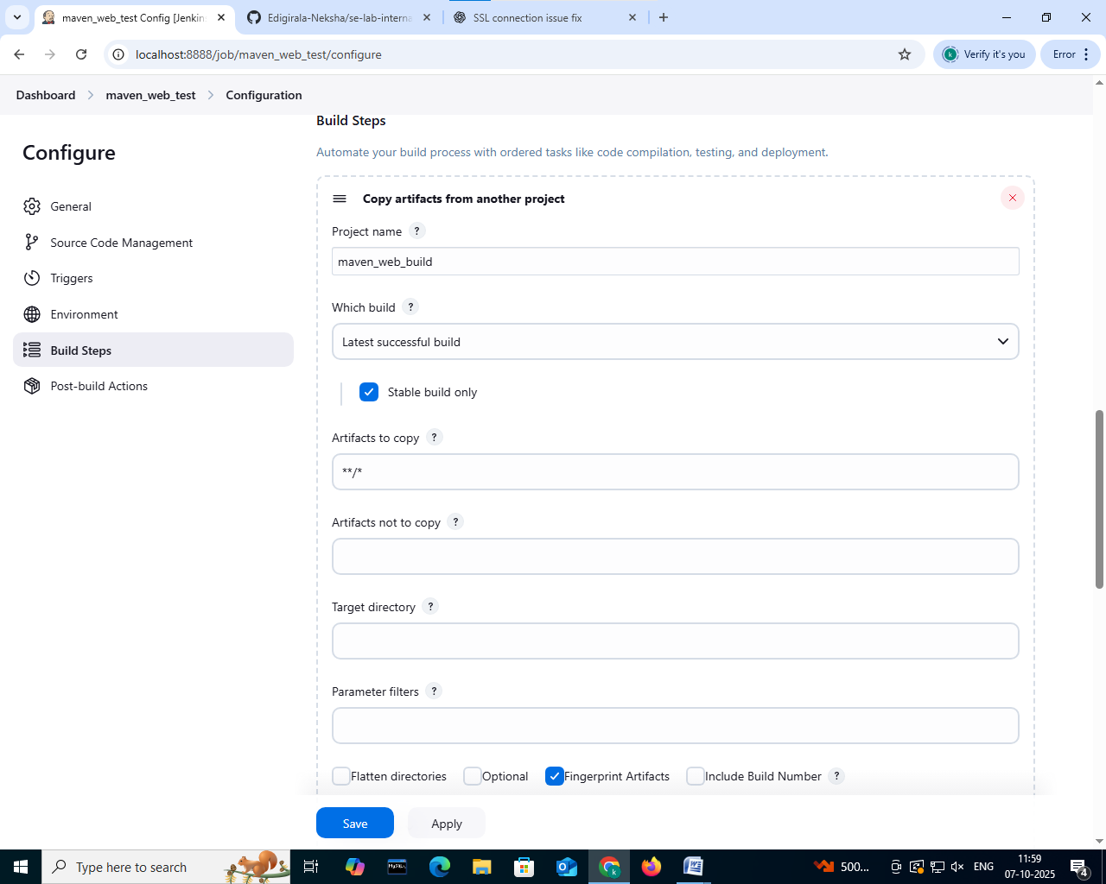

In the build steps click on add build step > give maven version as MAVEN_HOME > select invoke top-level maven targets > goals as test

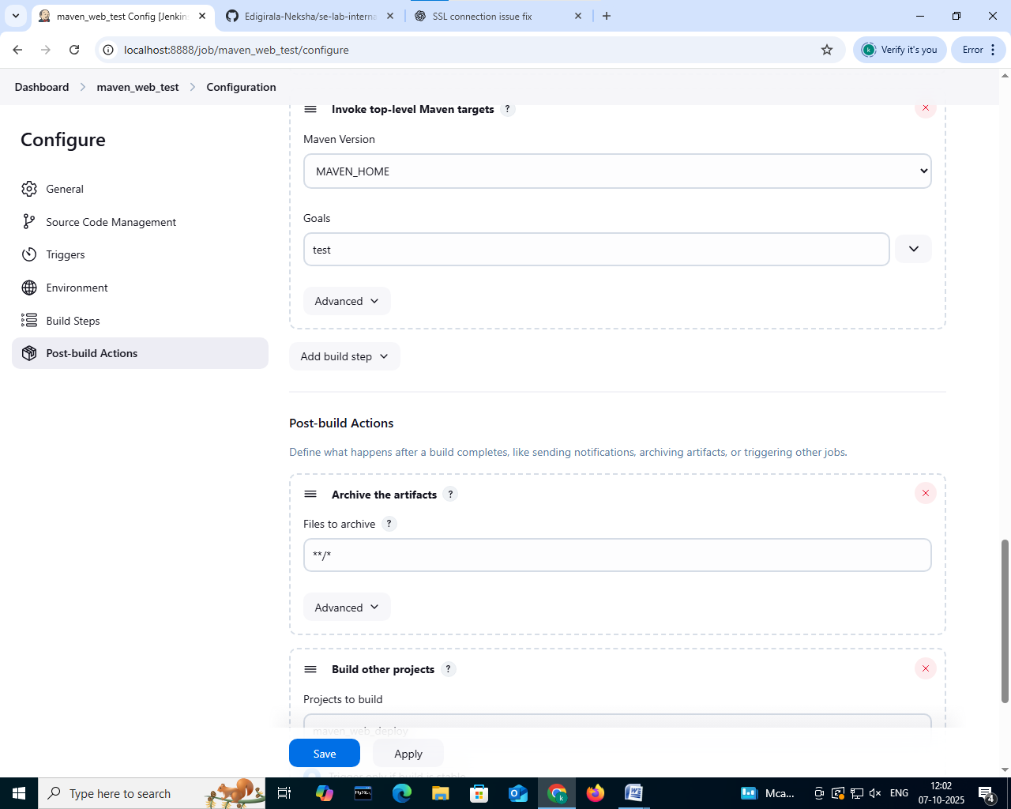

In the post build actions > click on add post build action > select the archive the artifacts > in the file to archive give **/*



In the post build actions > click on add post build action >select build other projects > give name as maven_web_deploy> select “trigger only if build is stable”

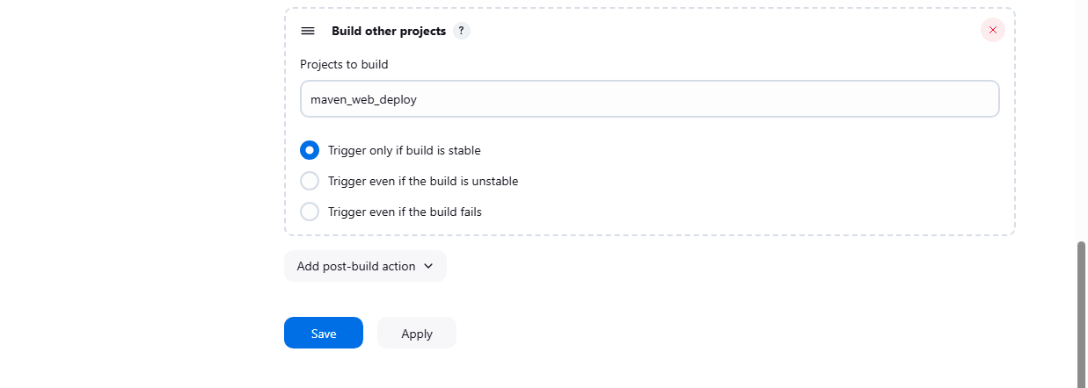

If the build is success:

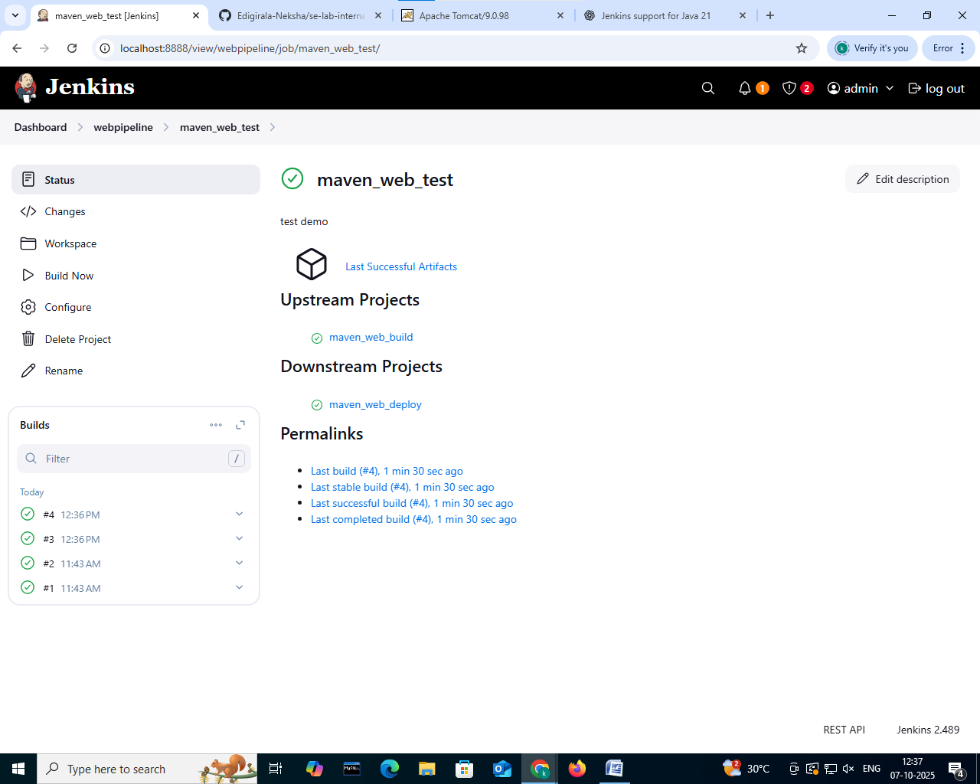

Create Freestyle Project (e.g., MavenWeb_Deploy):

**Step 1: Open Jenkins (localhost:8888)**

Click on "New Item" (left side menu) and name it as maven_web_deploy > select freestyle project > click on “OK”

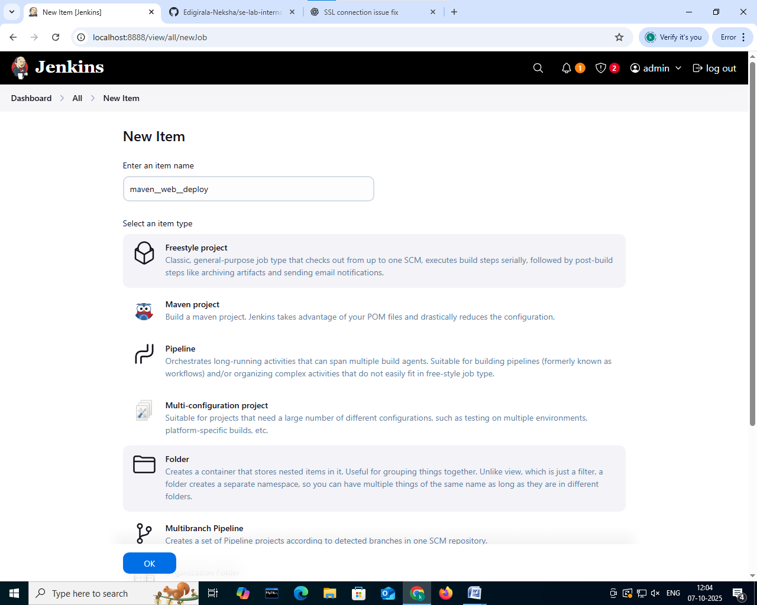

**Step 2: Configuration of maven_web_deploy project**

Give the description 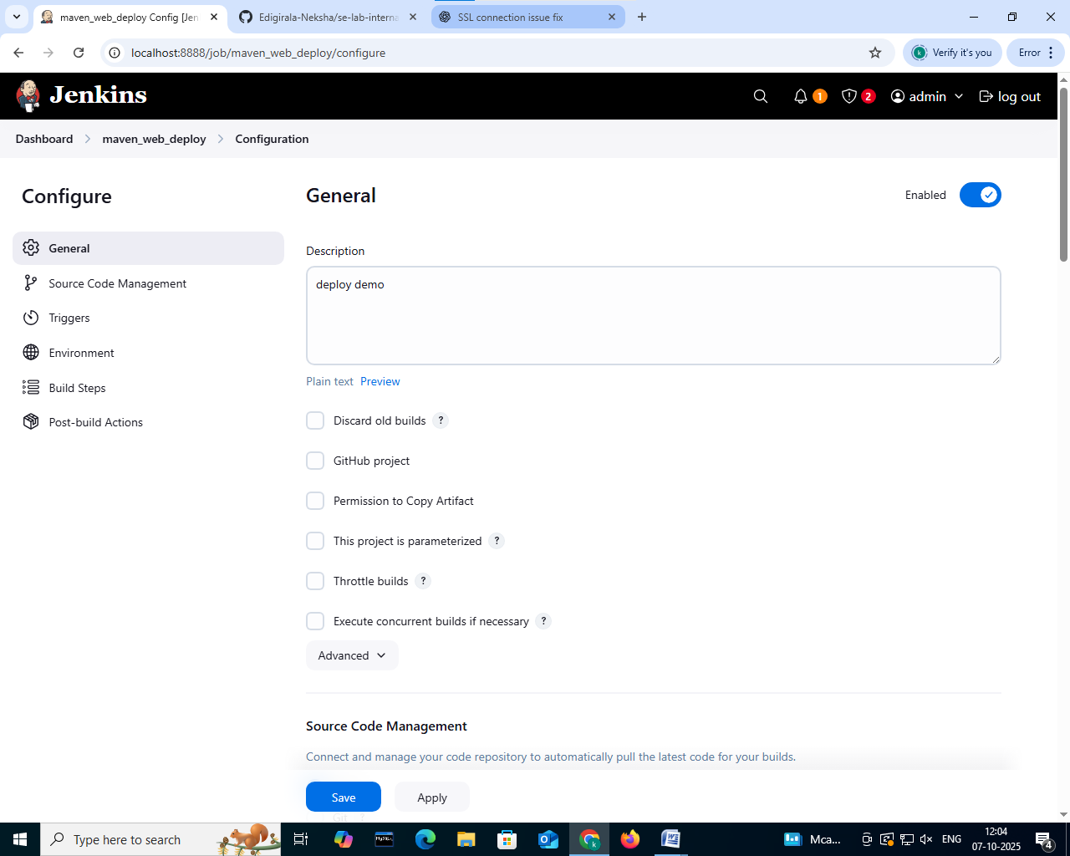

In the source code management select none and in environment select “delete workspace before build starts”

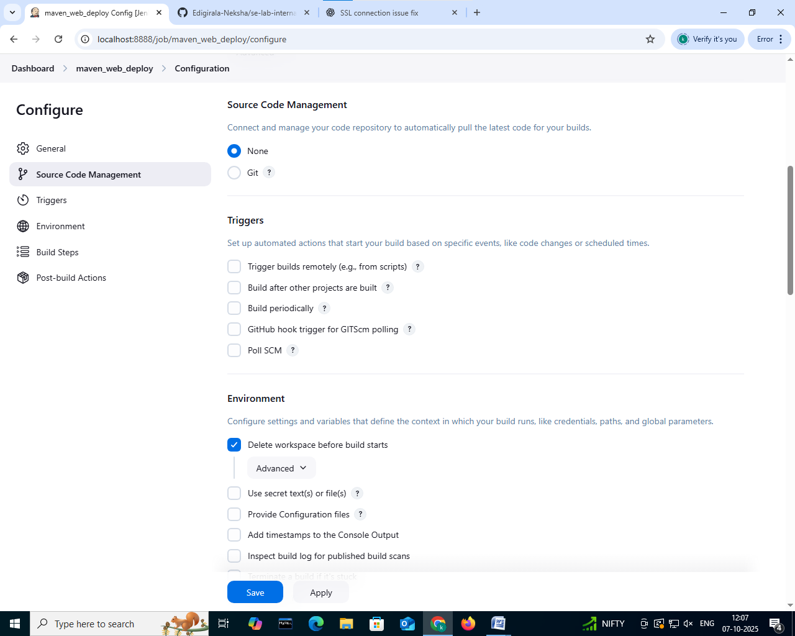

In the build steps click on add build step > select copy artifacts from another project > give project name as maven_web_test > give artifacts to copy as **/*

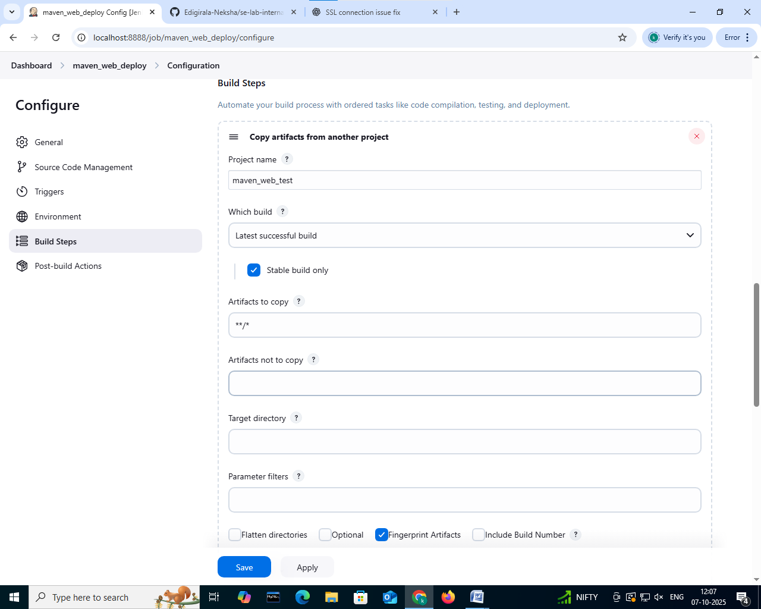

In the post build actions > click on add post build actions > select deploy war/ear to a container > enter war/ear files as **/*.war> context path as webpath > give the credentials and tomcat URL

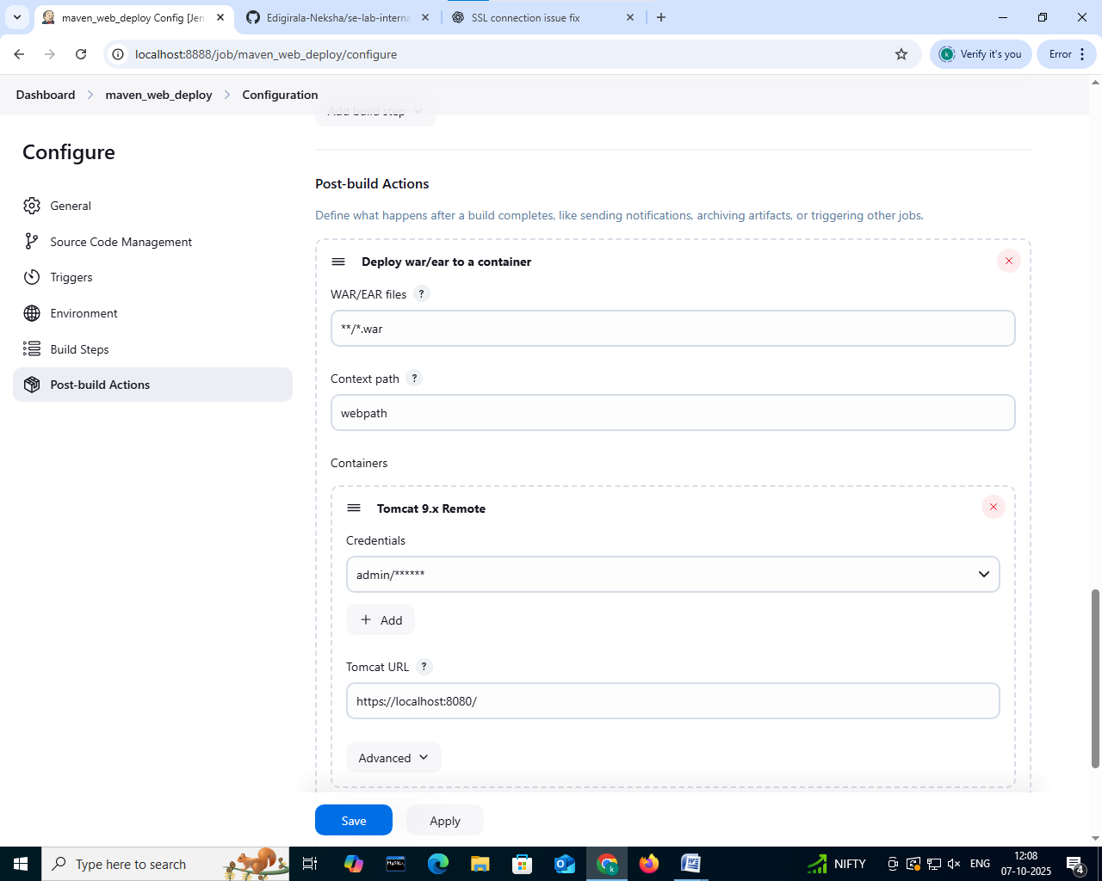

If the build is success:

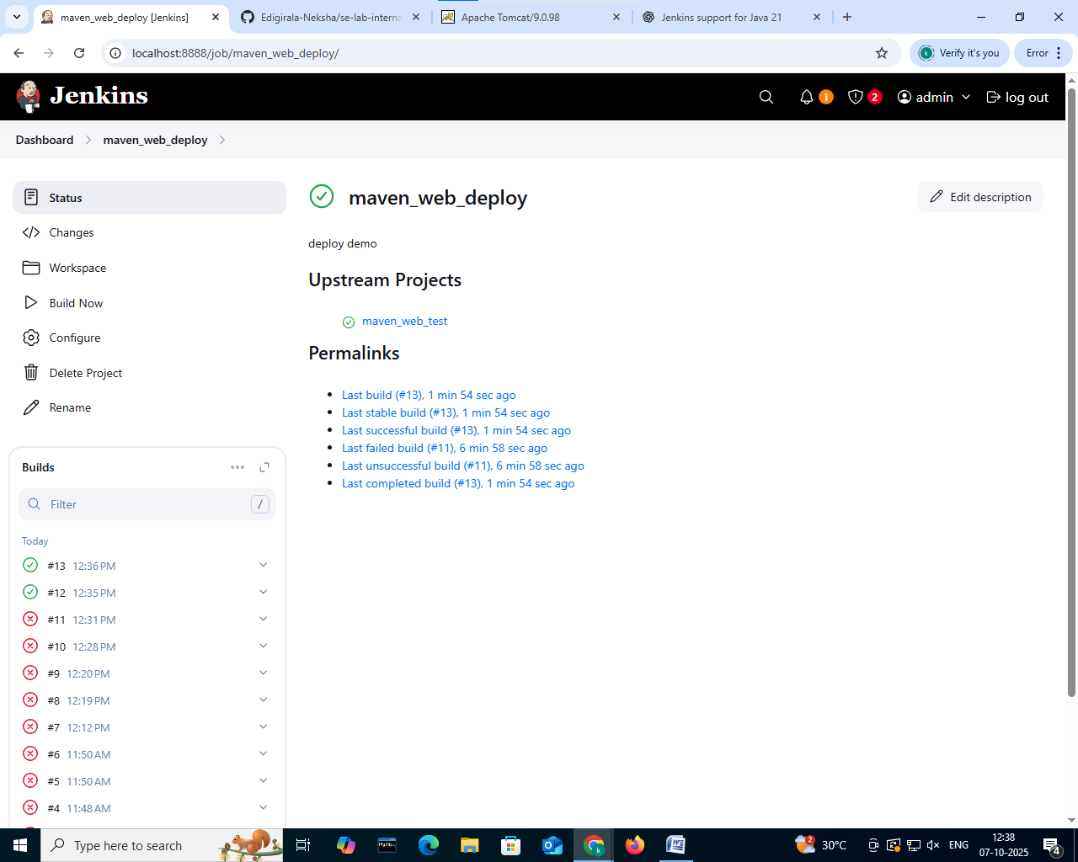

Create Pipeline View for MavenWeb

Click "+" beside "All" on the dashboard and Enter name as maven_web_pipeline

Select type as build pipeline view

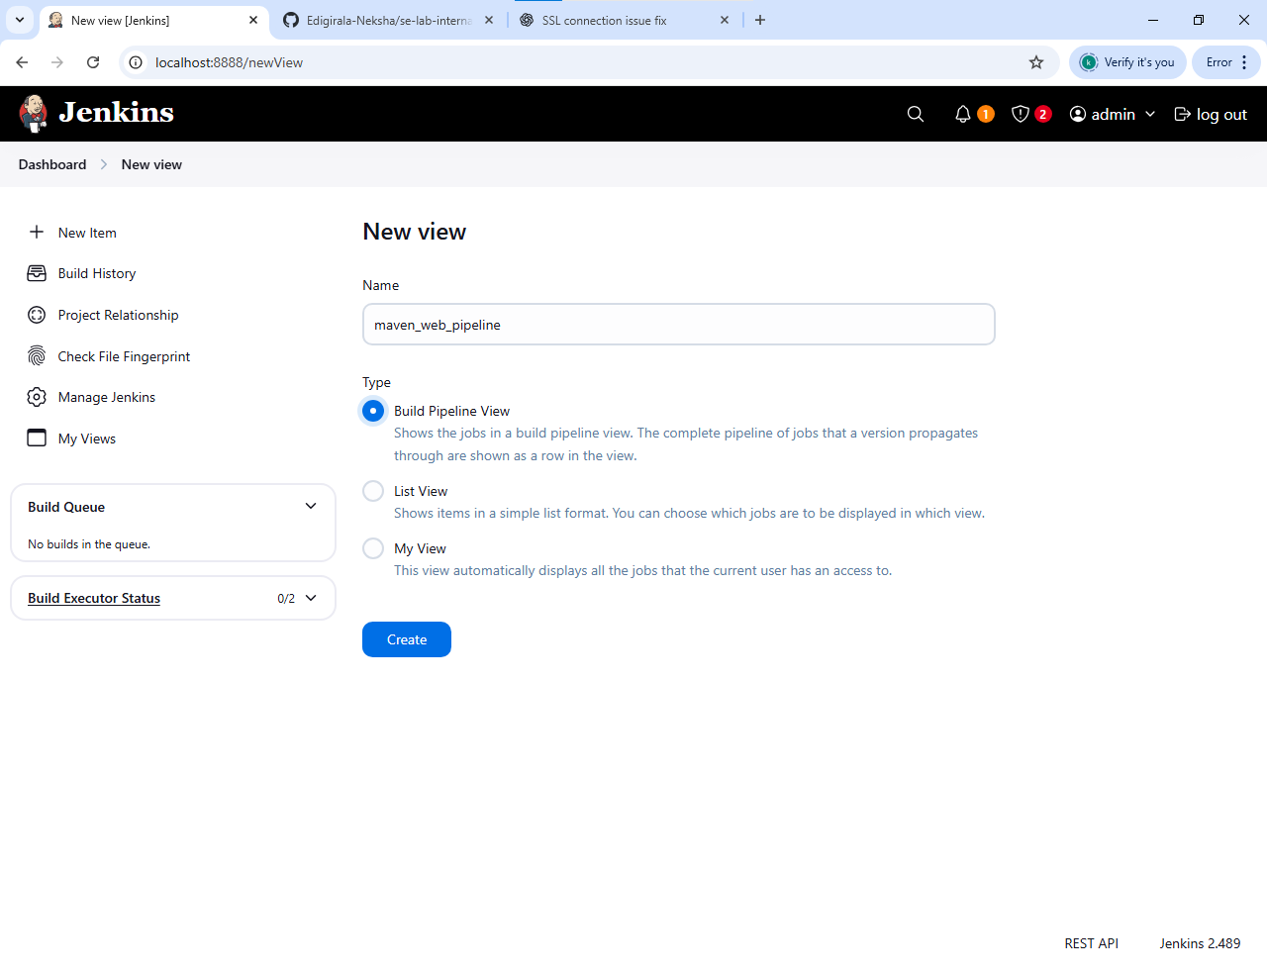

Give the description and in the upstream directly the maven_web_build will be shown

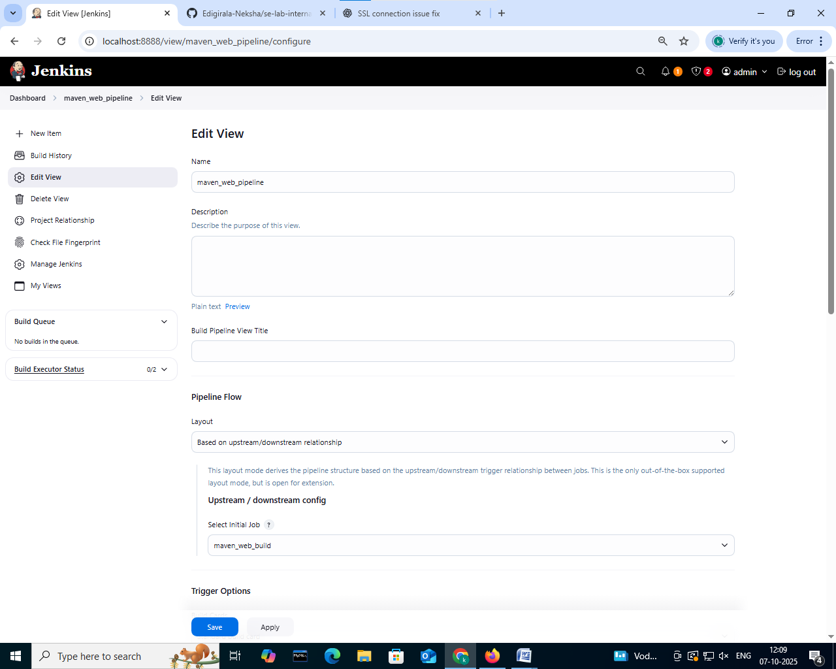

Click on apply and save

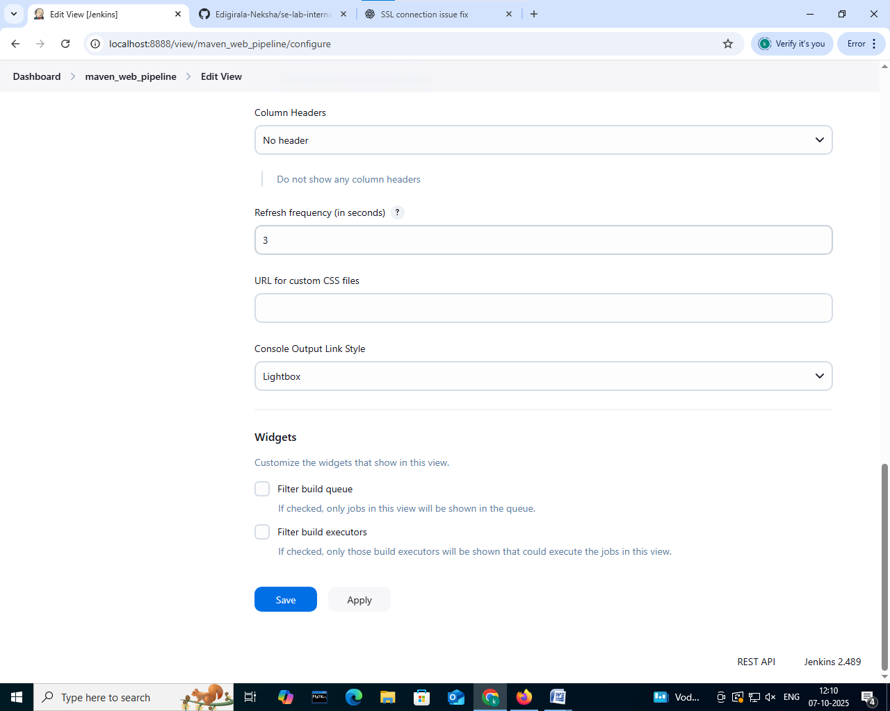

In the stage view it we be shown as:

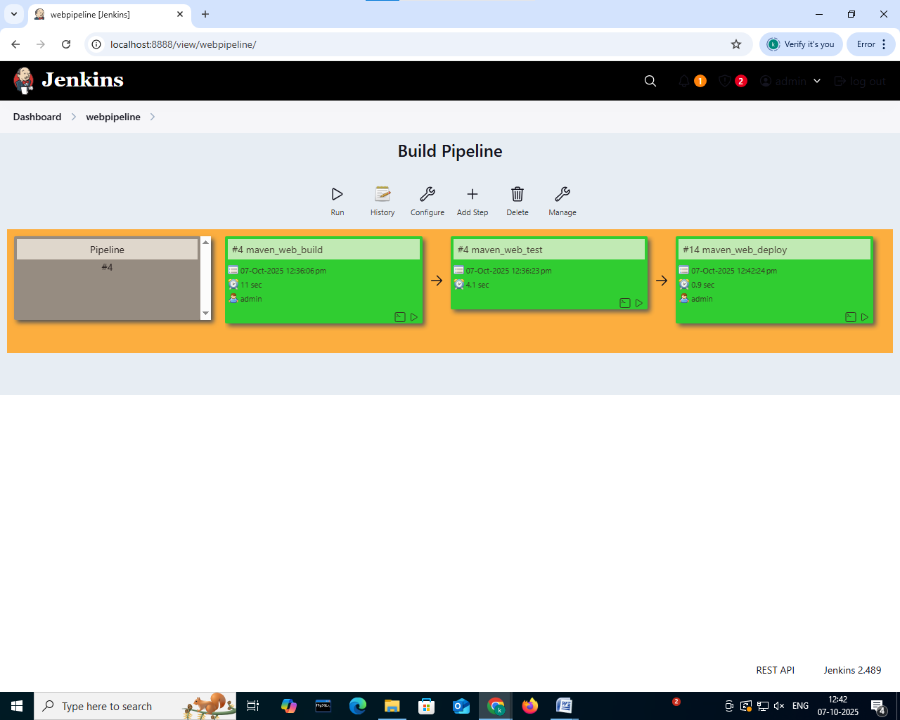

**9.Pipeline Creation using script**

Step 1: In the Jenkins select the new item and give the name as pipeline_script and select pipeline and click ok

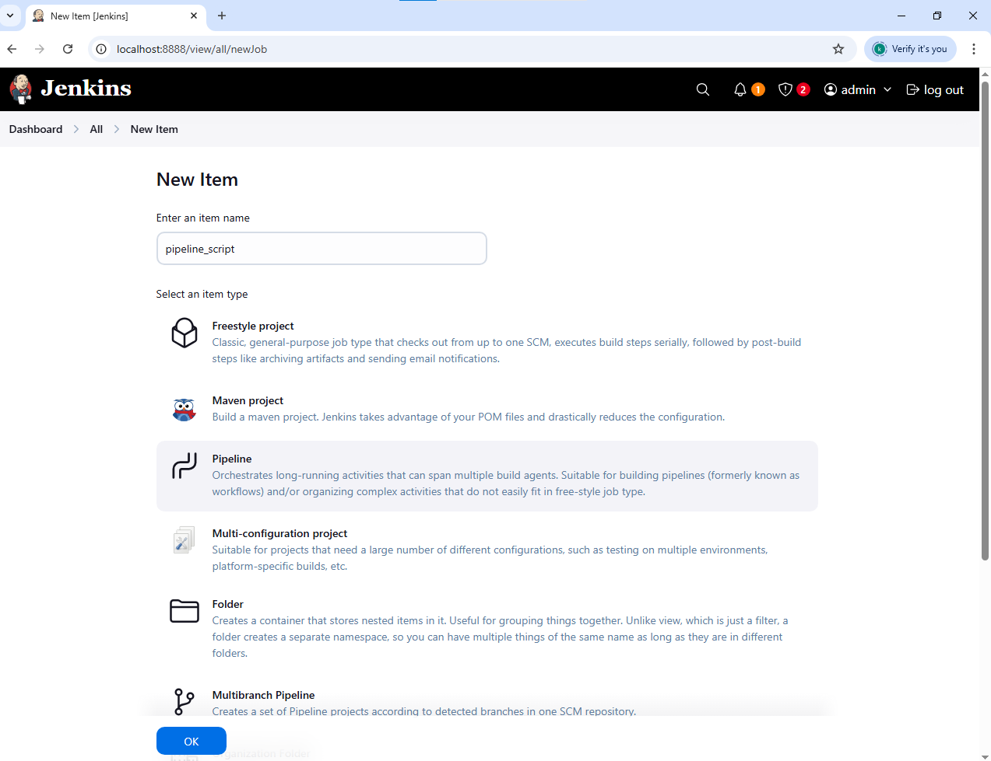

Step 2: In the configuration, give the description

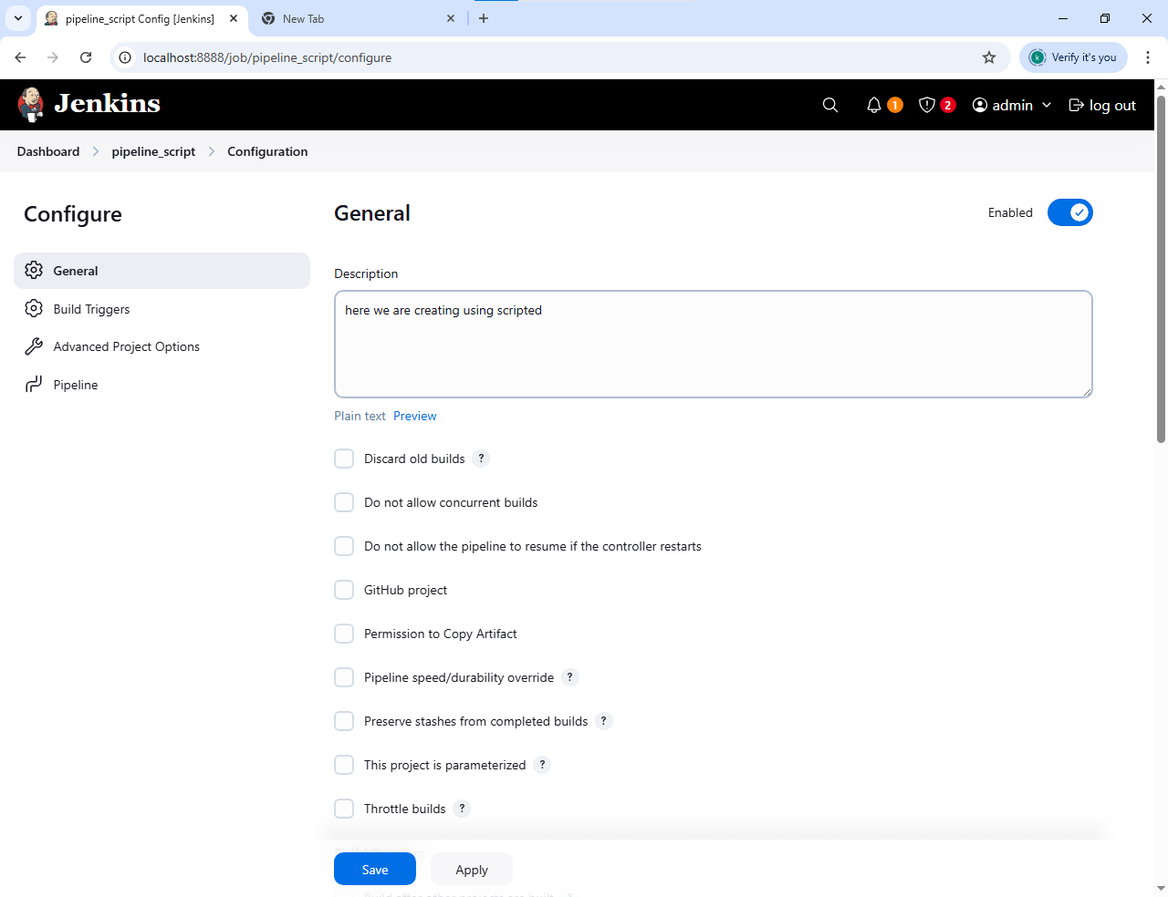

Step 3: In the pipeline section give definition as pipeline script and enter the script with git reop link and project name

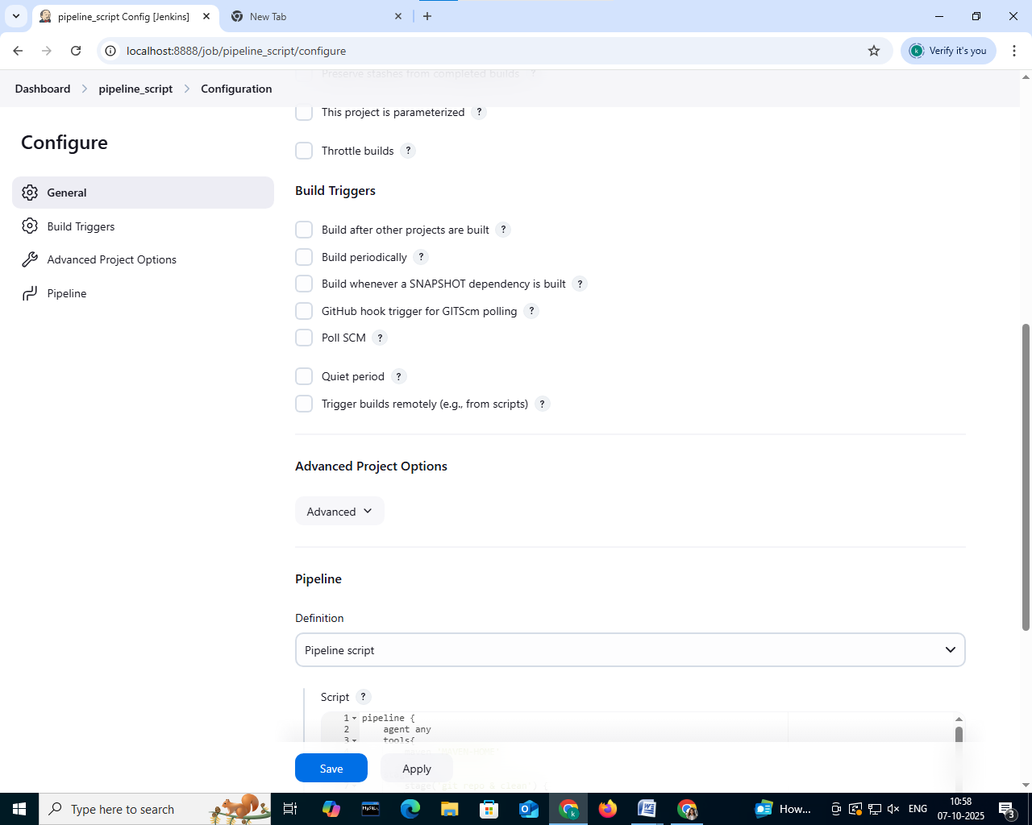

Step 4: click on apply and then save

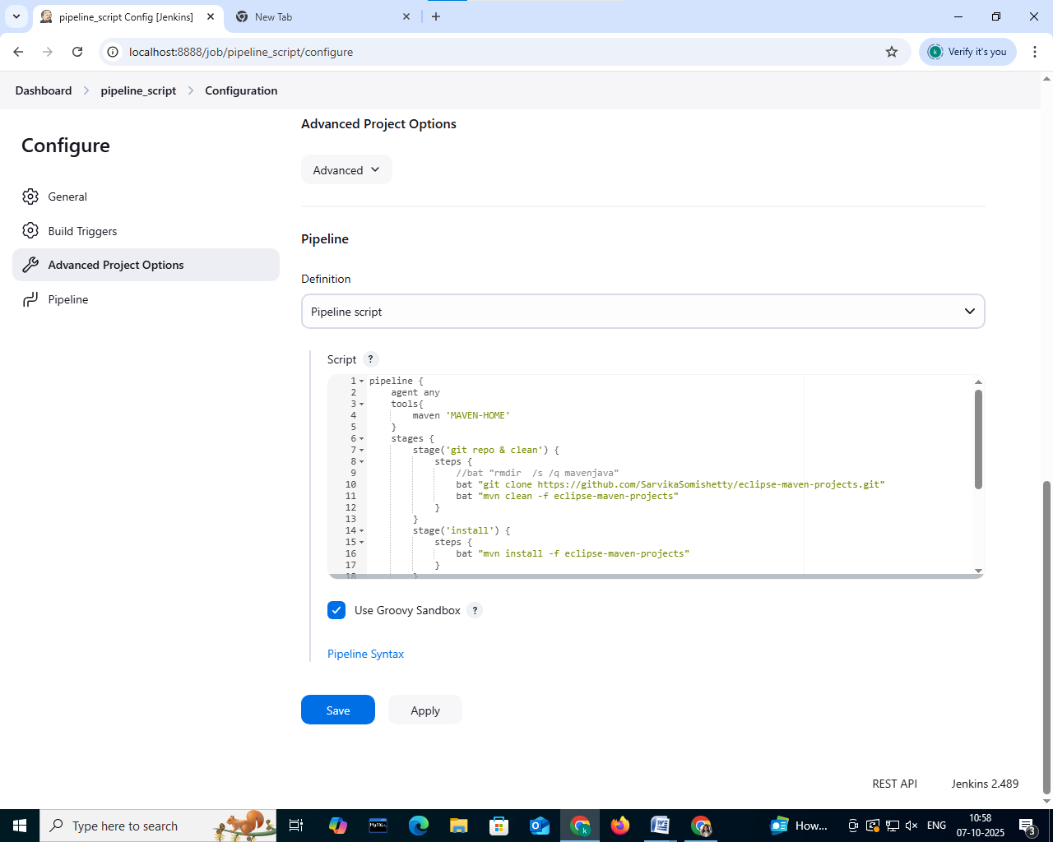

Step 8: Check the stage view. If is successful.

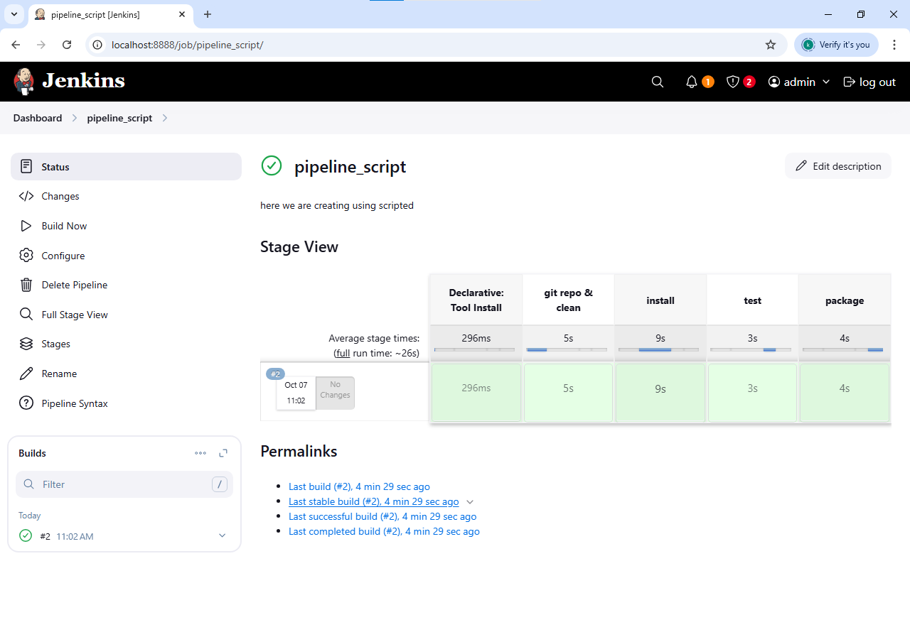

**10. Kubernetes Using Minikube:**

**Step -1:**

**Start Minikube : Command- minikube start**

* First, you need to start your Kubernetes cluster using Minikube.
* When you start it, Minikube sets up a lightweight virtual machine on your system and runs a local Kubernetes node inside it.

**Step-2:**Then check for the status Minikube status

**Step-**3:Create an image

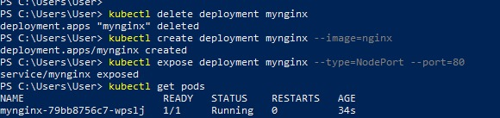

**Step-4:** Check the NGINX Service Details

* After creating the service, check its details to see which port Kubernetes assigned to it.

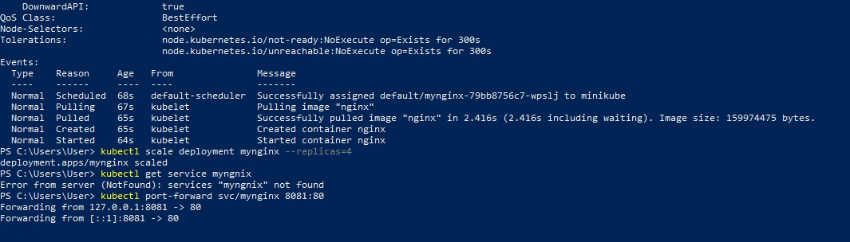

**Step-5**:check the detail of the kubectl .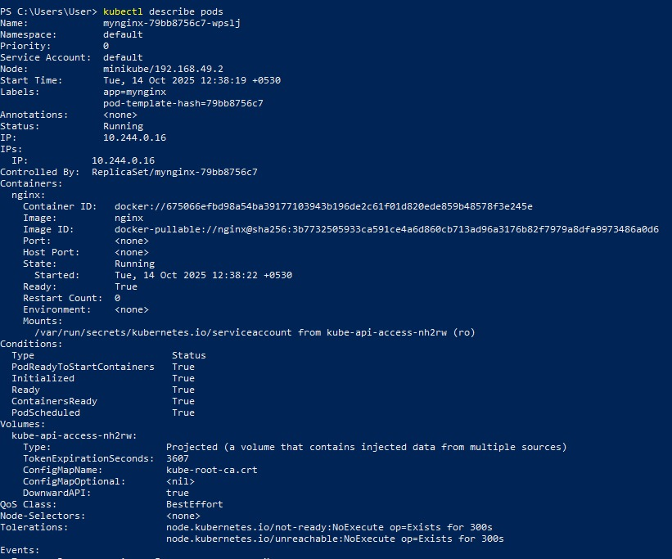

**Step-6:Check the NGINX Service Details**

* After creating the service, check its details to see which port Kubernetes assigned to it.

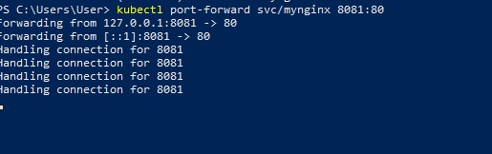

**Step-7: Open NGINX in the Browser**

* Now that your service is exposed, you can open NGINX in your browser.

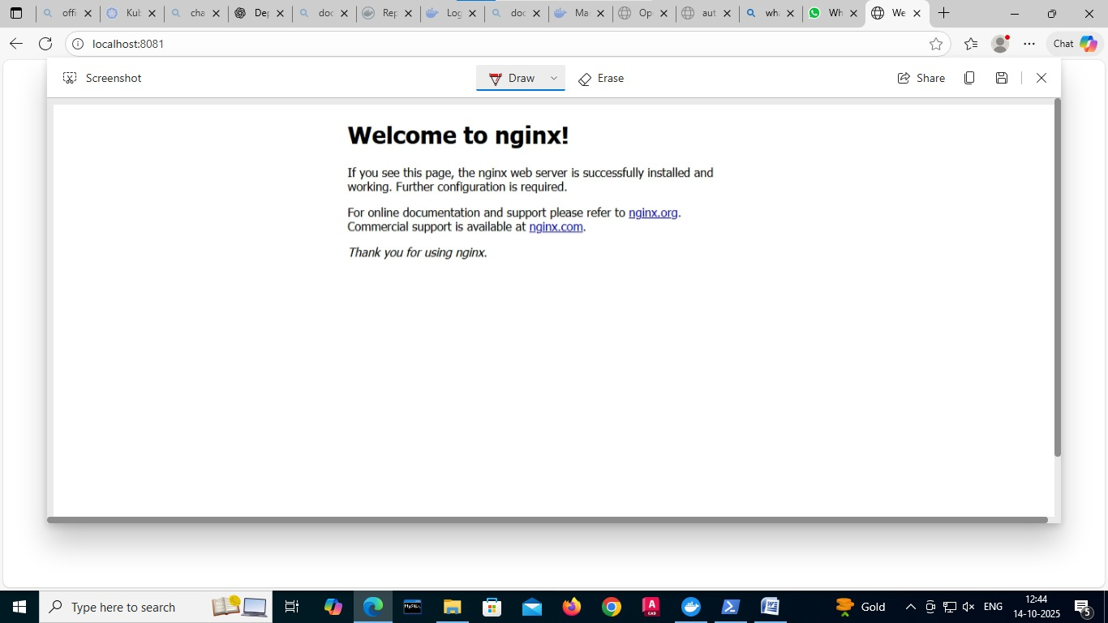

**11. Jenkins-CI/CD**

**Setting Up Jenkins CI------using GitHub Webhook with Jenkins**

Step 1: Take the authentication key from the ngrok and setup in ngrok terminal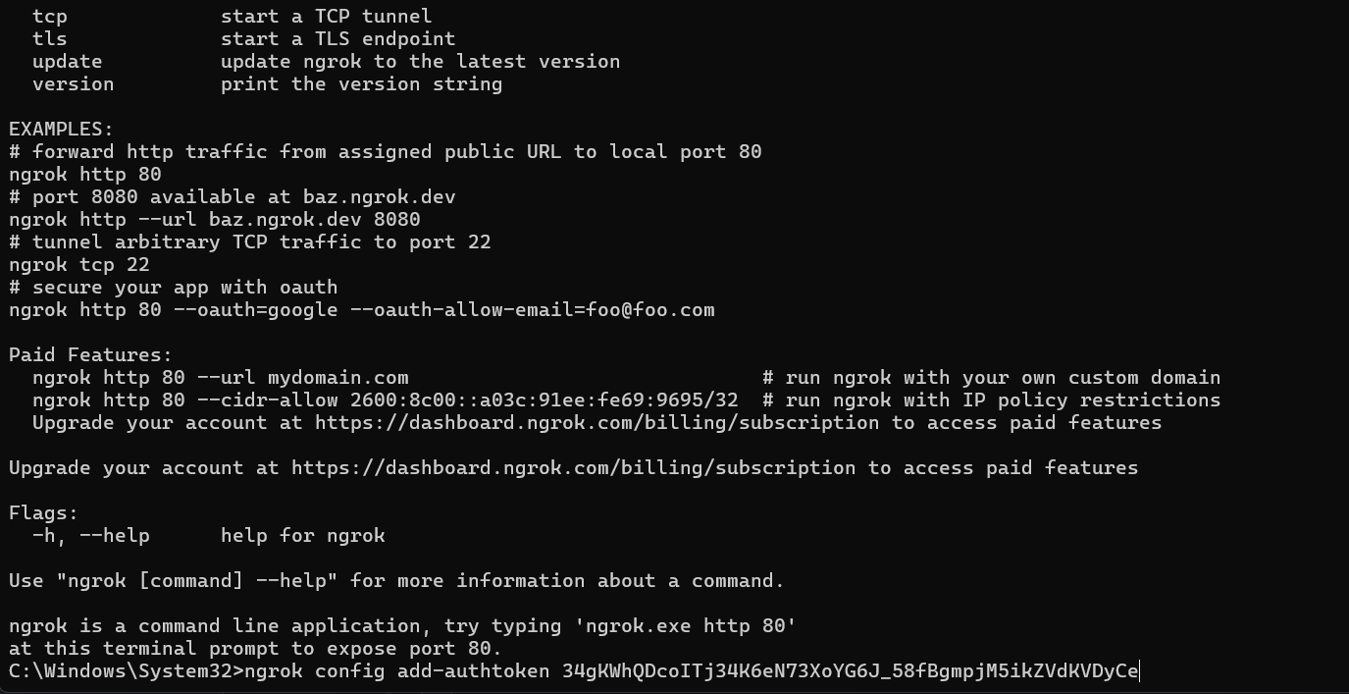

Step-2: Execute the following command using the port number on which Jenkins is running



* Following output will be given:

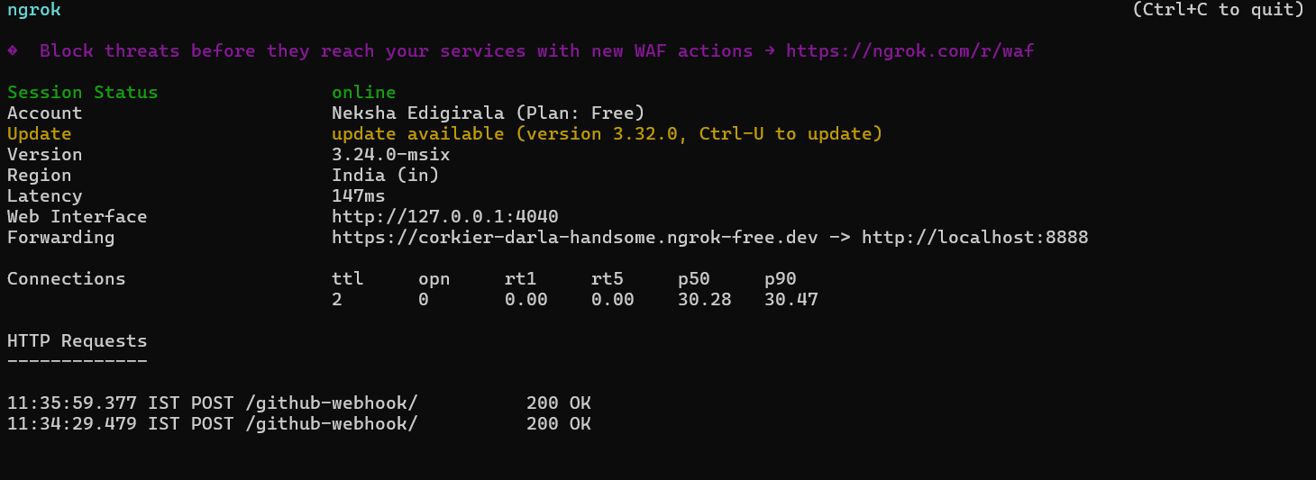

Go to Jenkins:

Step-3: Create the Jenkins job in the source code management select the git and enter git repo url and make sure the branch is same (i.e., main)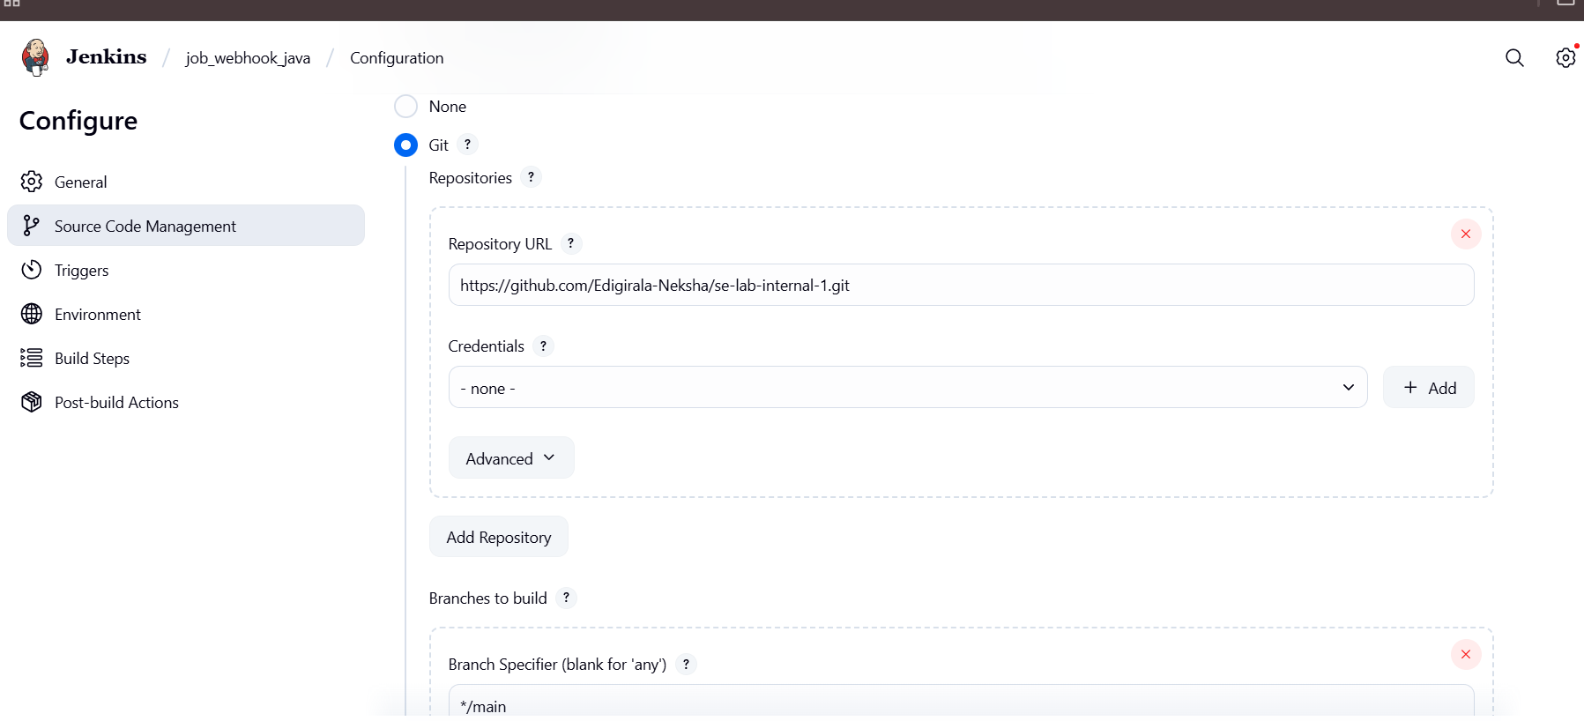

Step-4: In the triggers section select “Github hook trigger for GITScm polling”

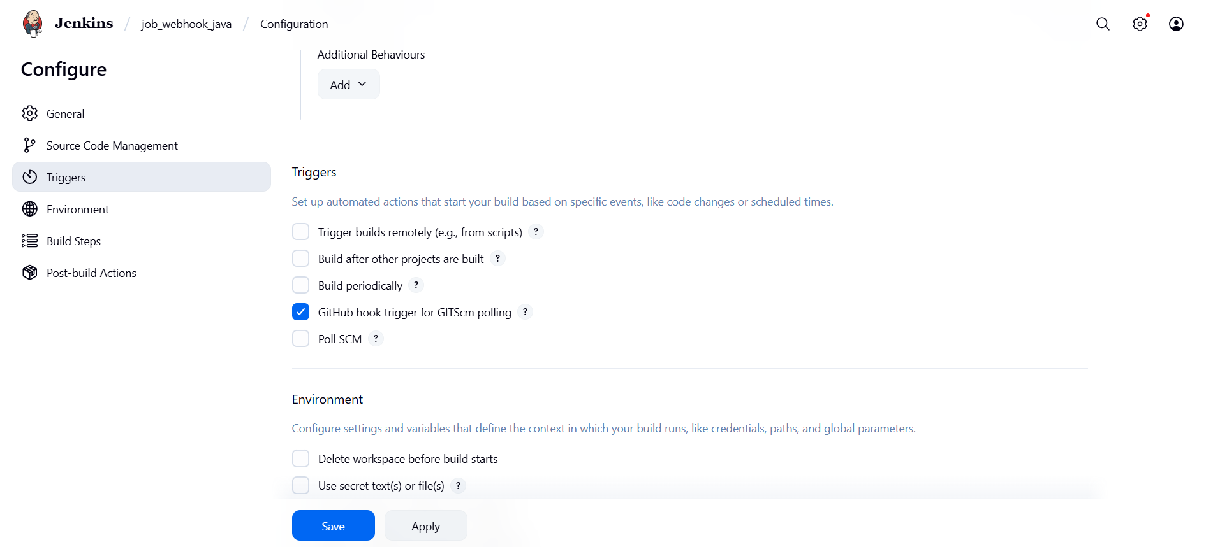

Click on apply and save

Step-6: open the git hub repo open setting of repo and then go to webhooks

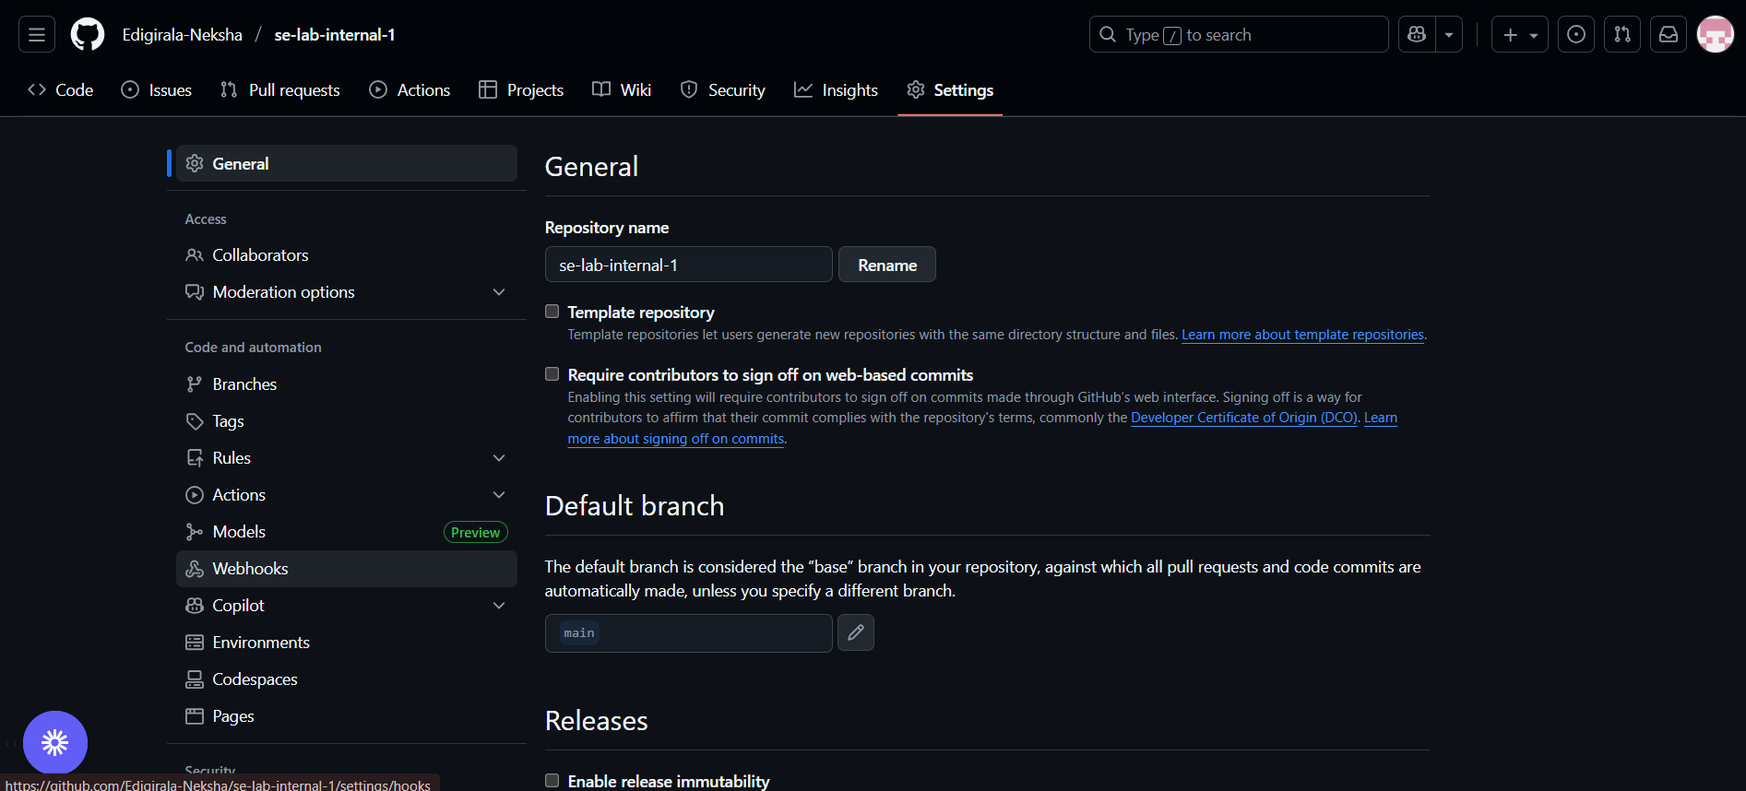

Step-7: Click on add a webhook and take the forwarding URL from ngrok and paste in payload URL and add /github-webhook/ along with the forwarding url

Forwarding URL: <https://corkier-darla-handsome.ngrok-free.dev>

Payload url: <https://corkier-darla-handsome.ngrok-free.dev/github-webhook/>

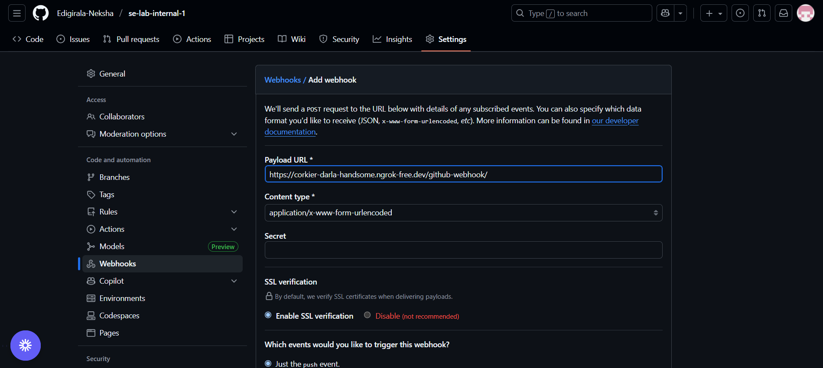

Step 8: make changes in the files in github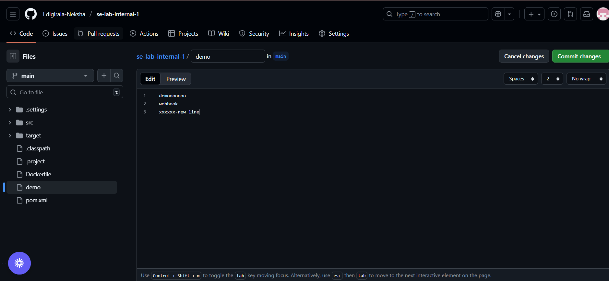

Step 9: click on commit changes

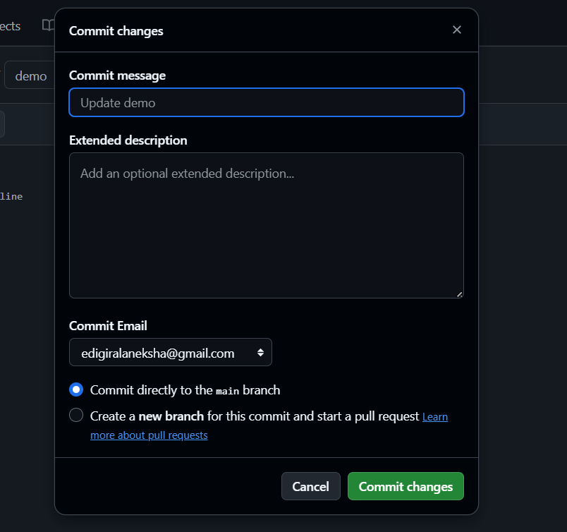

Step 10: open Jenkins the build will start automatically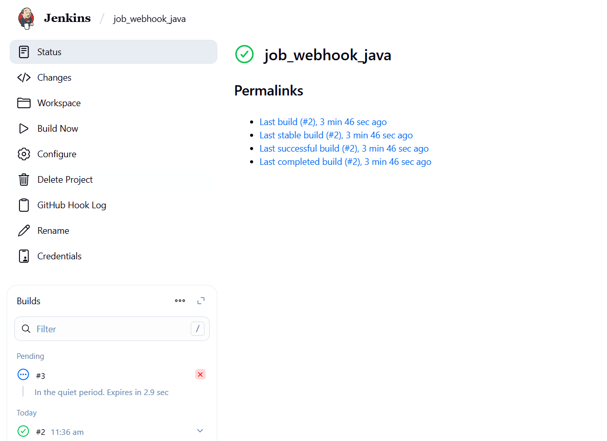

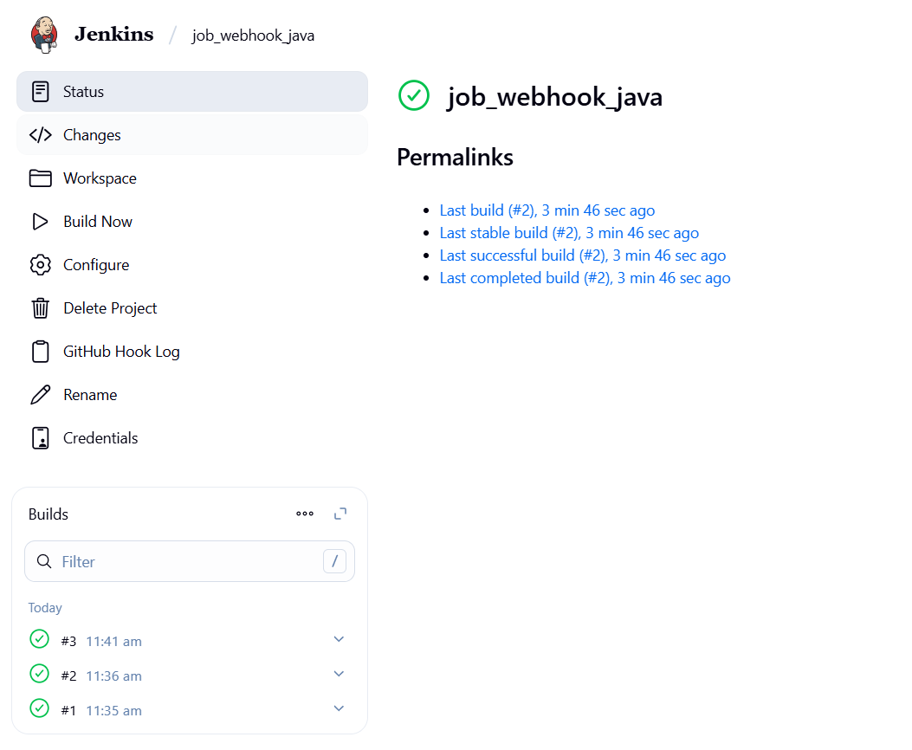

You can check status : started by git hub push

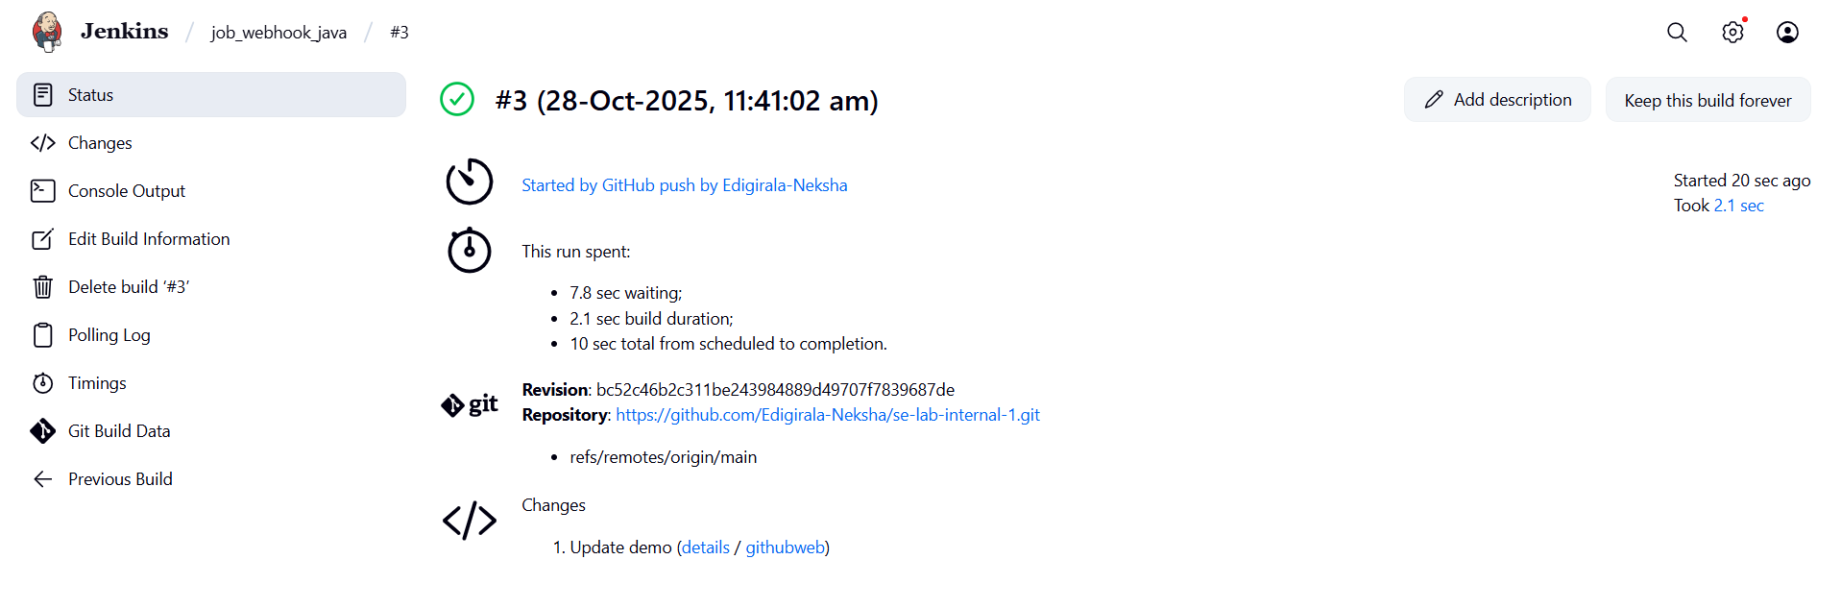

**Setting Up Jenkins Email Notification Setup (Using Gmail with AppPassword)**

**Step-1: Creation of app password**

**Gmail: Enable App Password (for 2-Step Verification)**

**ii. Enable 2-Step Verification**

**iii. Generate App Password for Jenkins**

* Go to:
  + Security → App passwords
* Select:
  + **App**: Other (Custom name)
  + **Name**: Jenkins-Demo
* Click **Generate**
* Copy the **16-digit app password**
  + Save it in a secure location (e.g., Notepad)

**2. Jenkins Plugin Installation**

**i. Open Jenkins Dashboard**

**ii. Navigate to:**

* Manage Jenkins → Manage Plugins

**iii. Install Plugin:**

* Search for and install:
  + Email Extension Plugin

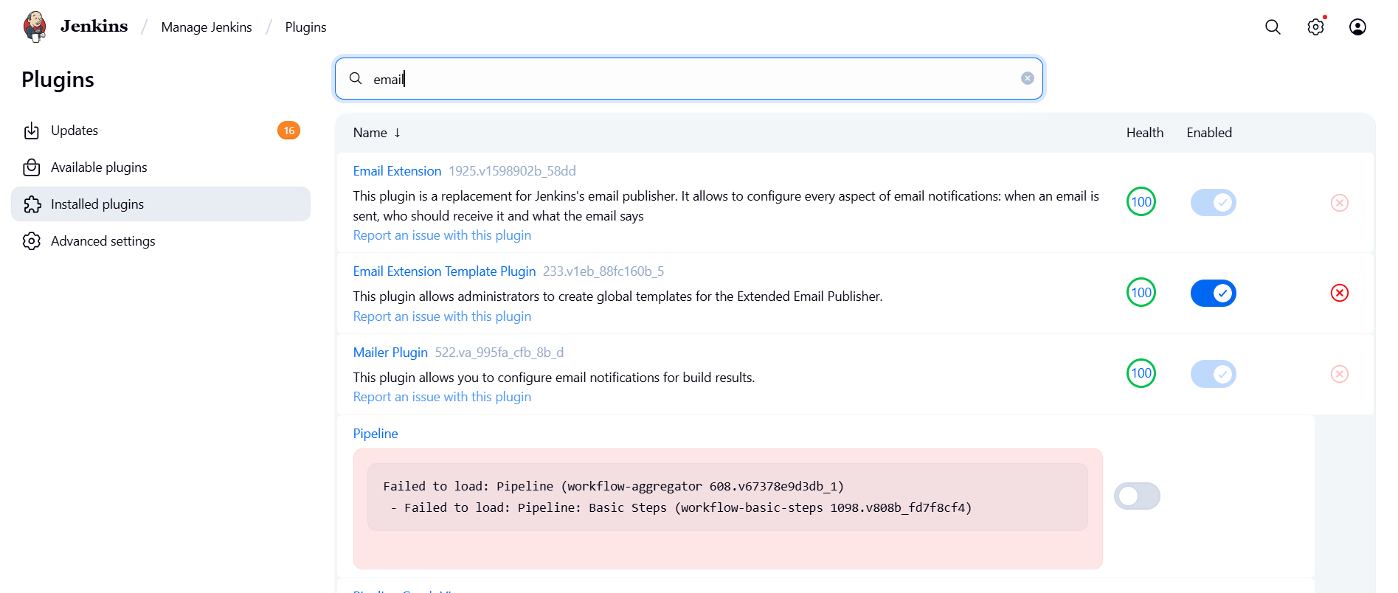

**3. Configure Jenkins Global Email Settings**

**Go to:**

* Manage Jenkins → Configure System

**A. E-mail Notification Section**

| **Field** | **Value** |
| --- | --- |
| **SMTP Server** | smtp.gmail.com |
| **Use SMTP Auth** | ✅ Enabled |
| **User Name** | Your Gmail ID (e.g., archanareddykmit@gmail.com) |
| **Password** | Paste the 16-digit App Password |
| **Use SSL** | ✅ Enabled |
| **SMTP Port** | 465 |
| **Reply-To Address** | Your Gmail ID (same as above) |

**➤ Test Configuration**

* Click: Test configuration by sending test e-mail
* Provide a valid email address to receive a test mail
* ✅ Should receive email from Jenkins
* 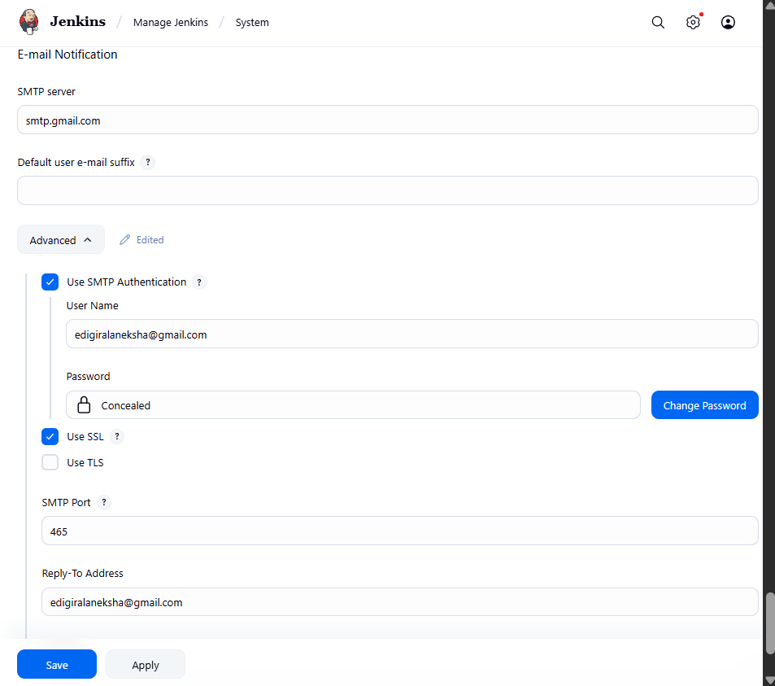

**B. Extended E-mail Notification Section**

| **Field** | **Value** |
| --- | --- |
| **SMTP Server** | smtp.gmail.com |
| **SMTP Port** | 465 |
| **Use SSL** | ✅ Enabled |
| **Credentials** | Add Gmail ID and App Password as Jenkins credentials |
| **Default Content Type** | text/html or leave default |
| **Default Recipients** | Leave empty or provide default emails |
| **Triggers** | Select as per needs (e.g., Failure) |

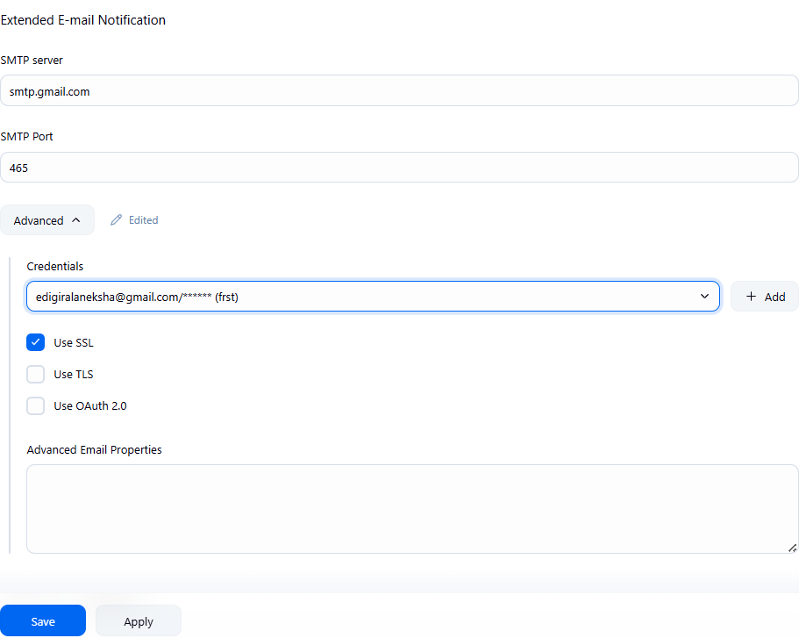

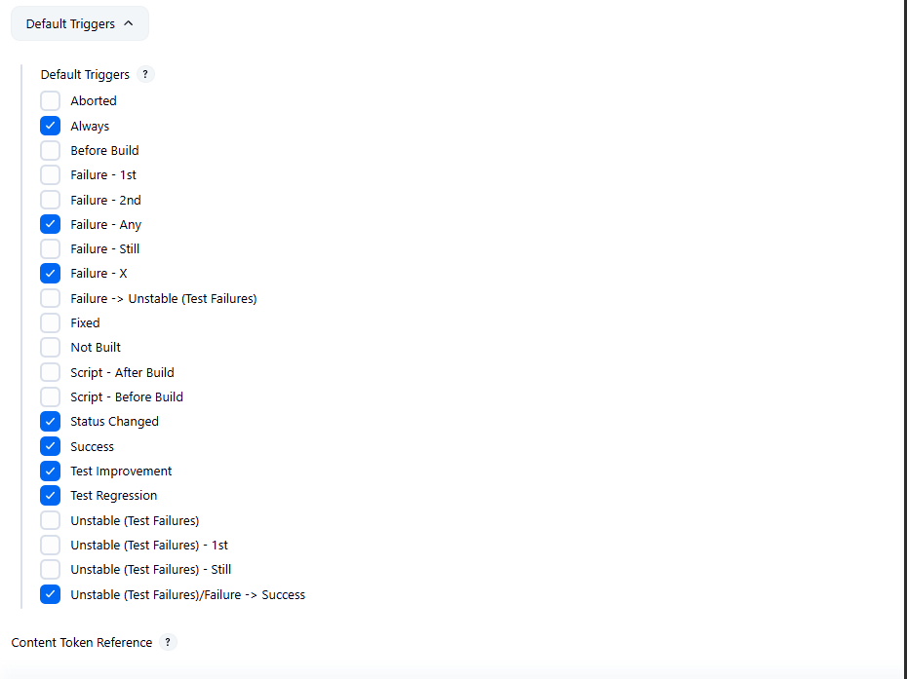

**4. Configure Email Notifications for a Jenkins Job**

**i. Go to:**

* Jenkins → Select a Job → Configure
* 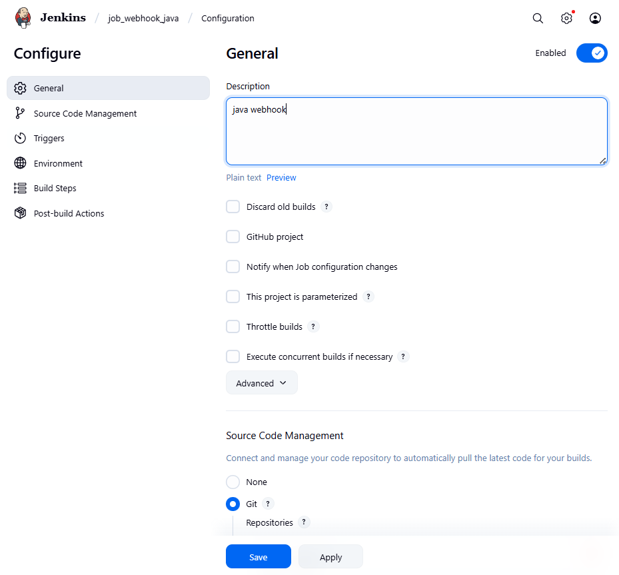

**ii. In the Post-build Actions section:**

* Click: Add post-build action → **Editable Email Notification**

**A. Fill in the fields:**

| **Field** | **Value** |
| --- | --- |
| **Project Recipient List** | Add recipient email addresses (comma-separated) |
| **Content Type** | Default (text/plain) or text/html |
| **Triggers** | Select events (e.g., Failure, Success, etc.) |
| **Attachments** | (Optional) Add logs, reports, etc. |

**iii. Click Save**

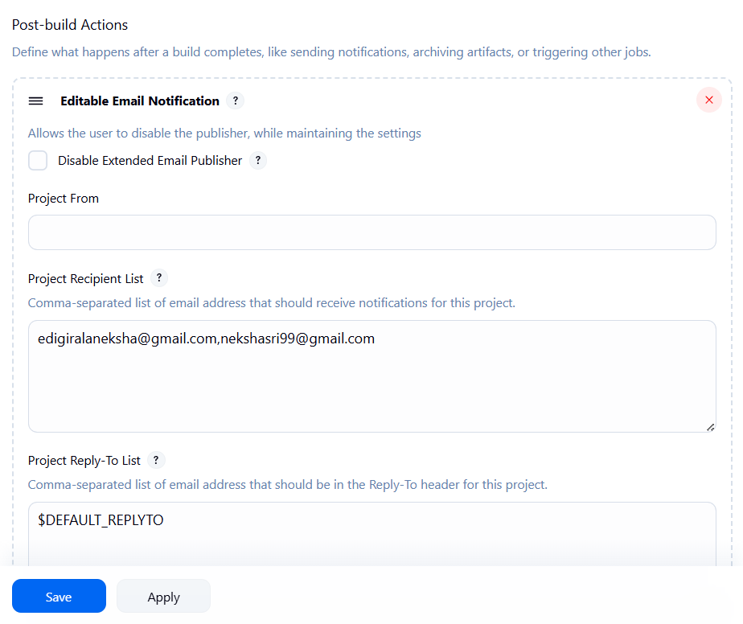

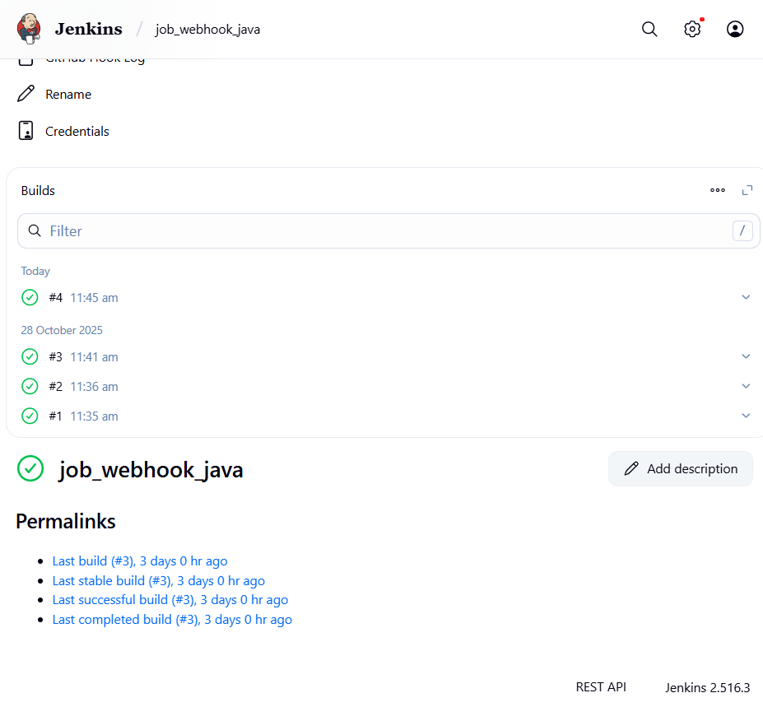

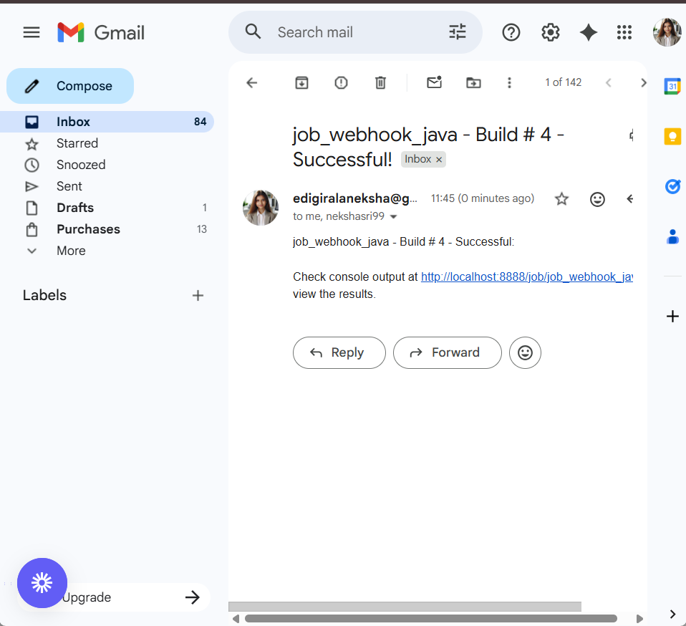

**TUNEORA – A Music Web App**

**1. Sequence Diagram:**  
A sequence diagram shows how objects interact in a particular scenario of a use case.  
It focuses on the time order of messages exchanged between different components in a system.

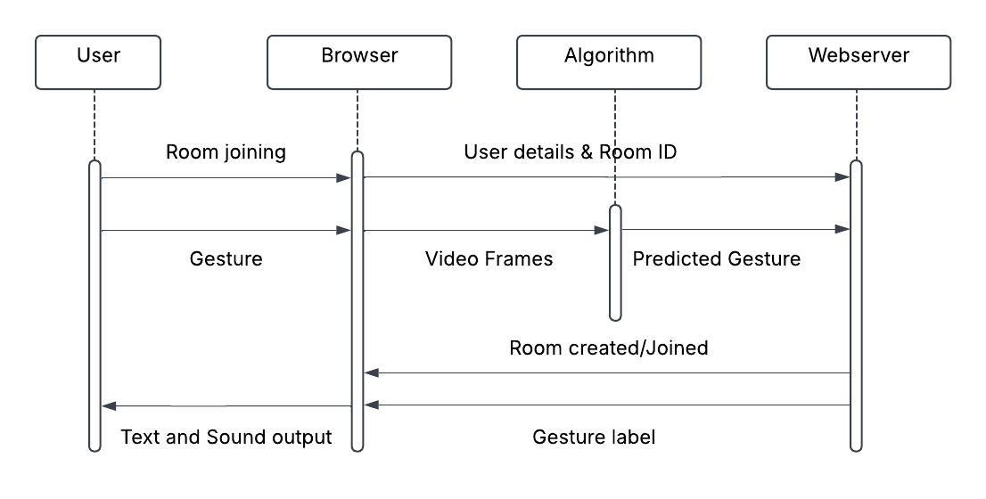

**2. Class Diagram:**  
A class diagram represents the static structure of a system by showing classes, their attributes, methods, and relationships.  
It is mainly used for object-oriented design and modeling data structures.

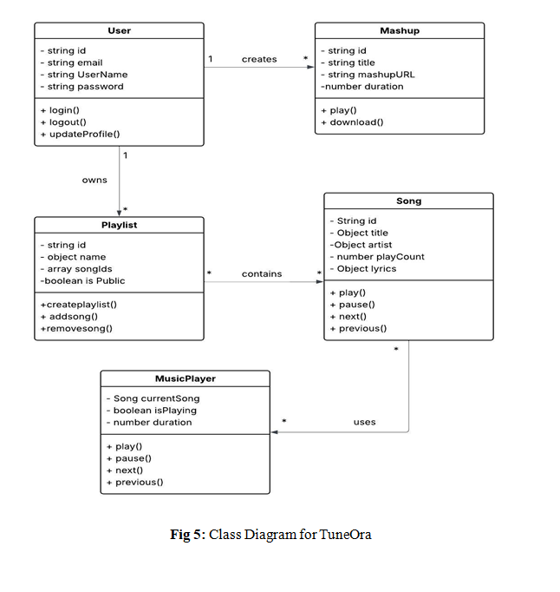

**3. Component Diagram:**  
A component diagram illustrates how different software components are connected and interact to form a complete system.  
It helps visualize the organization and dependencies among modules or subsystems.

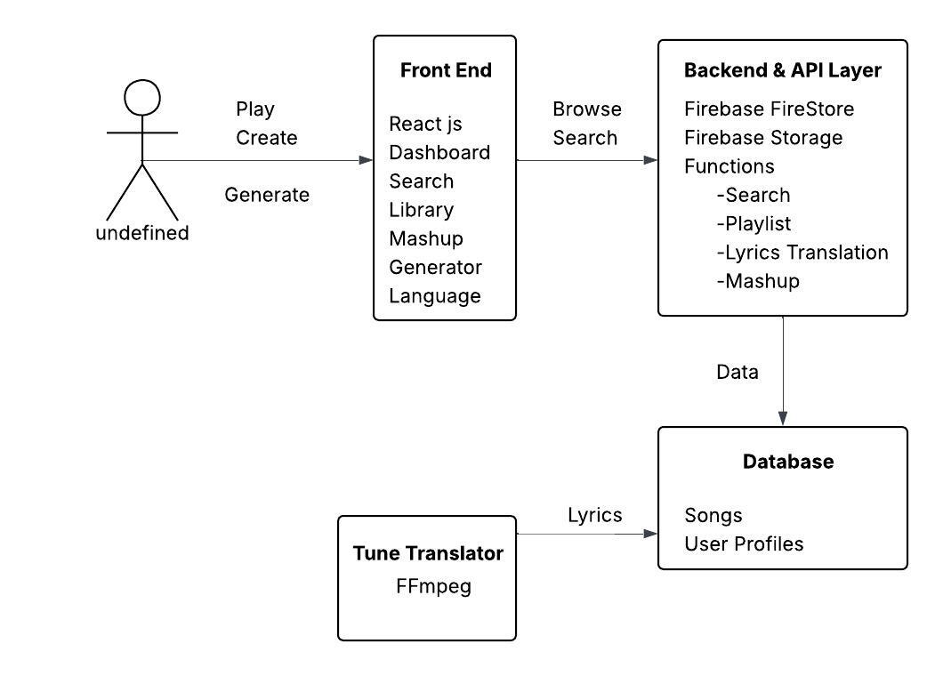



**12.Creation of virtual machine for Ubuntu OS and Deploying the web application**

DEPLOYMENT OF INDEX.HTML USING EC2 INSTANCE in AWS

Step 1: Click on Modules.

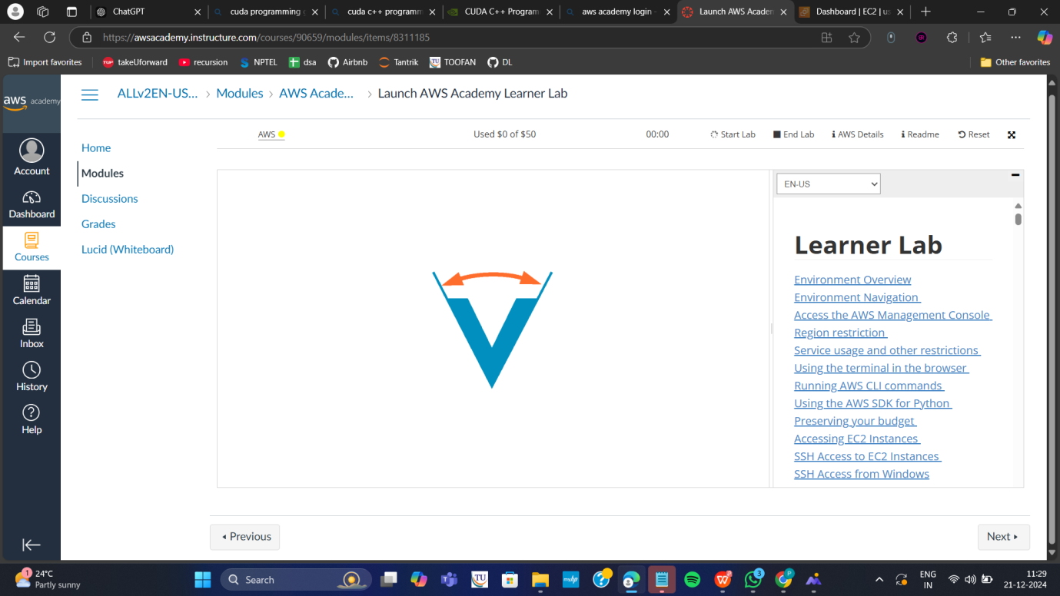

Step 2: Scroll down and select Lunch AWS Academy Lab

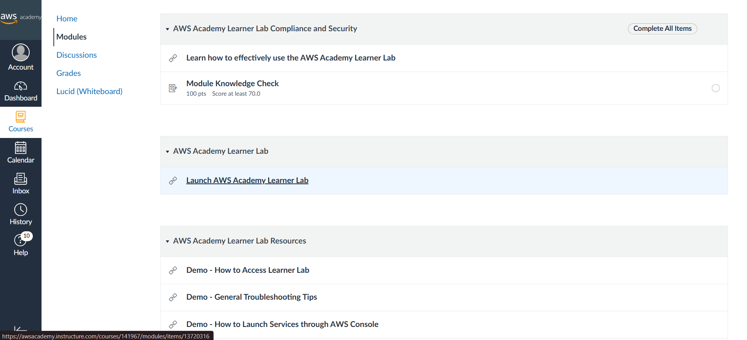

Step 3: click on start lab

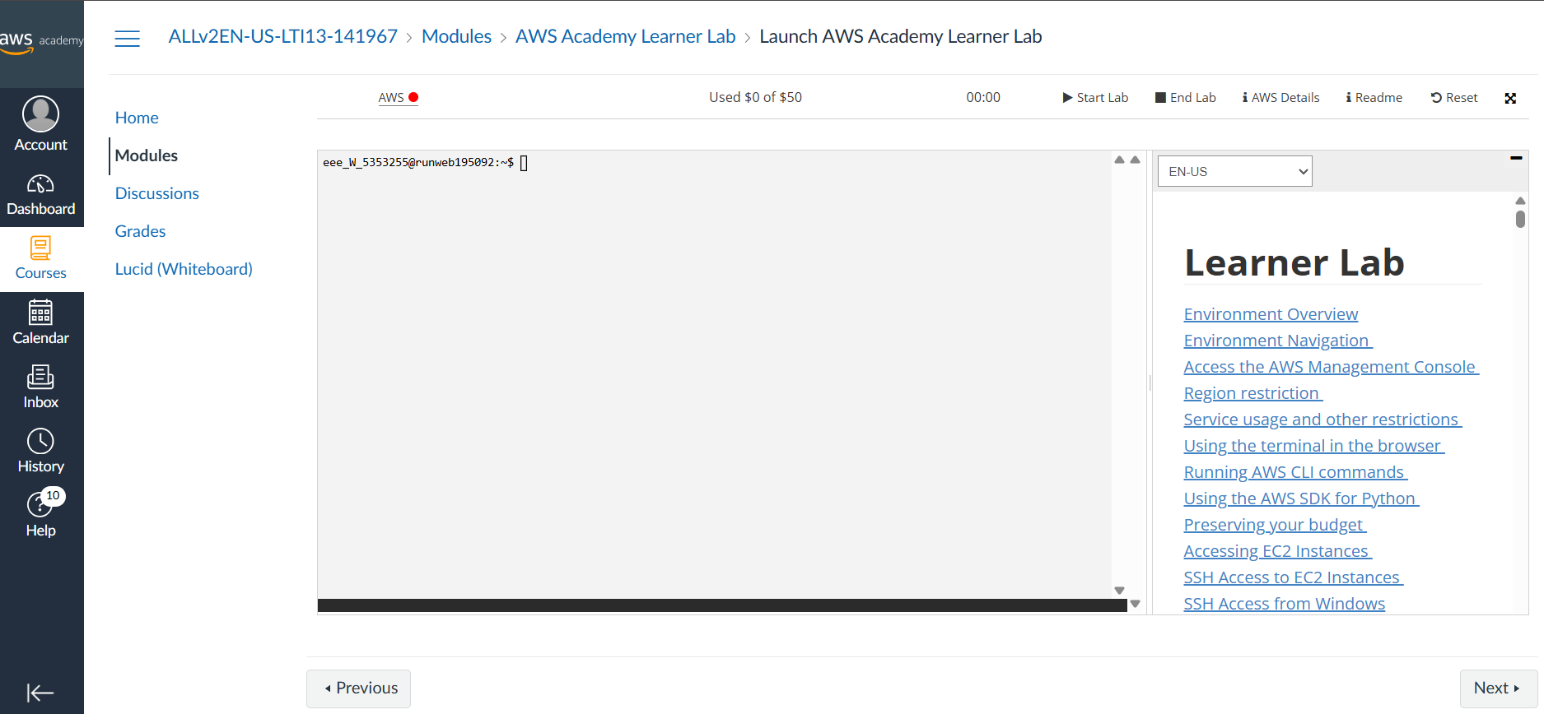

Step 4: click on AWS and in the services select EC2

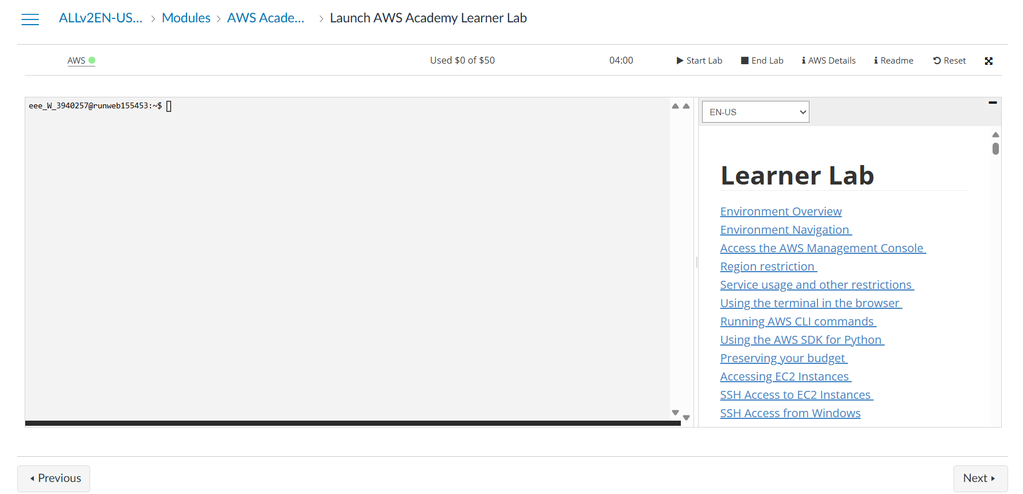

Step 5: select instances and select instance click on launch instance

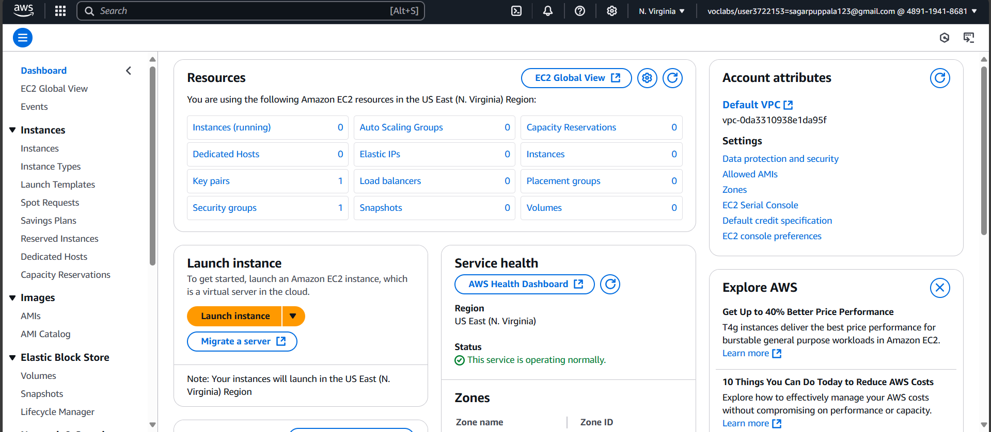

Step 6: Give the name of the machine “week-122”

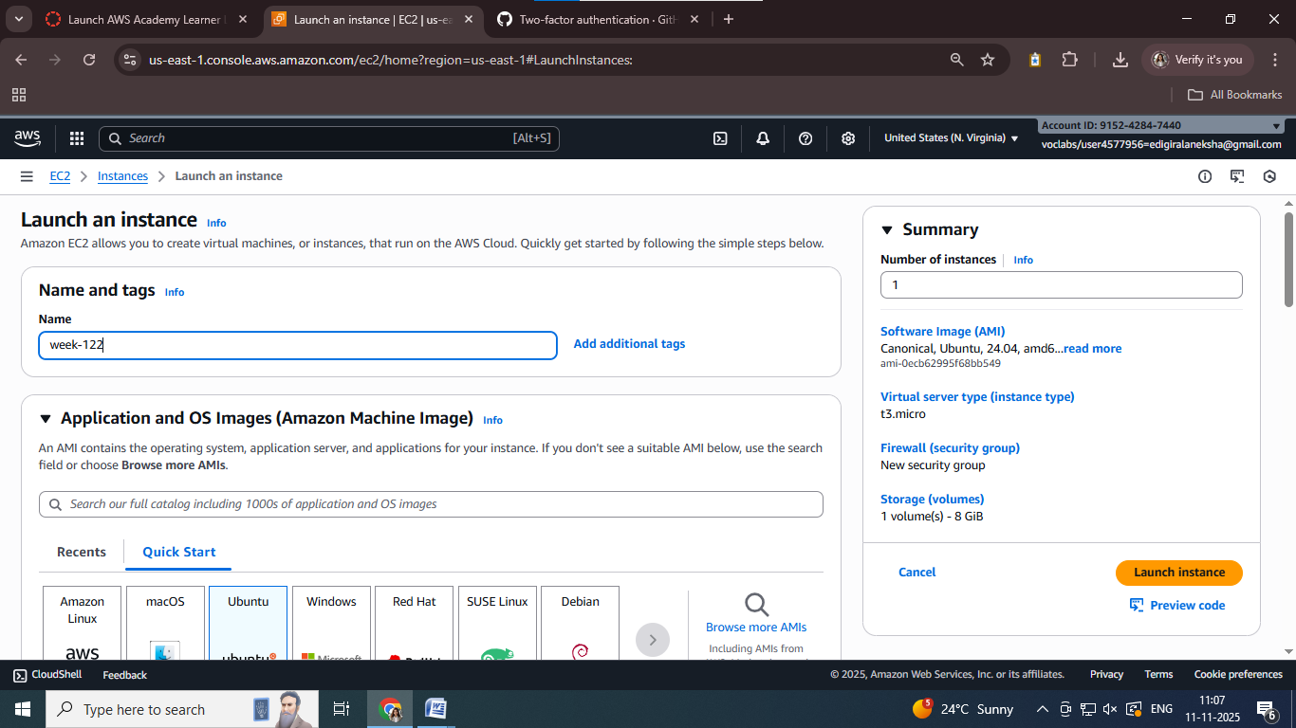

Step 6: Select the ubuntu server

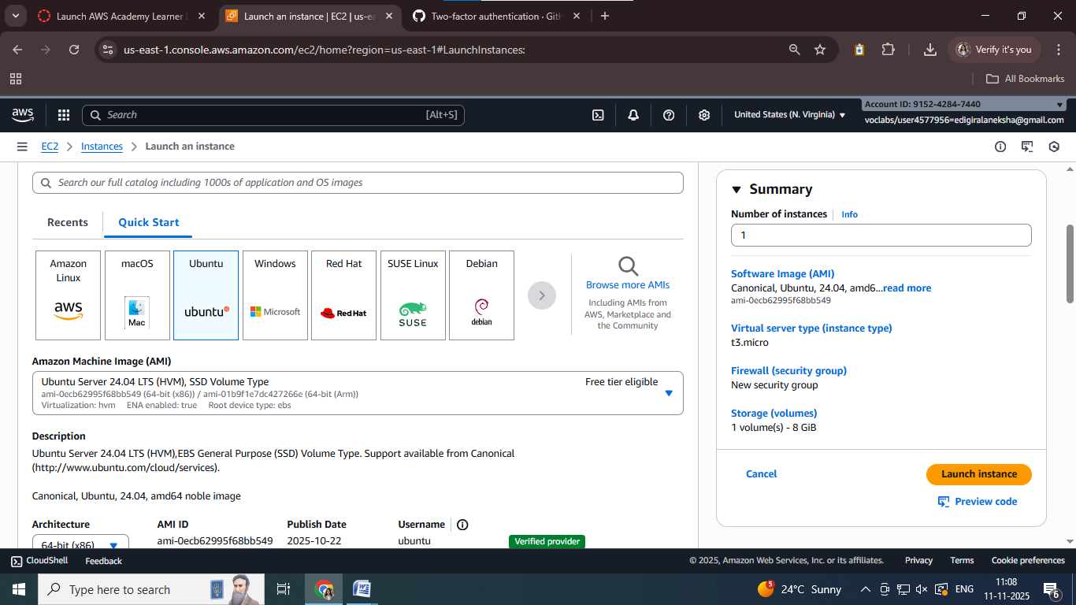

Step 7: select architecture as 64-bit and instance type as t3.micro(i.e., they are free)

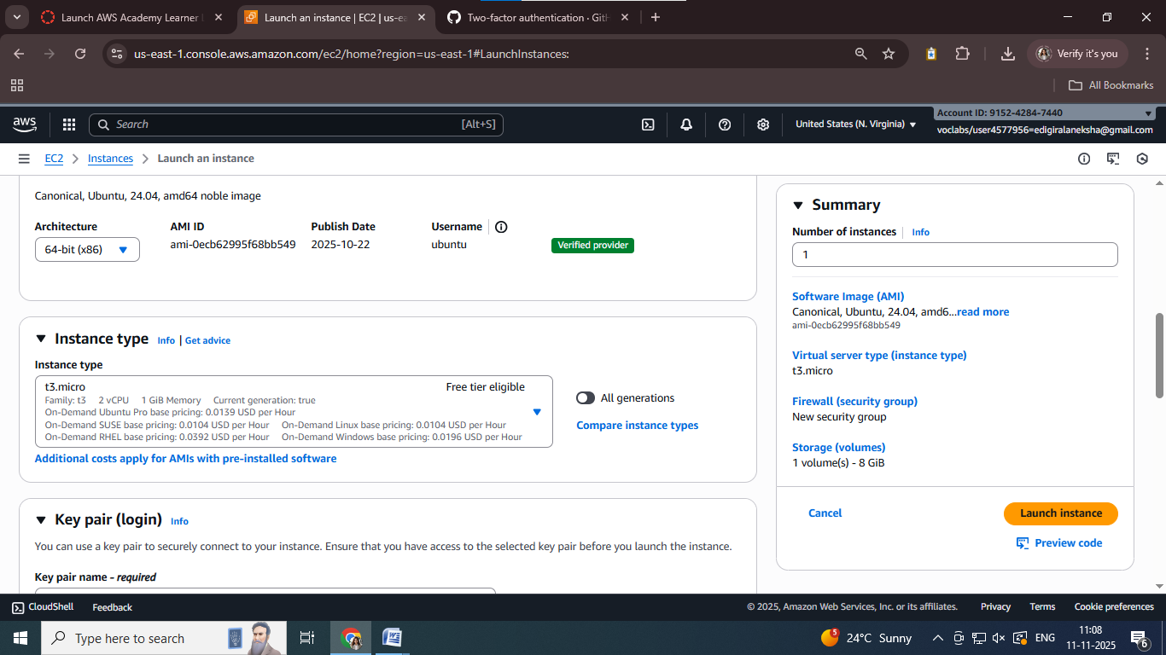

Step 8: Create a new keypair and select type as RSA and .pem option and click on create key pair

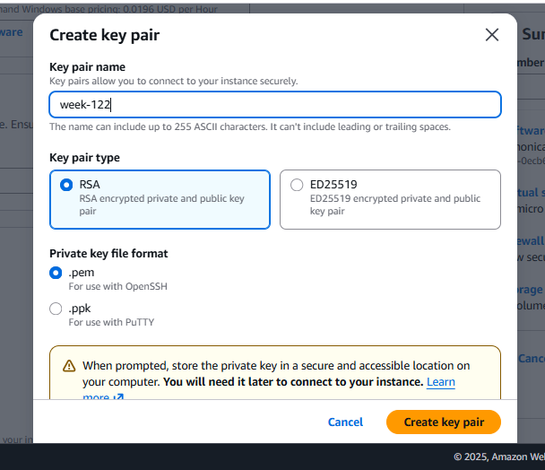

Step 9: In network settings select “create security group” and give the security group name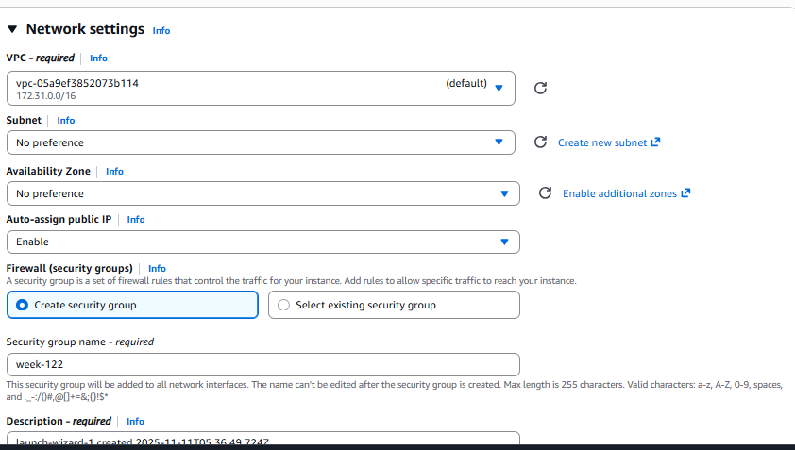

Step 10: Click on edit button on the top right corner and select

Type: ssh

Source: anywhere

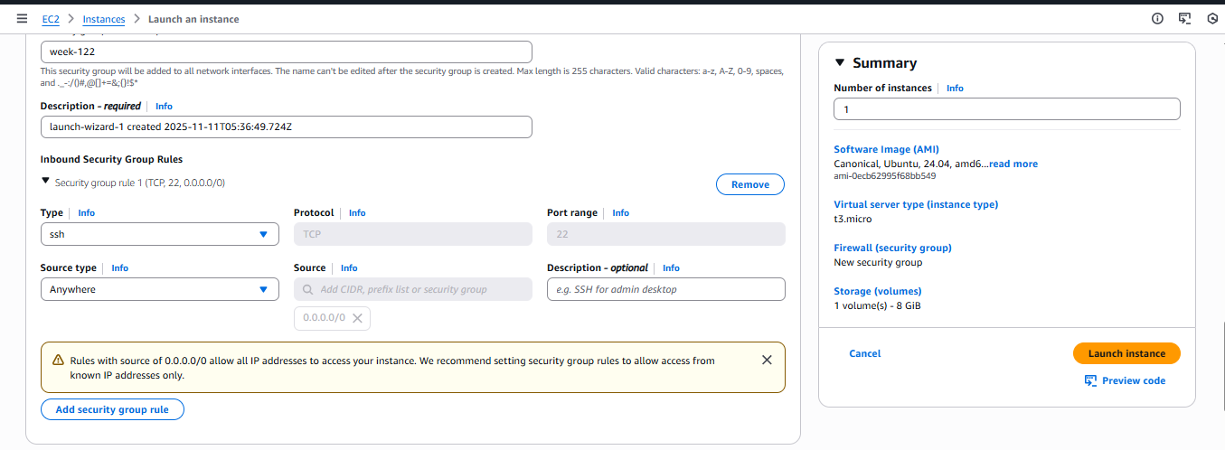

Step 11: in configure storage give 8GB and give number of instances as 2 and click on launch instance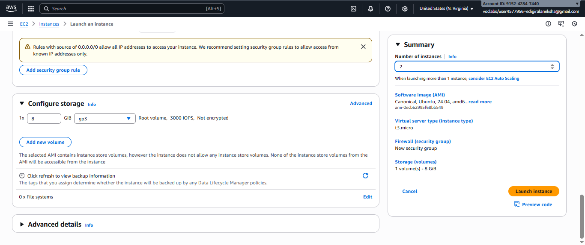

Step 12: The launching of instance will start and successful message will be shown

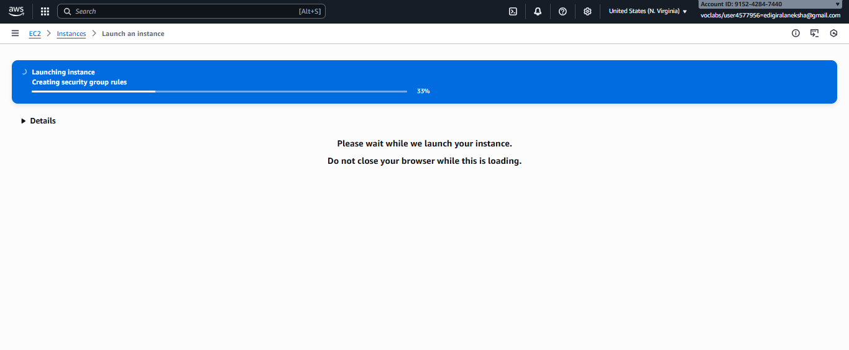

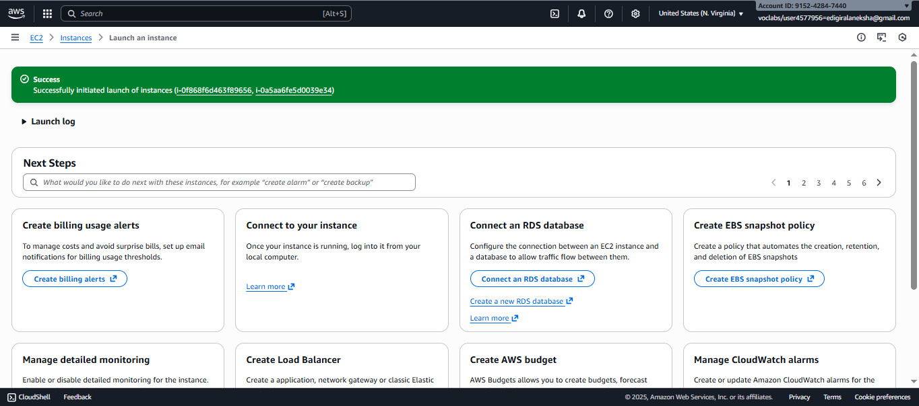

Step 13: In the instances the created ones will be shown, you can also rename the instance , changed week-1222 to “webapp”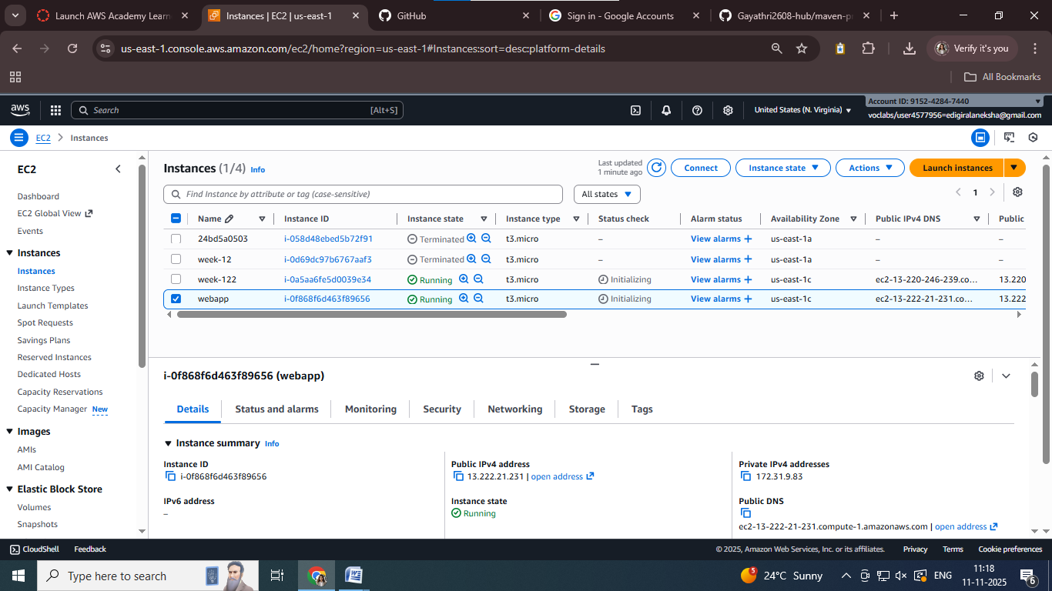

Step 14: click on connect and select “SSH Client” and copy the ssh command

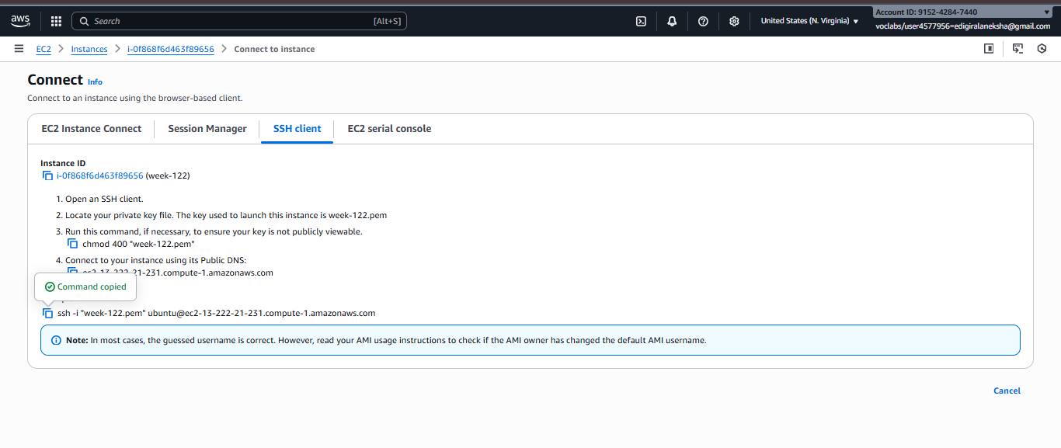

Step 15: Navigate to the path where the file with .pem extension is present(week-122.pem) and paste the command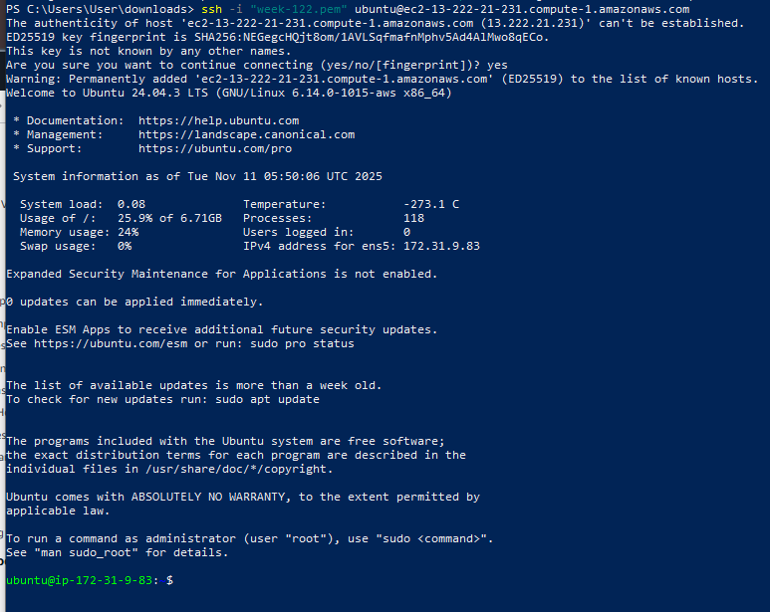

Step 16: check the docker and git version

If they are not present, then go to administrative terminal using command

“sudo su”

Then update using the command “sudo apt-get update”

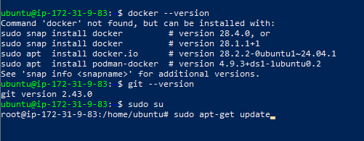

Step 17: use command “sudo apt-get install docker.io” to install docker

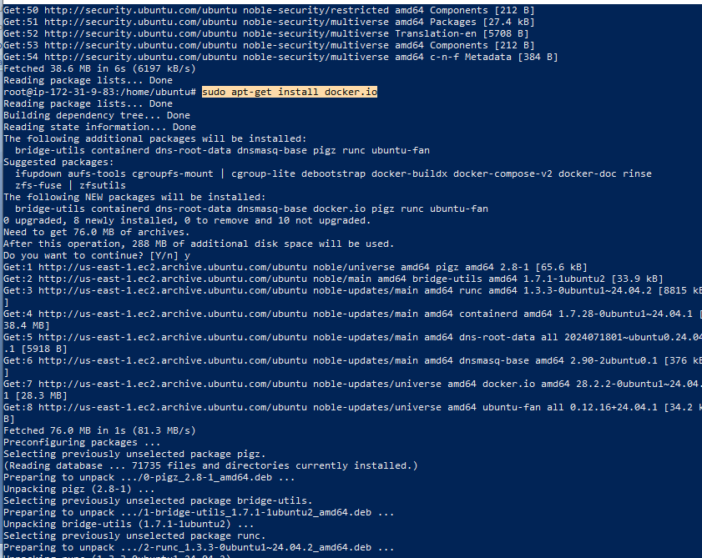

Step 18: Clone the git repo that has maven project and change to that directory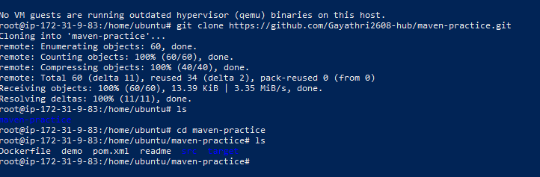

Step 19: change to the project directory and check for Dockerfile, if not present create the Dockerfile – “nano Dockerfile” and then build the image

“sudo docker build -t image_name .” name of image:img1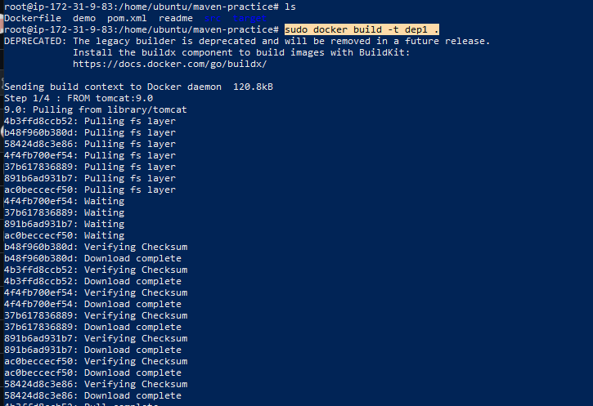

Step 20: Run the image “sudo docker run -d -p 8081:8080 img1”

Step 21: Chcek the images and the containers

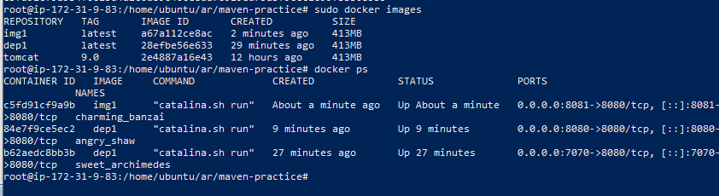

Step 22: Take the public IP address from the instances in AWS and open it in chrome along with the port number mapped.

Public IP- 13.222.21.231

Port used: 8081

Use: 13.222.21.231:8081, you will find your application that is deployed

